PROGRAMMABLE LOGIC CONTROLLERS

**✅** 1. PLC Fundamentals (Core Concepts)

* What is a PLC?  
  ▸ Definition & role in automation (why PLCs?) **✅**   
  ▸ Advantages over hard‑wired relay logic. **✅**
* PLC Architecture  
  ▸ CPU (control + scan cycle) **✅**  
  ▸ Memory (program memory, data table, I/O image table) **✅**   
  ▸ Input modules (digital/analog) **✅**   
  ▸ Output modules (digital/analog) **✅**  
  ▸ Power supply**✅**
* PLC Scan Cycle  
  ▸ Input scan → Program execution → Output update**✅**   
  ▸ Relation to continuous loops in software**✅**
* PLC Programming Languages (overview)  
  ▸ Ladder Diagram (main focus) **✅**   
  ▸ Mention of others: FBD, ST, IL, SFC (just awareness) **✅**

**✅** 2. Ladder Logic Essentials (Main Exam Meat)

* Contacts and Coils  
  ▸ Normally Open (or XIC) **✅**   
  ▸ Normally Closed (or XIO) **✅**   
  ▸ Positive Transition Sensing Contact**✅**   
  ▸ Negative Transition Sensing Contact **✅**  
  ▸ Output Coil / Output Energize (OTE) **✅**   
  ▸ Output Latch (OTL) and Output Unlatch (OTU) **✅**

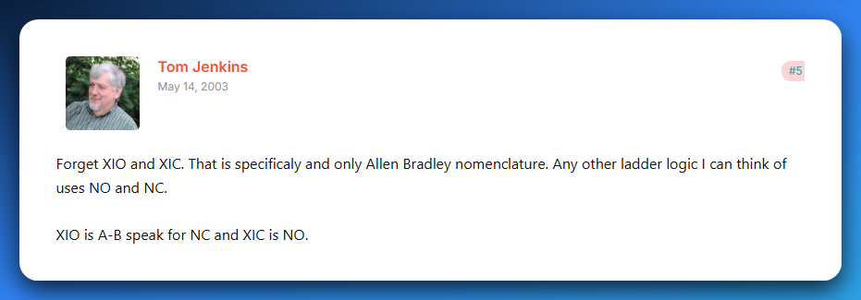

Source: [plctalk.net](https://www.plctalk.net/forums/threads/xio-xic-vs-no-nc.3486/)

* Logical Operations  
  ▸ AND (series contacts) **✅**  
  ▸ OR (parallel contacts) **✅**   
  ▸ NOT (using NC contacts) **✅**
* Internal Memory Bits  
  ▸ How to use internal relays (B3, M bits) for intermediate logic ❌
* Basic Programs  
  ▸ Start/Stop motor latch circuit❌  
  ▸ Simple interlock (two conditions must be true) ❌

**✅** 3. Timers (Time-Based Control)

* On‑Delay Timer (TON) ❌
* Off‑Delay Timer (TOF) ❌
* Retentive Timer (RTO) ❌
* Timer Reset (RES) ❌  
  *(Know their use‑cases and how to wire them in ladder logic)*

**✅** 4. Counters (Count-Based Control)

* Count Up (CTU) ❌
* Count Down (CTD) ❌
* Counter Reset (RES) ❌  
  *(Be able to create simple counting circuits)*

**✅** 5. Data Handling & Math

* Comparison Instructions  
  ▸ Greater Than (GRT) ❌  
  ▸ Less Than (LES) ❌  
  ▸ Equal (EQU) ❌
* Math Instructions  
  ▸ ADD, SUB, MUL, DIV❌  
  ▸ Scaling analog inputs (basic understanding) ❌
* Move Instruction (MOV)  
  ▸ Copy data between memory locations❌

**✅** 6. Program Structuring Techniques

* Sequencing (step-by-step control, e.g. washing machine cycle) ❌
* Subroutines / JSR (jump to subroutine) ❌
* State machines (using memory bits to track steps) ❌

**✅** 7. Troubleshooting & Simulation

* Diagnostics  
  ▸ Going online with PLC software❌  
  ▸ Forcing I/O (know concept) ❌  
  ▸ Monitoring and interpreting real-time values❌
* Common Faults-  
  ▸ Inputs not wired or misaddressed❌  
  ▸ Timers/counters not resetting as expected❌
* Simulation Practice *(you already reached this in class)*  
  ▸ Start/Stop motor latch❌  
  ▸ Traffic light (timers) ❌  
  ▸ Bottle filling/counting (counters) ❌  
  ▸ Door interlock (AND/OR logic) ❌

**✨** Your Study Priority

If time is tight, focus in this order:  
**Ladder Logic Basics → Timers → Counters → Comparisons/Math → Structuring → Troubleshooting/Simulation.**

**💡** Practical Tip

✅ Spend most of your time in a simulator (OpenPLC or LogixPro).  
✅ Build small circuits for each topic.  
✅ Write tiny notes after each topic with a quick ladder snippet.

**✨** WHAT IS A PLC?

A **PLC** is a ruggedized, solid-state industrial computer designed to run 24/7 in harsh environments. It **stores and executes control instructions** in real time to monitor inputs, make logic decisions, and control outputs. Think of it as the **brain of industrial automation**, replacing bulky relay systems with reliable digital control.

👉 It *takes in signals* from sensors and switches, processes them according to a stored program, and then sends commands to outputs like motors, valves, or lights.

**⚙️** Typical Instructions in a PLC Program

When programming a PLC, you’re basically giving it a toolbox of standard instructions. These fall into six core categories:

1. **🔄 Sequencing** – Controls step-by-step process flow (e.g., a car wash sequence: rinse → soap → scrub → dry).
2. **🕑 Timing** – Timers (ON-delay, OFF-delay, retentive) introduce precise delays or durations (e.g., keep a valve open for 5 seconds).
3. **🔢 Counting** – Counters (up, down, combined with timers) track events, products, or cycles (e.g., count 100 bottles, then trigger packaging).
4. **➕ Arithmetic** – Math operations (add, subtract, multiply, divide, floating-point) for scaling sensor data, setpoints, or calculations.
5. **📦 Data Manipulation** – Bit/word operations (masking, shifting, rotating, BCD conversions) to move, compare, or reformat data.
6. **🌐 Communication** – Lets PLCs exchange data with other PLCs, HMIs, or SCADA systems via protocols like Modbus, Profibus, or Ethernet/IP.

**📌** What Are PLCs Used For?

A PLC’s whole reason for existing is **to control and automate stuff in the real world** — especially in places too rough or complex for a normal computer.  
Here’s where you’ll see them flexing:

* ✅ Machine Control:  
  They’re the brain behind automated machines on factory floors — controlling motors, valves, and sensors with split‑second precision.
* ✅ Car Wash Systems:  
  Every step in an automatic car wash — soap, brushes, rinse, dryers — is sequenced by a PLC so your car gets clean without human intervention.
* ✅ Bottling & Packaging Lines:  
  PLCs handle the timing, counting, and coordination needed to fill bottles, cap them, label them, and pack them at insane speeds.
* ✅ Material Handling:  
  Conveyor belts, robotic arms, elevators, and palletizers all rely on PLCs to move products smoothly and safely through a plant.
* ✅ Data Acquisition:  
  PLCs don’t just control — they also **collect data** from sensors (temperatures, pressures, flow rates) and send it to HMIs, SCADA systems, or cloud dashboards.
* ✅ Pipeline Monitoring:  
  Oil, gas, and water pipelines use PLCs to watch pressures, control valves, and trigger alarms or shutdowns if something goes wrong.
* ✅ Hydroelectric Dams:  
  Gates, turbines, and safety interlocks are coordinated by PLCs to maintain power output and protect equipment.
* ✅ Process Control:  
  Industries like pharmaceuticals or refineries use PLCs to handle multi‑stage processes with loops, PID control, and precise logic.
* ✅ Food Mixing or Cooking:  
  In large-scale food plants, PLCs run mixers, heaters, and coolers to hit exact recipes, temperatures, and timings.

If it moves, mixes, counts, heats, cools, measures, or sequences — a PLC can control it.  
They’re everywhere in modern automation, silently running the show behind the scenes.

**⚙️** Main Parts of a PLC

PLC has two main parts: The **CPU** which has the memory and the **I/O subsystem.**



1️⃣) CPU (Central Processing Unit)

* **The brain of the PLC.**
* Contains the **processor + memory**.
* Reads inputs, executes your program logic, and decides what outputs should do.
* Memory stores the control program, I/O status, and working data e.g. flags, registers.

2️⃣) I/O Subsystem (Input & Output Modules)

* **Input Module** → Brings in signals from sensors, switches, etc. Converts them into digital data the CPU can understand.
* **Output Module** → Takes CPU decisions and drives actuators like motors, lights, or valves. Converts low-level CPU signals into usable power for devices.

**🖥️** Supporting Components of a PLC System

Besides the core **CPU + I/O subsystem**, PLCs often use external devices that help engineers and operators interact with the system:

1️⃣) Programming Device

* Laptop, handheld programmer, or software tool.
* Used to **create, edit, and download logic** into the PLC.
* Without this, you can’t even “teach” the PLC what to do.

2️⃣) Operator Interface (HMI – Human Machine Interface)

* Acts as the **dashboard** for the operator.
* Displays process info (e.g., temperatures, alarms).
* Allows parameter changes (e.g., speed, setpoints).
* Modern HMIs are usually **touchscreens** with graphics.

3️⃣) Terminals (Legacy Interfaces)

* **CRT Terminal** → Old-school monitor + keyboard setup. Worked like a command-line interface for real-time PLC interaction.
* **Printer Terminal** → Produced hardcopy printouts of programs, error logs, or reports for documentation.
* **Hardcopy** → Physical records on paper, important for backups or compliance in older systems.

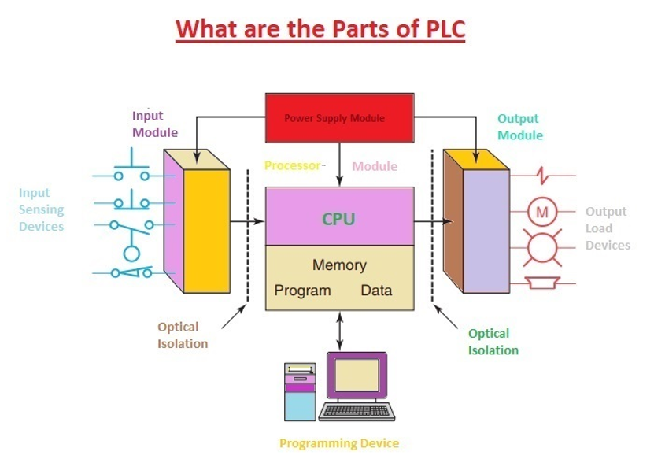

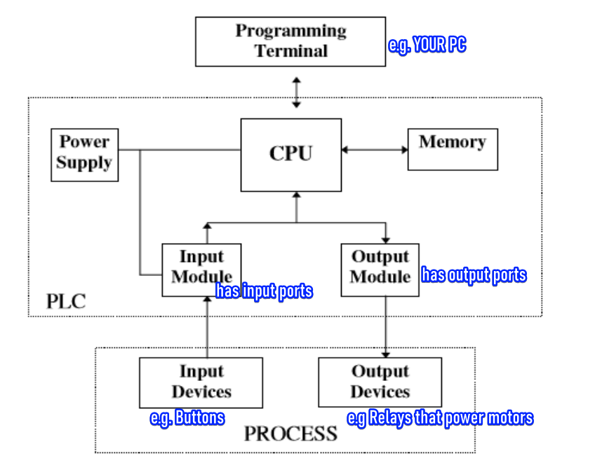

Process 1: Initializing the PLC System

You walk in, flip the switch, and the PLC comes to life. The power supply juices up the CPU and I/O modules. It's on but in **Programming Mode**, ready for you to tell it what to do. 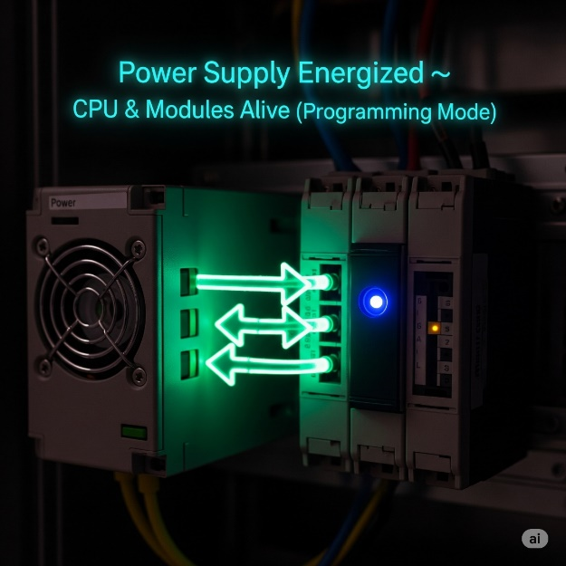

Process: Programming and Downloading Logic

Using your computer, you write the program in a language like **Ladder Logic**. Once you're happy with it, you download the code to the PLC's memory. This gives the PLC its new instructions and capabilities. It's like teaching it a new trick. 🧠

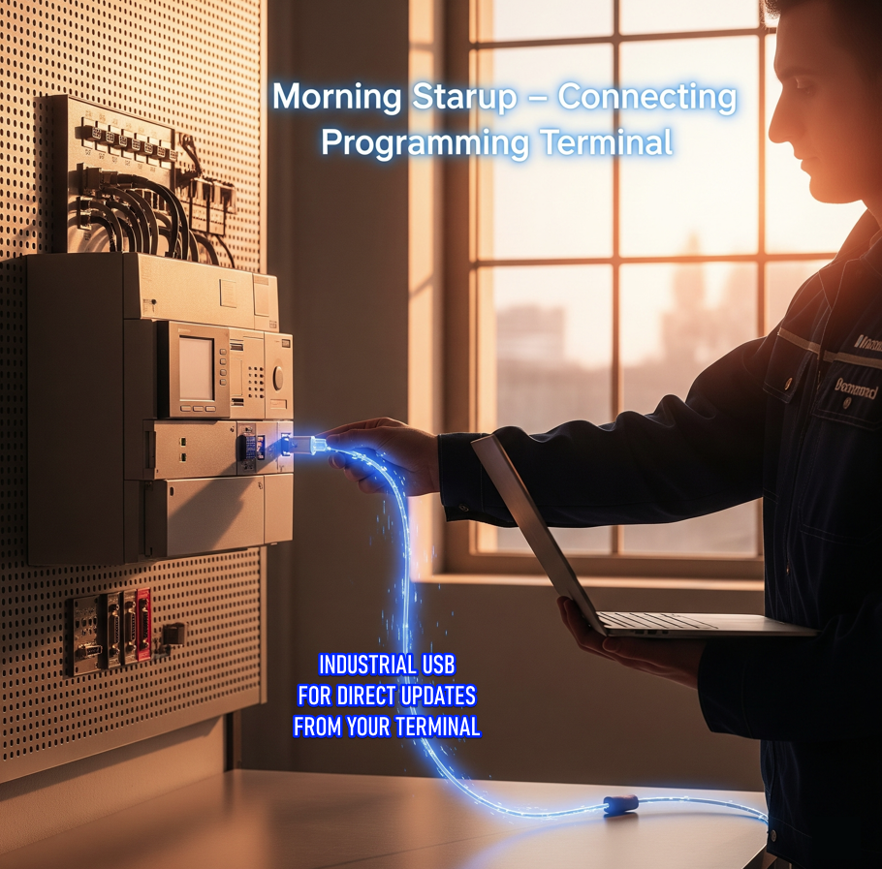

Process: Transition to Run Mode and Program Execution

When the PLC switches to **Run Mode**, it starts its endless scan cycle. It first **reads all the inputs**, then **runs the program's logic**, and finally, **updates all the outputs**. It's like a constant loop, making sure everything is working as it should. 🔄

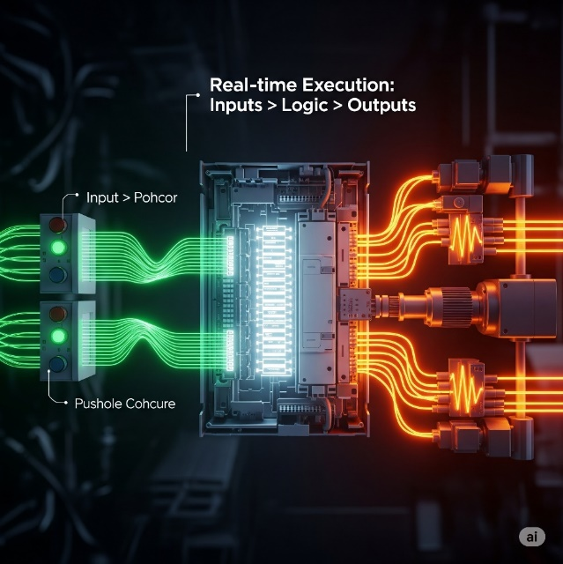

Process: Real-World Actuation via Output Chain

* The PLC CPU decides an action, like starting a motor.
* It sends a small, low-power signal to the Output Module.
* The Output Module converts this weak digital signal into a stronger electrical one.
* This stronger signal is sent to an external relay.
* The relay acts like a security guard for the motor.
* When energized, it closes its heavy-duty contacts.
* This allows high-power electricity to flow to the motor.
* The motor turns on and does its job.
* Small PLC command → big real-world action. 💥

Key real‑world use cases:

Controlling machines on a factory assembly line.

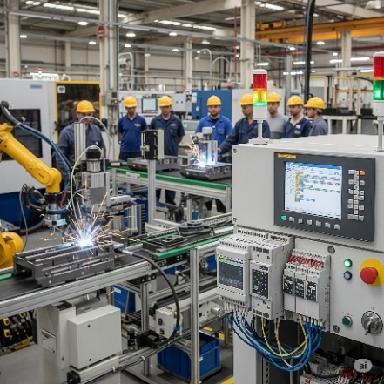

Managing amusement ride rollercoasters as they twist and turn.

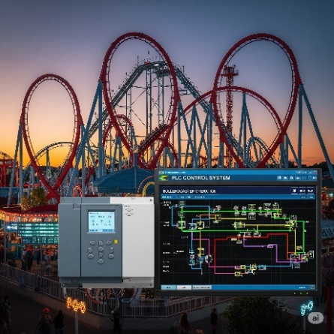

Automating food‑processing machinery that mix ingredients for your favorite snack.

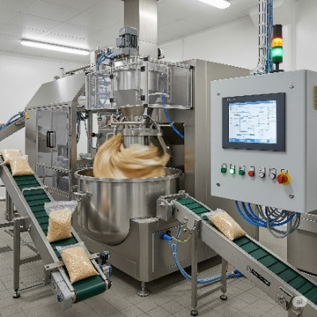

Why PLCs instead of normal PCs?

Designed to Handle Digital & Analog I/O:

PLCs have built-in I/O modules to directly handle digital and analog signals from industrial devices, while regular PCs need extra hardware and software, making them slower and harder to use for real-time control.

Survive Extreme Temperatures:

PLCs are rugged and built to survive extreme temperatures, while regular PCs can't handle the heat—or the cold—of harsh industrial environments.

Immune to Electrical Noise:

PLCs are built to resist electrical noise from heavy machinery, while regular PCs can glitch or fail in such interference-heavy environments.

Resist Vibration and Impact:

PLCs are designed with sturdy, shock-resistant casings and components, enabling them to withstand vibrations, impacts, and rough handling while regular PCs are too fragile and prone to hardware failures under physical stress.

**⚡** CPU Operating Modes

We said that the **CPU** is the brain of the PLC. It has a **microprocessor** that handles all the calculations, **memory chips** for storing the program and data, and **control circuits** that let it talk to everything else, like the I/O modules and other devices. 🧠

The PLC's CPU has distinct operating modes:

* **Programming Mode/Offline Mode:** The PLC is essentially stopped. Its CPU not executing any instructions that control machinery, so it’s in a safe state ready to accept new instructions. Control logic can be uploaded without the output being affected coz the PLC is off.
* **Run Mode/Online Mode:** The PLC's CPU continuously executes the program stored in its memory. It performs a high-speed scan cycle, reading inputs, processing logic, and updating outputs to control the connected machinery in real-time.

The **CPU** is the heart of the PLC. It handles **decision-making** and manages **user memory**, both of which are **fully controlled by the programmer i.e. you 😈).**



**🧩** 1. Decision-Making Section

The CPU is the brain of the PLC. Constantly *reads signals* from inputs like sensors, *compares* them to your preprogrammed instructions, and then *decides which outputs* to turn on or off.

Always checking inputs and making things happen based on your custom logic. 🤖

**🗃️** 2. User Memory Section

This is where your program and working data live.

**🧠 What’s stored here?**

*Instructions (Your actual program — logic, sequences, etc.)*

*Application-specific data, like:*

* Current status of inputs and outputs
* Temporary storage for values (like timers, counters, internal flags)
* Recipes, setpoints, operator-entered data

Inputs and Outputs (The Senses – How the PLC Gathers Info): 👂👀

This part of the PLC is constantly **listening and watching** for signals from the outside world.

**1) Input Field devices** gather real-world info (like temperature, position, pressure)

**2) Output Field devices** receive and act on commands to perform physical actions e.g. The PLC processes the signal from the proximity sensor and sends a command to a motor (an output device) to push the box off the conveyor.

**3) Sensors:** Sensors give the PLC *status updates*.

* A **proximity sensor** says, “Product is in place.”
* A **temperature sensor** warns, “It’s getting hot!” 🌡️🔥
* A **magnetic proximity sensor** detects when a metallic object is nearby. 🧲
* A **photoelectric sensor** sees if an object is present or absent by using a beam of light.
* A **limit switch** signals when a mechanical part has reached its full travel distance e.g. garage door hits a limit switch signal sent to stop motor meaning gate is fully open or fully closed. ✋
* A **pressure sensor** measures the force of a gas or liquid in a system e.g. hydraulic press. 🌬️
* A **flow sensor** checks if a liquid or gas is moving through a pipe. 💧
* A **level sensor** tells you how full a tank or container is. 📏
* An **encoder** tracks the rotation or position of a shaft. 🔄
* A **vision sensor** uses a camera to inspect, identify, or locate an object. 👁️
* An **ultrasonic sensor** detects objects using sound waves. 👂
* An **infrared sensor** senses heat or motion. 🔥

**4) Switches:** A switch is a device that completes or breaks an electrical circuit to send a signal to the **PLC**. It acts as a digital input, like a simple on/off button, telling the PLC to start or stop a process.

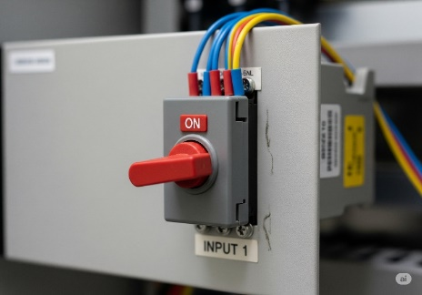

**5) I/O points** are the physical terminals on the PLC where you connect field devices like sensors and switches.

Each of these points is assigned a **unique memory address** (for example, X000), allowing the PLC's CPU to monitor its state.

When a device is activated, the **corresponding bit in the PLC's memory flips**, changing its value from **0 to 1** to signal the change. 🔌

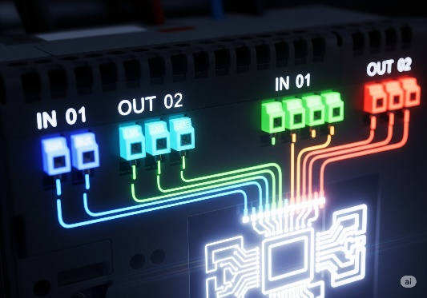

**📌** Discrete Inputs (a.k.a Digital Inputs)

**Discrete inputs**, also known as digital inputs, are *signals sent from devices* that can only be in one of two states: **ON** or **OFF,** noin-between.

They are used by the PLC to know if a switch is pressed, a sensor detects an object, or a motor is running e.g.



* **Pushbuttons (Normally Open / Normally Closed):** Think of a "start" or "stop" button on a conveyor belt. You push it to either turn the machine on or off. 🟢
* **Limit Switches:** These are like a tripwire for a machine's movement. For example, they tell a robotic arm that it has reached the end of its path. ⚙️
* **Float Switches:** Imagine a water tank. A float switch tells the PLC when the water level is too high or too low, so it knows when to turn a pump on or off. 💧
* **Toggle Switches:** These are just your basic light switches. You flip it on or off to send a constant signal to the PLC. 🔄
* **Flow/Pressure Switches:** A flow switch might tell a PLC that water is flowing through a pipe, or a pressure switch could warn that the air pressure in a tank is too low. 📈
* **Foot Pedals / Safety Interlocks:** A foot pedal lets a worker control a machine hands-free, like a sewing machine. A safety interlock on a machine door prevents it from running if the door is open. 🦶
* **Proximity Switches:** These are like magic eyes for machines. A proximity switch on an assembly line detects a metal soda can as it passes by, triggering the next step in the process. 🧲

**🔌** Analog Input



**Analog inputs** are signals that represent a range of continuous values, not just ON or OFF. They provide the PLC with a detailed measurement of something in the real world. Think of them as a dimmer switch rather than a light switch.

* **Temperature Sensor:** Measures a continuous range of temperatures, from freezing to boiling. 🌡️
* **Pressure Sensor:** Reports the exact pressure in a pipe, not just if it's high or low. 💧
* **Flow Meter:** Measures the specific rate at which a liquid is flowing, like a certain number of gallons per minute. 🌊
* **Strain Gauge:** Detects and quantifies a tiny change in a material's shape, like how much a metal beam bends under a heavy load. ⚖️
* **Potentiometer:** A variable resistor that can be used to control things like the speed of a motor by providing a variable voltage signal. ⚙️

**📌** Discrete outputs

**Discrete outputs**, or **digital outputs**, are signals from the PLC that can only be **ON** or **OFF**. They are used to turn devices on or off, just like a light switch. The PLC sends a signal to a relay or a switch that then controls a device.

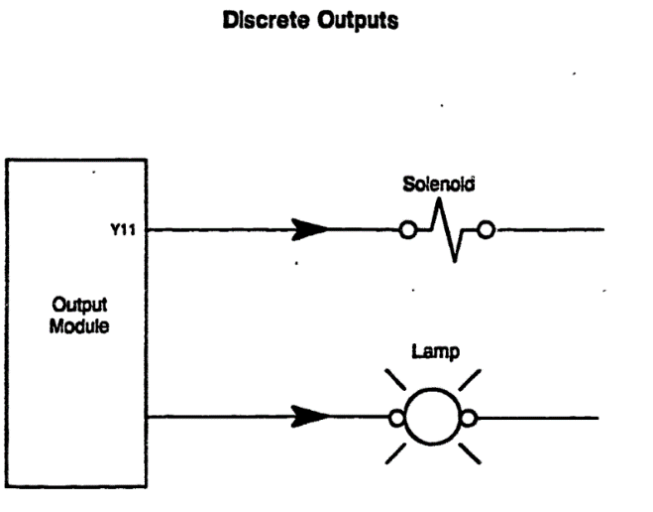

They control devices that either:

* *turn ON/OFF*
* *open/close*
* *light up or go dark*

Just like inputs tell the PLC what’s happening outside, **discrete outputs** are how the PLC **tells machines what to do.**

A **discrete output** sends an ON or OFF signal to a field device — nothing fancy, just pure binary power delivery.

* **Solenoids and Solenoid Valves 💧**  
  A solenoid works like an automatic gate lock — when the PLC sends an ON signal, it either opens a valve to let air or liquid pass, or closes it to stop the flow.
* **Motor Starters and Contactors ⚙️**  
  Since PLC outputs are low-power, they send signals to contactor coils, which then close heavy-duty switches to safely start large motors or pumps with high voltage.
* **Indicator Lamps / Pilot Lights 🚦**  
  These are the colored status lights controlled by the PLC that show machine states — for example, green for running and red for stopped.
* **Buzzers and Alarms 🚨**  
  When the PLC detects a problem or a critical event, it turns on a buzzer or alarm to immediately alert human operators.
* **Relays 🔌**  
  A relay is an electrically operated switch; the PLC energizes it with a small signal, and in response it controls bigger devices or acts as part of more complex circuits.

**🔌** Analog Outputs

**Analog outputs** are signals that can have a continuous range of values, not just ON or OFF. They are used to control the speed, position, or intensity of a device. Think of them like the volume knob on a stereo, allowing for fine-tuned control.



**Variable Frequency Drives (VFDs) 💨**  
The PLC sends an analog signal to a VFD to smoothly adjust the speed of a motor, such as controlling the RPM of a fan or pump.

**Proportional Valves 🌡️**  
Using analog outputs, the PLC can regulate how much a valve opens, allowing precise control of fluid flow instead of just ON/OFF.

**Heater Control 🔥**  
An analog output from the PLC can regulate temperature to a specific degree, making heating systems variable rather than simply full power or off.

**Position Control 🤖**  
PLCs use analog signals to control positioning systems, like robotic arms, moving them smoothly and precisely to exact locations.

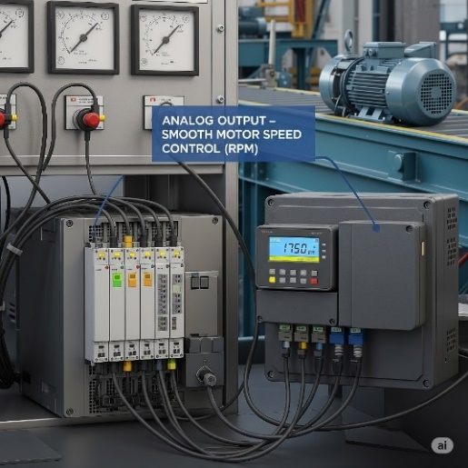

Real World Example:

* An **I/P (Current-to-Pneumatic) Transducer** converts the PLC's analog electrical signal into a proportional air pressure.
* For example, the PLC sends a **4-20 mA current signal** to the transducer, which then adjusts a pneumatic valve.
* A low signal like **4 mA** opens the valve slightly, while a high signal like **20 mA** opens it fully, allowing for precise control of fluid or air flow.
* This entire process is part of a larger control loop, where the PLC's output is just one piece of the puzzle.

**Beware!** Sometimes, due to mechanical or electrical factors, the system might behave in a **non-linear (disproportionate)** way — *meaning that doubling the signal doesn't necessarily double the effect.*

Summary for PLC Inputs/Outputs

The PLC's **output interface** is how it sends commands to devices in the real world.

**Actuators** are the "doers" that receive these commands and perform a physical action.

The PLC can control things like **motors** to start a machine or **lamps** to show a machine's status.

The PLC often uses a **relay** as a remote-controlled switch to safely control larger devices, as it cannot directly power them. 🦾

***A PLC is a programmable controller composed of a CPU, power supply, and I/O modules that work together to replace complex, hard-wired relay logic with flexible software control.***

**💾** PLC CPU Memory – What it stores and tracks

Stores the **program logic**, the actual instructions.

Tracks the current **status of inputs and outputs.**

Data Values – Stores values for:

* Timers ⏱️ (e.g., wait 5 seconds before starting)
* Counters 🔢 (e.g., count 10 items passing a sensor)
* Internal Bits ⚙️ (virtual switches used inside the program)

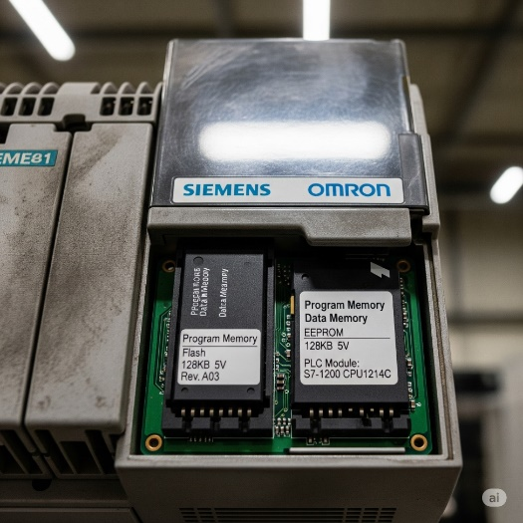

**📝** Real Talk:

If the CPU is the brain, then the **user memory** is like a combo of short-term memory (RAM) and long-term habits (program logic). Your logic tells it what to do, and the CPU keeps checking reality to follow those instructions. The memory holds the “how-to” list (instructions you give it) and the “what's happening” info (current readings or values from sensors).

**🧪** Summary with Example Flow

1. Input says: “Tank is full” → sensed by a float sensor.
2. CPU reads this input.
3. It checks your program (user memory): IF tank is full THEN close valve.
4. Decision is made: Close the valve.
5. Output is activated to shut off the valve via a relay/solenoid.

That’s how **industrial automation magic** happens. Simple, logical, powerful.

The Scan Time: Blazing Fast Automation! **🚀**

*A PLC is a dedicated industrial controller, built to run a single control program — and it does so continuously and extremely fast.*

1. **🔍 Read Inputs**  
   The PLC checks the status of ***all input devices*** (e.g., are switches pressed? Is the sensor triggered?).
2. **🧠 Execute Program**  
   Using the input data, the CPU **runs the logic** stored in its memory — this includes timers, counters, and all the if/then conditions in the control program.
3. **⚡ Update Outputs**  
   Based on the results, the PLC **sends commands to output devices** (e.g., turn on a motor, light a lamp, or open a valve).

The time it takes for the CPU to complete **one full cycle** – reading inputs, executing the program, and updating outputs – is called the **scan time**.

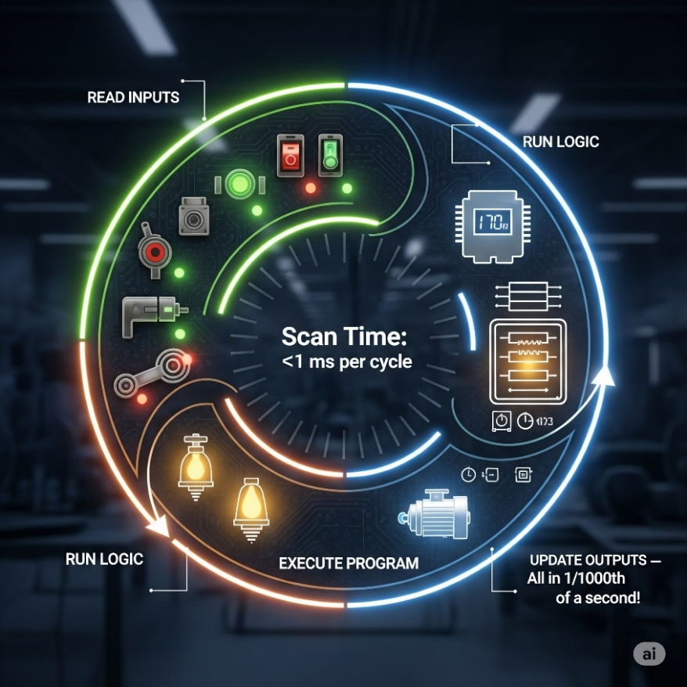

This happens with mind-blowing speed, often in the range of **1/1000th of a second** (that's 1 millisecond!).

Imagine blinking, and the PLC has already completed several hundred scans!

This rapid cycling is crucial for ensuring that industrial processes respond instantly to changes in the real world.

**⚙️** PLC Scan Cycle Recap:

Every PLC constantly runs in a **loop** like this:

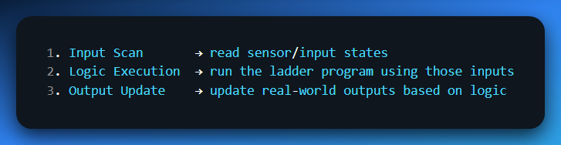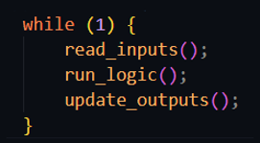

Except it’s optimized, real-time, and done in **hardware** + **firmware**.

**⚙️** Why the Scan Cycle Matters

* **Inputs don’t update outputs instantly** → outputs only change on the *next scan*.
* **Timing issues** can happen if the program takes too long to execute (long scan time).
* **Instruction behavior**: some (like **SET/RESET**) persist across scans, others (like **OUT**) only work if the rung is true on *every* scan.
* A PLC is **scan-loop based** (not event-driven like normal PC code).

**🔥** Exam Essentials

* Define what a PLC is and where it’s used.
* Explain its main parts (CPU + I/O).
* Distinguish between **program mode** and **run mode**.
* Describe the **scan cycle** and what “scan time” means.
* Show why **memory** is crucial for holding programs, I/O states, and values.

**✅** Main parts of a Programmable Logic Controller Summary

CPU (Central Processing Unit)  
👉 *The brain.*

Executes the control program (ladder logic, etc.) Does all the decision‑making. Handles communication with other modules. Stores the logic in memory and updates outputs based on inputs.

Power Supply  
👉 *The heart pumping electricity.*

Feeds the CPU and I/O modules with stable DC power (often 24volt DC). Without this? Dead PLC. 💀

Input Module(s)  
👉 *The senses (eyes, ears).*

Reads signals from field devices (sensors, pushbuttons, limit switches). Converts them into logic levels the CPU understands.

Output Module(s)  
👉 *The muscles (hands, feet).*

Sends commands to actuators (motors, relays, lamps, solenoids). Converts CPU logic to real‑world signals.

Programming Device (not always mounted, but essential)  
👉 *The interface.*

Laptop or handheld used to load/edit programs into the PLC. Without this, you can’t tell the PLC what to do.

Communication Ports / Interfaces  
👉 *The mouth and ears for networking.* Ethernet, RS‑232, Profibus, etc. for talking to HMIs, SCADA, or other PLCs.

**✨** HISTORY OF THE PLCs

Before 1968, factories-controlled machines using **relay-based systems**:

* Relays = little electromagnetic switches turning things on/off.
* To control one motor, you needed a power relay.
* To control *that relay*, you needed control relays.
* Add timers, counters… soon you had cabinets stuffed with hundreds of relays.  
  👉 Result: a hot mess. Hard to wire, hard to change, a pain to troubleshoot. 🤯



Enter 1968 (Hydra-Matic division of General Motors):

* Replace relay logic with a **solid-state controller**.
* Must support **ladder logic** programming (familiar to electricians).
* Must handle **harsh industrial environments** (dust, vibration, electrical noise).
* Must be **modular** (easy to expand and maintain).

Dick Morley’s team delivered:

Dick Morley's team first created the **Modicon 084**, the first commercial PLC, but it had limited success due to its speed and memory issues.



The subsequent **Modicon 184** was a more robust and user-friendly design that became an industry standard, replacing relay-based control systems.



Key innovation:

Instead of physically rewiring circuits, engineers now just modify software logic.  
✅ Faster changeovers.  
✅ Reduced downtime.  
✅ Lower maintenance.  
✅ Space-saving, scalable control.

Leveling Up: New Powers for the PLC Brain **🧠✨**

**Early PLCs** were limited, only handling basic ON/OFF inputs/outputs, simple logic, and basic timers and counters. This contrasts with **modern PLCs** which have much more advanced capabilities.

**1) Math Calculations:** Building on their ability to handle numbers for timers and counters, PLCs quickly learned to perform basic math and later mastered floating-point calculations for precise measurements and complex operations.

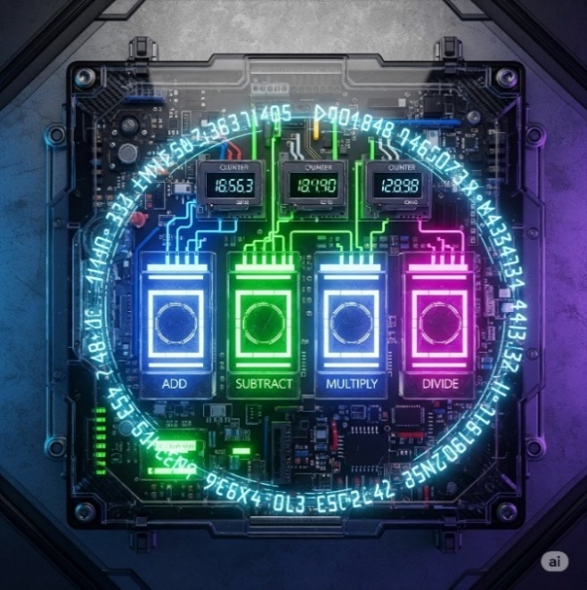

**2) Enhanced Timing & Counting:**

PLCs advanced from basic timers to include **one-shots** and more sophisticated timers and counters, allowing them to precisely control complex sequences and react to quick signal changes. 🧠

**3) Process Control Superpowers (PID):**

PLCs gained built-in **PID controllers (Proportional-Integral-Derivative)**, which act like a lightning-fast autopilot to maintain perfect stability in a system. They constantly fine-tune things like temperature or pressure to keep them exactly where they need to be without a human having to constantly make adjustments. 🌡️ A **pharmaceutical company** uses PID controllers to maintain precise pressure in tablet compression machines.

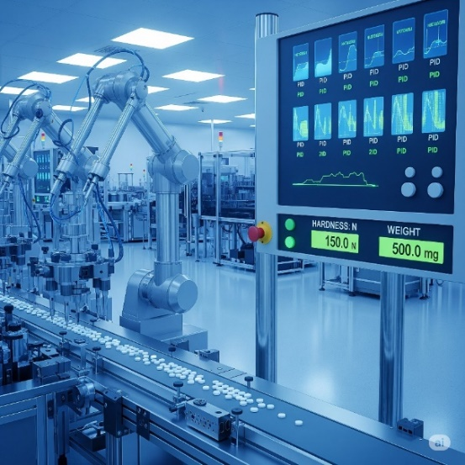

**4) Drum Sequencers:**

A **drum sequencer** is a type of PLC instruction that controls a machine through a fixed series of steps, one after the other. It's like a checklist for a robot, ensuring each task is done in the right order and completed before moving to the next. 🥁 Auto-Carwash:  
*pre-rinse → soap → scrub → rinse → dry → wax.* This ensures consistent results for any repetitive process.



**5) Smarter Programming:**

**Fill-in-the-blank programming** made it easier to set up common functions without writing a lot of code, similar to filling out a digital form.

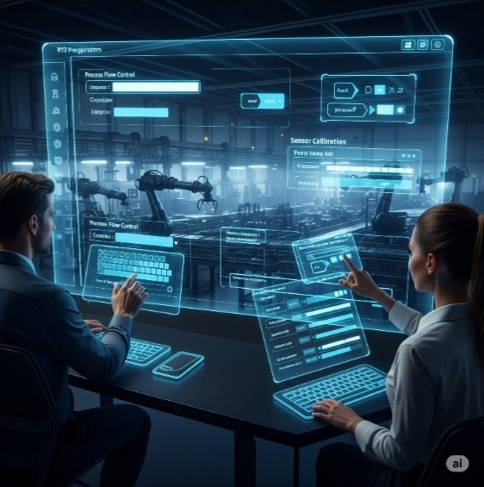

**Meaningful Tag Names** replaced cryptic addresses (like I:0/0) with clear, descriptive names (like Start_Button). This is like assigning names to your phone contacts instead of just using their numbers, making the program much easier to read and debug.

 

The ability to Import/Export Tags allowed these names to be easily shared between different devices, like a PLC and an HMI, saving time and reducing errors.

**Human-Machine Interfaces (HMIs)** replaced old-school, hardwired panels with digital, on-screen controls, leading to less physical clutter and better data visibility.



We moved from hardwired panels to smart HMIs. Less physical clutter, more data visibility, fewer mistakes.

TALKING THE TALK: PROGRAMMING & COMMUNICATION EVOLUTION **🗣️💻**

As PLCs got smarter, so did the tools used to program them and the ways they communicated with the outside world.

Programming Devices:

**The "Suitcase" Era:** Early programming devices were dedicated, clunky, and literally the size of suitcases! Not exactly portable.

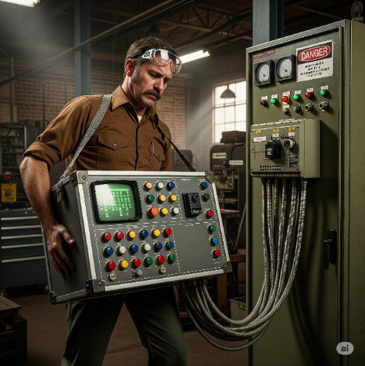

**Handhelds:** Then came smaller, handheld devices, offering a bit more freedom.

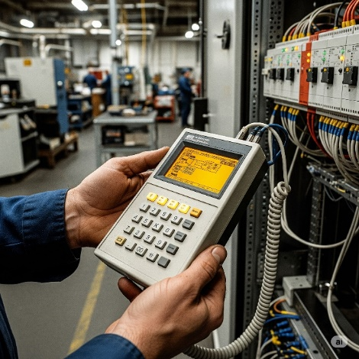

**PC Software Takes Over:** The real revolution happened when proprietary programming software moved to personal computers (PCs).

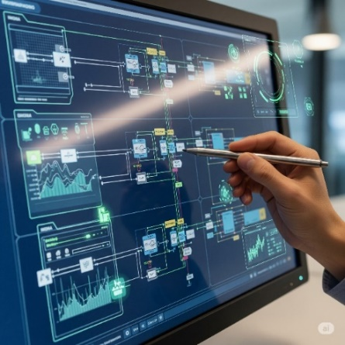

AutomationDirect's **DirectSOFT** was a pioneer as the first Windows-based PLC programming package. This was huge!



**🛠️** Software, Hardware, Firmware



🔁 The CPU runs two “layers” of code:

* **Firmware**: Low-level code (like an OS) that makes the PLC even *function*. You can't edit this — it’s stored inside the chip.
* **User Software**: Your custom ladder logic or structured text. This is the code that makes your specific plant or machine behave how you want it to.

Communication Protocols:

PLCs needed to talk to other devices, and this area saw rapid growth.

1) The Early Days (MODBUS & RS-232):

Used basic serial protocols.

Direct cable link between two devices.

Slow, point-to-point communication.

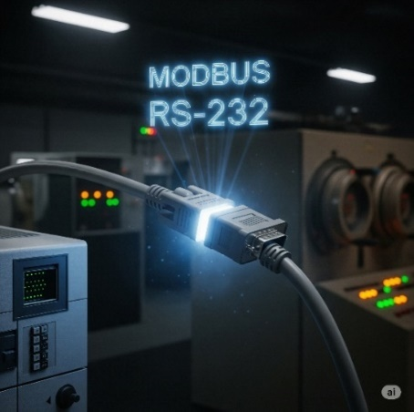

2. Expanding the Network (RS-485, DeviceNet, Profibus):

Allowed multiple devices over longer distances.

Think of it like a small office network for machines.

* ***Sensors*** *= factory’s eyes and ears (temperature, pressure).*
* ***Drives*** *= factory’s muscles (motor speed, direction).*
* ***Remote I/O*** *= factory’s nerve endings (extend reach across plant).*



3. The Ethernet Era:

Fast and flexible.

Standard for industrial communication.

Connects PLCs with drives, robots, HMIs, and SCADA.

Enables “smart factories” where everything communicates.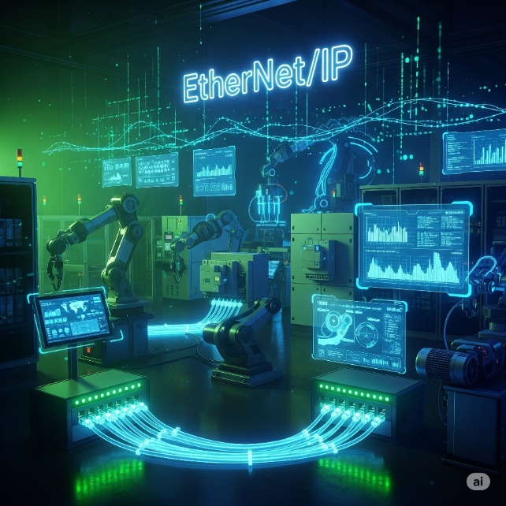

HOW TO CHOOSE YOUR PLC

Choosing the right PLC for a project is like picking a perfect teammate; it requires careful consideration of key factors to ensure it's a good fit for the system's needs. 🧠

Step 1: New System or Existing System? 🏗️🔄

When choosing a PLC, you must first determine if you're building a **new system** or **upgrading an existing one**, as your PLC needs to be compatible with all existing equipment to avoid costly communication issues. 🏗️

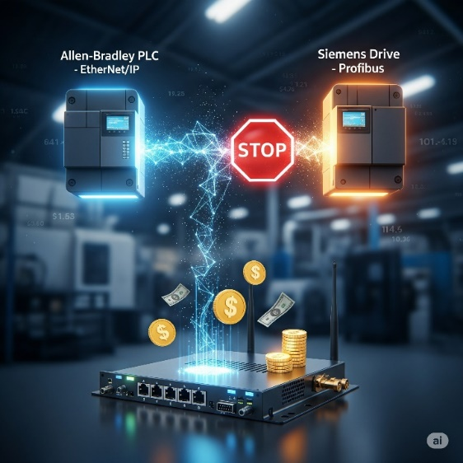

Step 2: Environmental Check **🌡️💨**

When choosing a PLC, you must consider the environment it will be in, ensuring it can handle factors like temperature, dust, vibration, and safety codes e.g. explosion-proof, waterproof, to prevent premature failure. 🌡️

Choose **ruggedized controllers** for harsh environments or **protect standard ones** with proper enclosures. Skip this step and your whole operation stops when the controller dies.

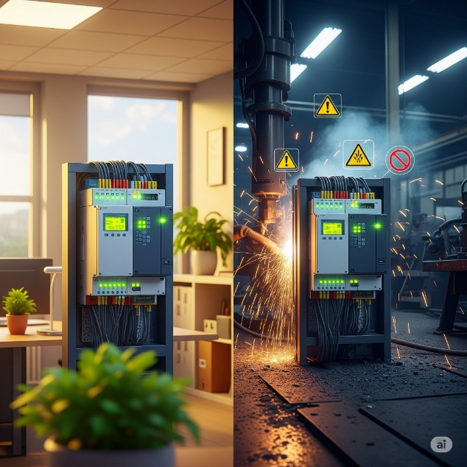

Step 3: Counting the "On/Off" Crew (Discrete Devices) **🚦**

Before selecting a PLC, you must count all the **discrete devices** (on/off components like buttons and lights) in your system and determine if they use AC or DC power to ensure your controller has enough compatible I/O points. 🚦 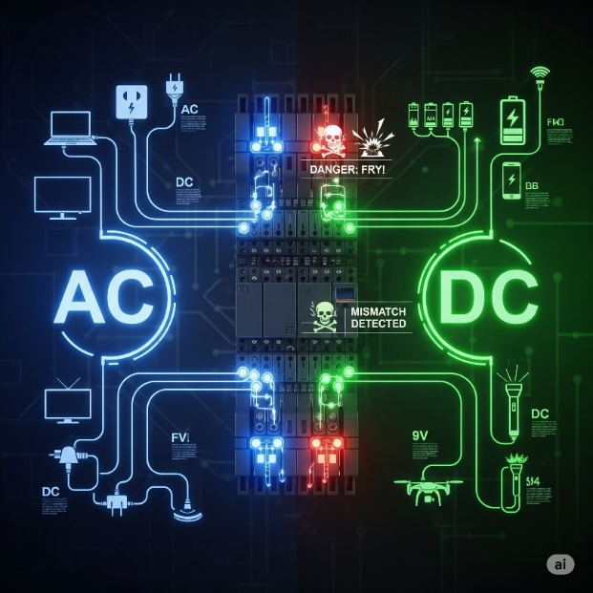

Step 4: Count Your Analog Devices **📏🌡️**

These are the ones that **measure a continuous range of values**, like a temperature sensor. You need to count how many of these devices you have and what type of signal they use (e.g., voltage or current) to ensure your PLC has the correct analog input modules. 📏

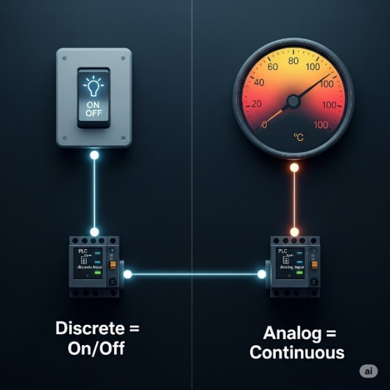 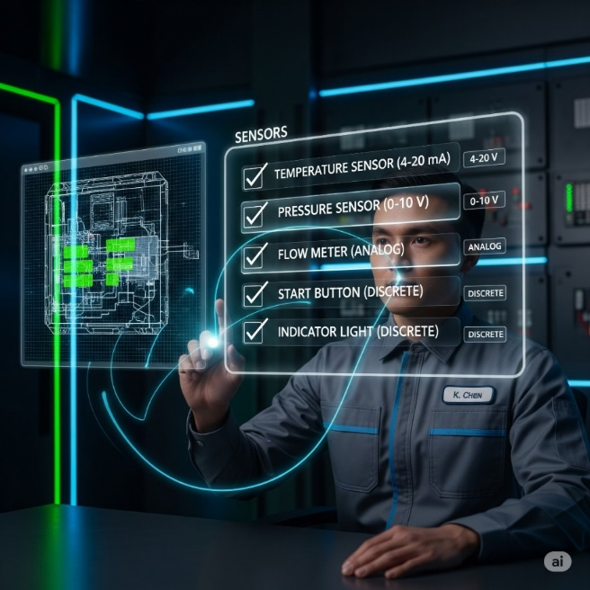

Step 5: Special Features Check **✨🚀**

Special features like **high-speed counting** or **precise positioning** are needed for systems that require more than basic on/off control. **Standard PLCs** often cannot handle these tasks because their scan cycle is too slow, so they need specific, and often expensive, **add-on modules** to work correctly. For example, a *high-speed counter module* is required to accurately count items on a fast-moving production line to prevent the PLC from missing events. ✨

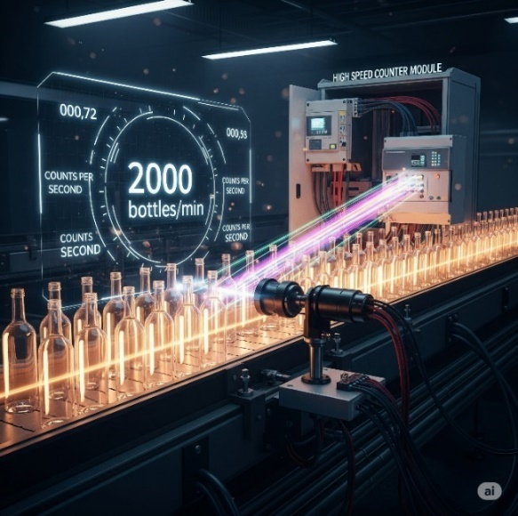

Step 6: CPU Power Check **💻⚡**

Choose your controller's CPU well, check the PLC's CPU power by looking at two types of memory.

* **Data memory** *is for temporary storage of live values like sensor readings.*
* **Program memory** *is where your permanent code instructions are stored.*

You need to ensure the PLC has enough of both to handle your system's data and code.

To estimate how much memory you need, a simple rule of thumb is to *allocate about 5 words per on/off device* and 25 words per measuring device. A **"word"**is a unit of memory, typically 16 bits, which acts like a small storage box for data. 💻

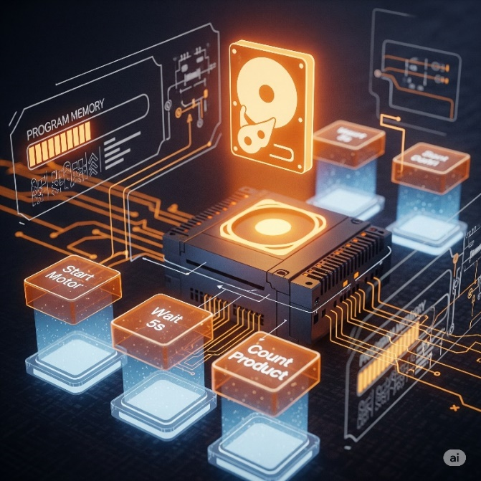

**Real-world example:** A simple bottling line with 20 on/off devices (start/stop buttons, motors, lights) and 4 measuring devices (temperature sensors, flow meters) would need roughly:

* **20 devices × 5 words = 100 words**
* **4 devices × 25 words = 100 words**
* **Total: ~200 words of program memory**

So, you'd need a PLC with at least 200+ words of program memory capacity.



Step7: How fast does it need to be? (Scan Time):

When selecting a PLC, you need to consider its **scan time**, which is how fast the CPU can read all inputs, execute the program, and update outputs.

A faster scan time is crucial for **high-speed operations**, such as fast packaging lines, to prevent the PLC from missing events or reacting too slowly.

For complex tasks like **PID control**, choose a CPU with a fast scan time for heavy calculations, not just simple on/off logic. 💻⚡



Step 7: Where Are Your Devices Located? **📍🌐**

Are all your sensors, buttons, and motors close to the main PLC/controller, or spread across a big factory or different buildings?

**Remote I/O:** Devices are far away, so you use small connection boxes near the devices that talk back to the main PLC through one cable – similar to using Wi-Fi extenders across a big office.



Running many individual wires over long distances is expensive and complicated. **Remote I/O** solves this by using a *single communication cable* instead. Just like a Wi-Fi extender broadcasts your internet signal, remote I/O modules extend the PLC's reach to communicate with devices that are far from the main control cabinet. 🌐

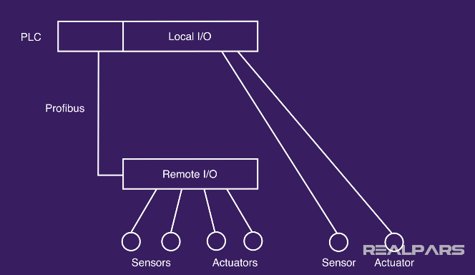

Step 8: Who Needs to Talk to Whom? (Communication Requirements) **🗣️💬**

Before buying a PLC, you must identify all the other systems it needs to communicate with to ensure you choose a CPU with the right communication ports and protocols, or budget for any necessary add-on modules. 🎯

Your PLC needs to communicate with other devices in the system, and you must know who it needs to talk to before you choose one. This communication can happen in a few ways:

* **PLC to PLC**: For two or more PLCs to share data and coordinate tasks.
* **PLC to Higher-Level Systems**: To send production data to systems like **SCADA** for monitoring or **ERP** for business management.
* **PLC to Smart Devices**: To communicate directly with things like **smart sensors** or **barcode scanners**. 🔗

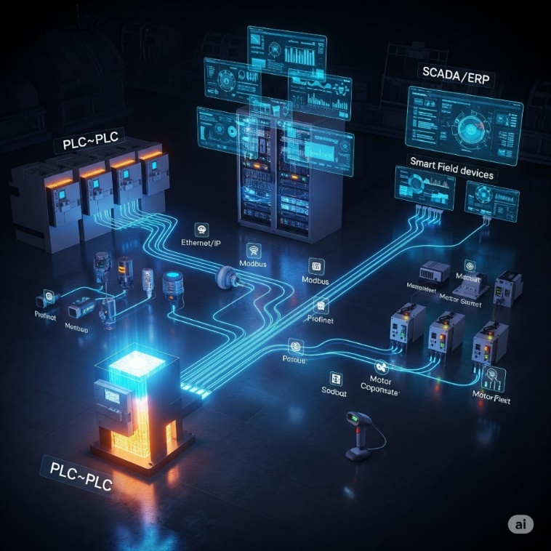

Step 9: **✨** Programming Requirements

**Do You Need More Than the Basics?**

Choosing a PLC requires you to first determine if your application only needs basic instructions like timers and counters, or if it also requires more specialized, built-in instructions. Not every controller supports all types of instructions, so you must select a model that can handle everything your project needs. ✨

**Standard instructions** cover the basics of PLC programming, including **timers** for counting time, **counters** for counting events, and **basic logic** for making simple decisions.

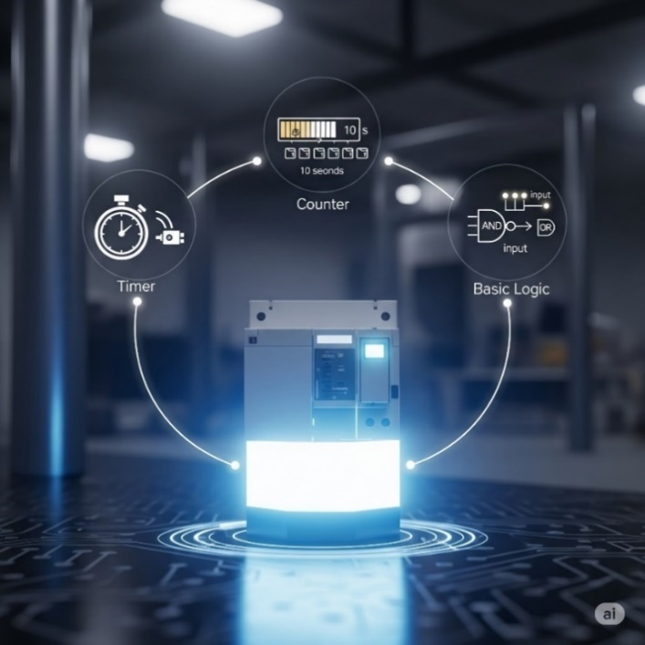

**Special instructions** are advanced, built-in functions that handle complex tasks like **PID control** for smooth process regulation or **motion control** for precise movements, saving you from writing complicated code.

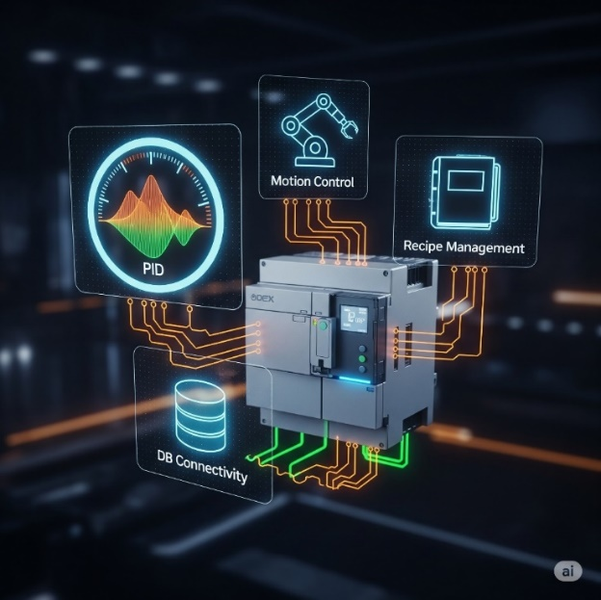

WHY WE USE PLC SOFTWARE??

**🛠️** PLC Software: Your Digital Toolbox

We use PLC software because it is the essential digital toolbox for programming, debugging, and bringing the PLC to life.

It's **where you write the commands** that tell the hardware what to do. Choosing the right software is just as important as choosing the right PLC itself. 💻

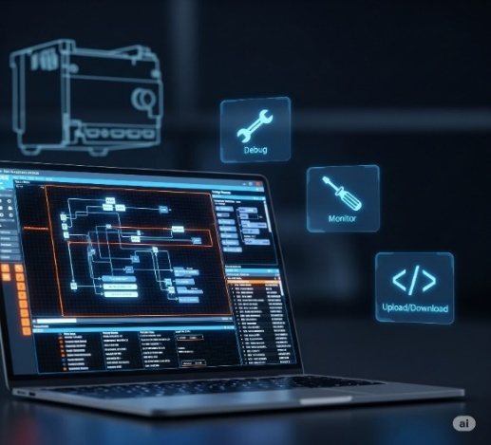

**🎮** 1. Built‑in Simulator: Your Virtual Playground

It gives you a safe virtual environment to test your ladder logic (or other code) *without touching the real machine.*

* You can **test your code**.
* **Try out different scenarios** to catch errors.
* You can mimic analog sensors and buttons, giving you a full‑blown run.

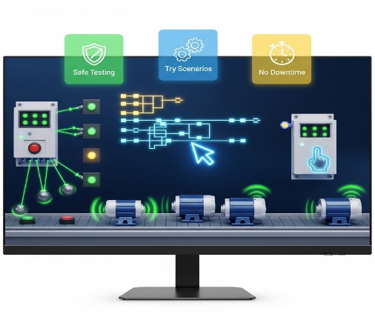

**🔥** 2. Hot Swapping & Run‑Time Transfers: No Downtime, Baby!

**Hot swapping** and **run-time transfers** are crucial features in modern PLC software that prevent system shutdowns.

Hot swapping allows you to replace hardware modules while the system is still running, similar to changing a part on a live machine.

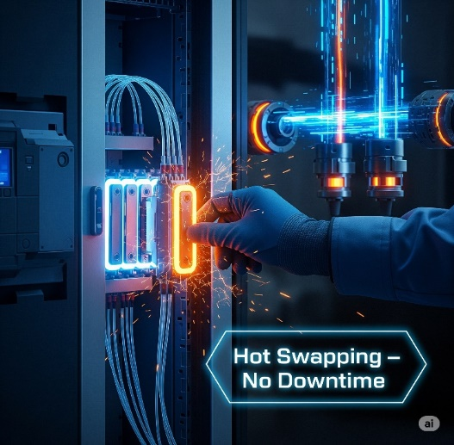

**Run-time transfers** also known as online edits, let you update the PLC's program code without stopping the controller, saving significant time and money on maintenance. These features are essential for 24/7 production environments. 🚀

**✨** 3. Auto Discovery: Plug‑and‑Play Magic

**Auto discovery** is a time-saving feature in PLC software that allows it to automatically detect and identify hardware modules as you connect them.

Instead of **manually configuring** each module's address, the software instantly recognizes what's been plugged in, making setup a seamless.

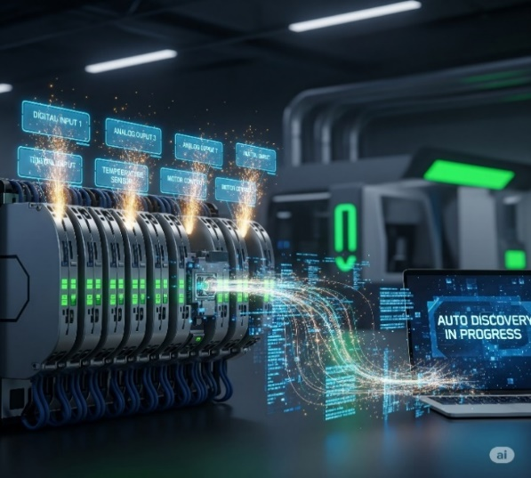

**📊** 4. Data View & Histograms: Seeing What’s Up, Live!

PLC software includes powerful diagnostic tools that give you a live view into your system's operation.

**Data View Windows** let you watch and even adjust live values as the program runs, while **Graphical Trend Charts** and **Histograms** visualize how values change over time, making it much easier to debug and fine-tune your process. 👓📈

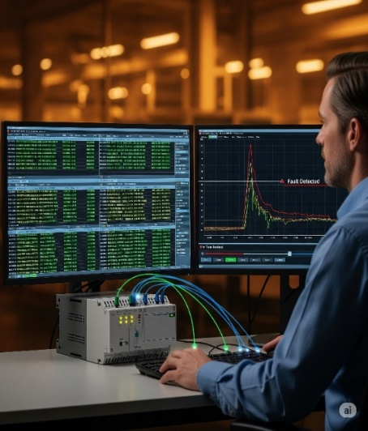

**🔐** 5. Security: Who’s Got the Access? **👤**

PLC software includes **security features** that let you control access to your system. This is crucial because it allows you to set up user accounts with different permission levels, ensuring that only authorized individuals can make changes to the control logic. This protects your system from both accidental and intentional errors. 🔐



**🔍** 6. Search & Cross Reference: Your Code GPS

When your program gets big and messy, these tools save your brain (and your time). You’ll use them all the time.

**🔎 Search:** Find exactly where an address, variable, comment, or instruction is used.

**🔄 Search & Replace:** Find something and update it everywhere it appears.

**🗺️ Cross Reference:** Shows you all instances of a particular tag or address.

**🚨 Why it’s clutch:** It’s like having GPS in a huge city of code, for preciseness.



**📖** 7. Help Files:

Provide clear explanations, visuals, and examples to help you understand new instructions, troubleshoot code, so you're not stuck when you hit a wall. 📚



**🌐** 8. Connectivity: Plugging In & Getting Online

**💻** USB Connections:

Connecting a PC to a PLC for programming or updates is usually done directly via **USB connections** using an industrial-grade cable. An engineer simply plugs in their laptop, downloads the new logic, and the PLC accepts the updates. This direct connection is fast and easy, but it requires the laptop to be physically close to the PLC. 💻



**🌍** Ethernet:

For networked PLC systems, **Ethernet** is the standard communication method. It allows you to connect to the PLC over long distances, similar to how you connect devices on a home internet network. However, for some setups, you might need to install extra drivers or software to ensure a proper connection. 🌍

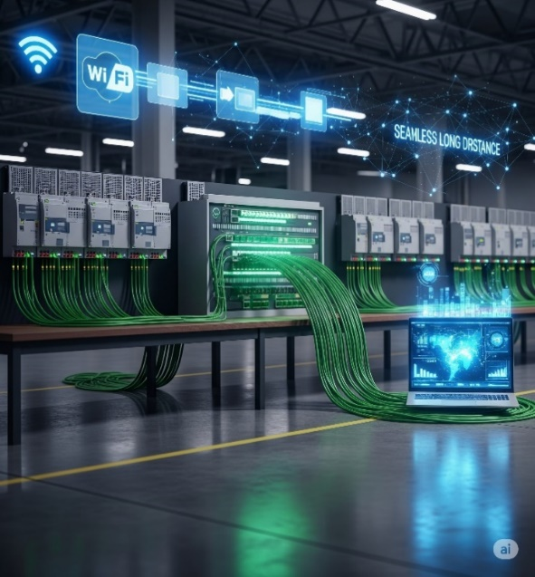

**📦** USB Project Transfers:

Some PLCs let you load a project onto a **USB stick** and plug it straight into the PLC. Perfect for remote sites where lugging a laptop isn’t practical.

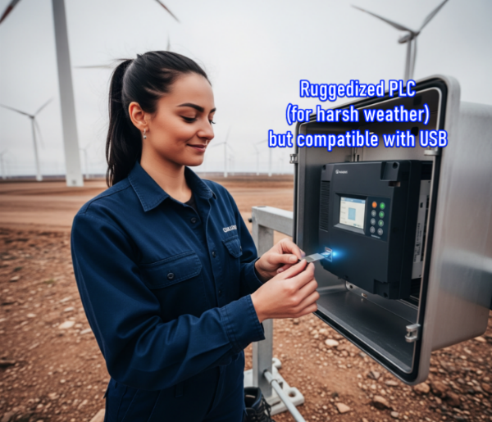

**🎨** 9. Customizable Layouts: Make It Yours! **✨**

User-friendly PLC software is crucial because it allows you to **customize your workspace**, much like setting up a personalized coding environment. 💻

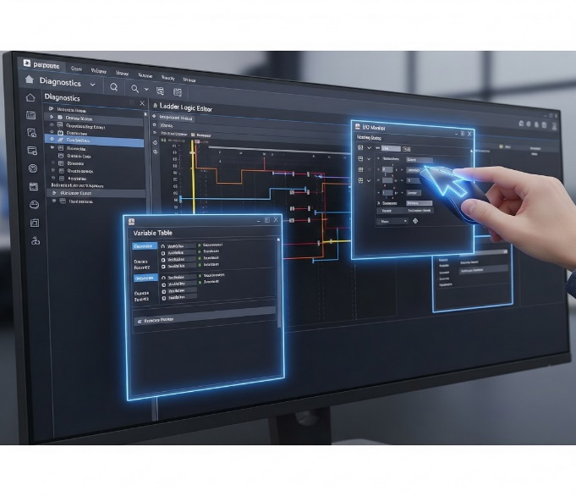

**🤔** 10. Project Compare: What Did I Change?! **📜**

Ever download a project and later wonder, *“Wait… why’s it acting weird? What did I even change?”*  
**Project compare tools** are essential for this, as they show you the differences between your current project and an older version, or the one currently loaded in the PLC.

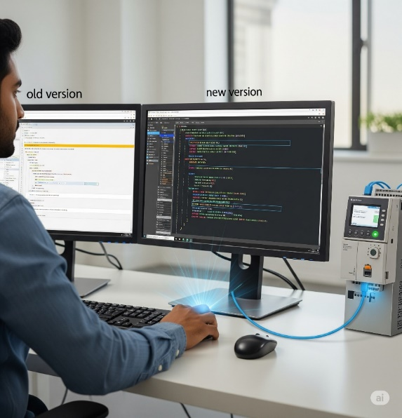

**🐛** 11. Debugging Tools: Squashing Bugs Like a Pro **💥**

Debugging tools are essential because they allow you to step through your program's logic, pause execution, and simulate conditions in real time, helping you quickly pinpoint and fix exactly where a problem is occurring. 🐛🛠️



**📱** 12. Web Server & Mobile Apps: Control on the Go **🌐**

Modern PLCs aren’t chained to the factory floor anymore—now you can keep tabs from anywhere.

**✅** Web Server Functionality:

Your PLC can host its own little web page. Just type in the PLC’s IP address in a browser and boom—you can see live diagnostics, process values, and status updates from anywhere with internet access.

**✅** Mobile Apps:

Many brands offer mobile apps that talk directly to your PLC.

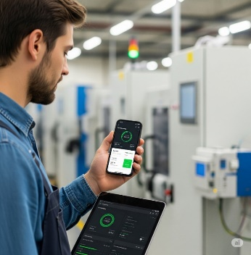

**📧** 13. Email Integration: Get Notified! **🚨**

Some PLCs have the ability to **send email alerts** on their own for critical events, instantly notifying you and your team of issues like machine faults or low material warnings b4 issues escalate.

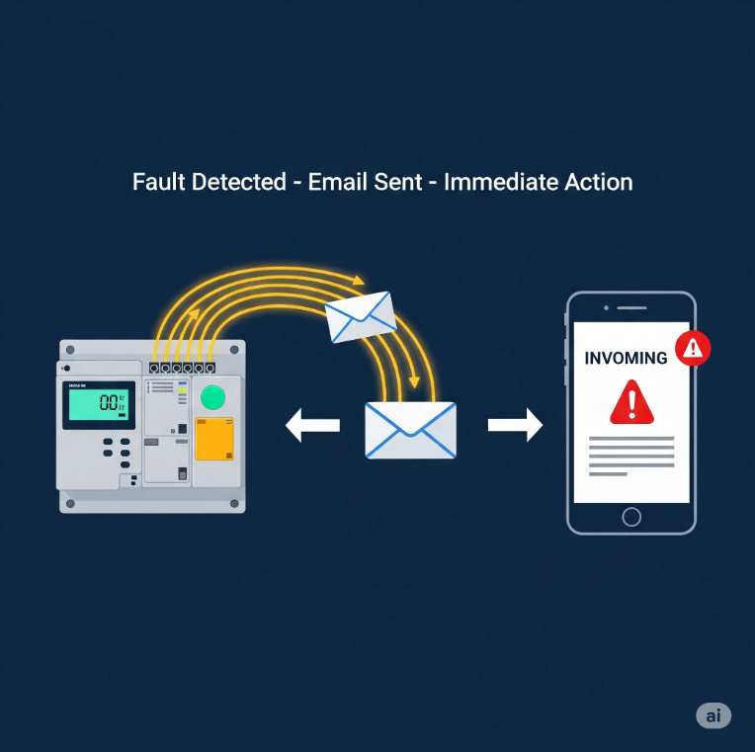

**🌀** 14. PID Options: Smooth Operator Mode **⚙️**

A **PID (Proportional-Integral-Derivative)** controller is a control loop feedback mechanism used in PLC programming to precisely regulate variables like temperature or pressure. It works by continuously calculating the difference between a desired setpoint and the current value, then applying a corrective action based on three terms (**Proportional**, **Integral**, and **Derivative**) to maintain stability. ⚙️



**🔢** 15. Powerful Math Functions: Crunch Those Numbers! **➕**

For modern processes that require complex calculations, great PLC software allows you to directly enter advanced mathematical equations, resulting in cleaner code and saving you from using messy workarounds. ➕➖



**📝** 16. Task Manager: Organize Your Program’s Flow **⏱️**

A **task manager** is a PLC software feature that allows you to divide a large program into smaller, more manageable pieces. This lets you run each task only when necessary, which optimizes the PLC's scan time and makes your logic easier to maintain. 📝

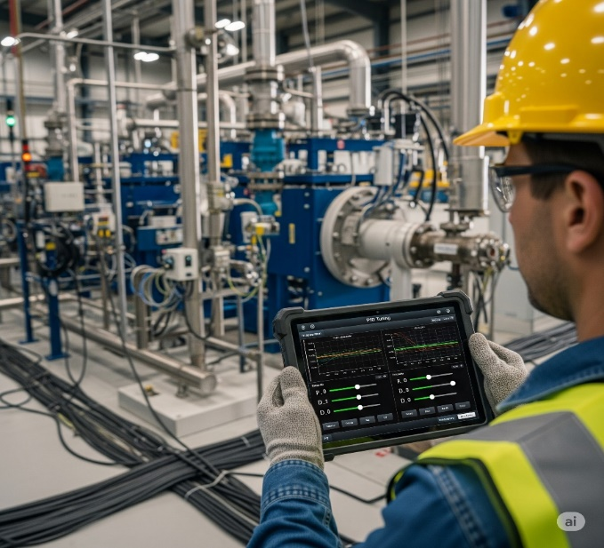

**🧱** 17. Integrated Function Blocks: Programming Shortcuts **🚀**

**Function blocks** are like ready-made mini-programs for common tasks. Instead of writing dozens of lines of code, you just insert a single block and configure it, which leads to faster programming, fewer errors, and cleaner, more modular code. 📦



**🗣️** Programming Languages: Speaking Your Language

Ladder Logic still rules the industrial world, but PLCs speak more than one language — so pick what vibes with you:

**Ladder Logic (LD)** is the most commonly used language in PLCs, especially in standard industrial applications. It resembles electrical relay diagrams, which makes it intuitive for electricians to understand and troubleshoot.



**Function Block Diagram (FBD)** is often used in automation-heavy systems. It allows users to drag and drop logic blocks, making it especially appealing to visual thinkers who prefer graphical representations of control logic.



**Structured Text (ST)** is typically used in advanced control systems. It resembles the Pascal programming language and is best suited for applications involving complex logic or mathematical operations.



**Instruction List (IL)** is largely obsolete in modern PLCs. It is a low-level language that resembles assembly code. While deprecated, it may still be encountered in older systems.



**Sequential Function Chart (SFC)** is ideal for batch processes. It is designed to represent step-by-step workflows using a visual state machine approach, making it excellent for modeling sequential operations.



**🚨 TLDR**: *Ladder Logic is king* because plant technicians already know relay circuits. Familiar = faster = fewer errors.

**🤖** PLC vs. Traditional Control Systems

PLCs are a superior choice for modern industrial control because they outperform traditional relay systems in:

* **Flexibility**: PLCs can be reprogrammed easily with a few clicks, while relays require physical rewiring to change their logic.
* **Reliability**: PLCs are designed for harsh environments and are more reliable due to their solid-state components. Relays are prone to mechanical failure as their physical contacts wear out over time.
* **Data Collection**: PLCs can log data using built-in sensors, counters, and memory, providing valuable insights. Relays have almost no data collection capabilities.
* **Expandability**: You can easily expand a PLC's functionality by adding new modules, but expanding a relay system often means building a new control panel.
* **Repeatability**: PLCs execute the same sequence perfectly every time. Relays can wear out, causing inconsistent timing and faulty operations.
* **Space**: PLCs are compact modules that save cabinet space, whereas relays are bulky and require large control panels for complex systems.

**💻**PLC vs. Personal Computers (PCs)

* **Operating & Storage Temperature**: PLCs are built to withstand extreme heat and cold on a factory floor, with a wider range for both operating and storage temperatures. PCs are designed for stable, comfortable office environments.
* **Humidity & Air Quality**: PLCs can handle damp, non-condensing air and corrosive gases, resisting industrial fumes and dust. PCs have a lower tolerance for humidity, and dust and corrosive gases can quickly damage their internal components.
* **Vibration & Shock Resistance**: PLCs are designed to military-grade standards (MIL-STD 810C) to withstand constant vibration and physical shocks. PCs have weak resistance, which can easily damage hard drives and internal components.
* **Voltage & Electrical Noise**: PLCs can handle power spikes and electrical noise, and they have high insulation resistance. PCs are not rated for such conditions and are easily affected by voltage fluctuations and electromagnetic interference.
* **Noise Immunity**: PLCs meet industrial NEMA specs, filtering out electrical interference from other machinery. PCs have no serious noise protection, making them vulnerable to glitches caused by electromagnetic interference.

📎 *Basically, PLCs are built to work in factories, next to loud motors, heat, vibration, electrical spikes… PCs would be crying in a corner.*

**💻**PLCs vs. Computers & PCs (Part B: Software + Programming)



🛠️ Part C: Maintenance Comparison – PLCs vs PCs

PLCs win big on maintainability and ease of integration for industrial settings. They're designed for quick fixes by on-site teams, minimizing downtime.



**🧠** Quick Summary: Why PLCs Win in the Factory

* They **diagnose themselves**.
* Use **relay-style logic** so any technician can understand.
* Can **run 24/7** with minimal maintenance in harsh environments.
* PCs may be smarter, but **PLCs are built tougher** for plant floors.

PLC Sizes and Their Applications (Simplified & Upgraded)

**🔢** 1. Understanding PLC Size Categories

PLCs come in different “sizes” — not physically, but in terms of memory, input/output capacity, and what kinds of tasks they can handle.

Think of it like phones: a basic **flip phone** vs. a **midrange Android** vs. a **flagship iPhone** **Pro Max.**



**💾**2. Memory Tech Used in PLCs

PLCs rely on specific memory types to keep their programs running, even when the power flickers. Here's a quick look at the key tech.



Here’s a realistic sample…



**💡** PLCs Usability Benefits + Practical Benefits Table

Let’s go beyond marketing fluff and break it down: *Inherent Features of PLCs*

* Solid-State Components (no moving parts = fewer failures)
* Programmable Memory (non-volatile, editable logic)
* Compact Size (small footprint)
* Microprocessor-Based Operation (real-time logic control)
* Built-in Timers/Counters
* Software-based relays (replace physical hardware)
* Modular Architecture (easily swappable modules)
* Multiple I/O Interfaces (digital, analog, remote)
* Remote I/O Stations (connected via coax/twisted pair)
* Real-Time Monitoring & Diagnostics
* User-editable memory and logic

LADDER LOGIC





Based on the provided relay ladder diagram, here's a simple explanation of its operation.

* The circuit has two main paths for power to flow: one through a push button (**1PB**) and a control relay contact (**2CR**), and another through a limit switch (**3LS**).
* For the solenoid (**SOL A**) to energize, power must flow through either of those two paths.
* No matter which path is active, the power then has to pass through two other contacts: **4CR** (which must be closed) and **5CR** (which must not be energized, so its normally closed contact remains closed).
* Essentially, the solenoid will turn on only when one of the first two conditions is met AND the final two conditions are also met.



👉 **Ladder logic** is still the *main language everyone uses in factories*, but PLCs aren’t stuck with only that, as you saw above.

Tag Names are generally more intuitive and easier to manage in large projects. 🏷️

* **Tag Name-based systems** let you use descriptive names, like Start_Button, which are easier to read and more beginner-friendly.
* **Fixed Memory systems** use hard-coded, cryptic addresses like N7:0.

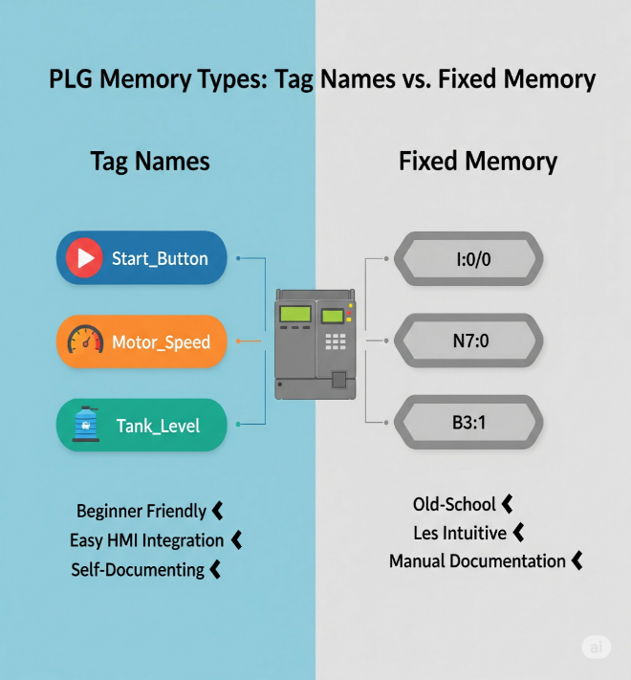

The Logic of Ladder Diagrams



Just like reading a book, a ladder diagram is read from left to right, with electricity (or logic) flowing from the left vertical rail to the right.

The key to understanding your specific diagram is realizing that **4CR** and **5CR** are not relay coils you're energizing; they are relay contacts, which are controlled by coils located somewhere else in the program.

* A **relay coil** is the *electromagnet* that you energize with a current.
* A **relay contact** is a *switch* that opens or closes only when its associated coil is energized.

In your diagram, current flows through the contacts of **4CR** and **5CR**.

The state of the **4CR** contact (which is "normally open" or NO) depends on whether the **4CR coil** is energized elsewhere.

Similarly, the state of the **5CR** contact (which is "normally closed" or NC) depends only on whether the **5CR coil** is energized.

*The current passing through these contacts does not change their state.*

Analogy: The Smart Switch

Think of it like a smart switch controlling a light. Just because electricity is flowing through the physical wiring of the switch doesn't mean the light turns on. The light only turns on when the smart switch receives a signal from its controller (like a phone app), which is the equivalent of the **relay coil** being energized.

Final Takeaway

* **Coil controls the contact**: Energizing a relay's coil is the only thing that changes the state of all its contacts (NO becomes closed, NC becomes open).
* **Contact does not change itself**: Current passing through a contact does not change its state. It simply passes through or is blocked, depending on whether the associated coil is energized.

So, in your diagram, the **5CR** contact will only open if its associated coil is energized somewhere else in the circuit. It will not open just because current is flowing through it. 💡

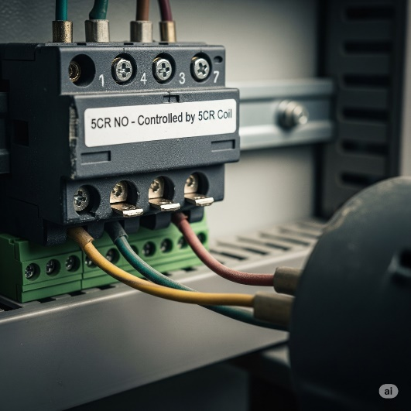➡️ The relay **contact is just a puppet.**  
➡️ The relay **coil is the puppeteer.**

**“Coil controls the contact. Contact does not control the coil.”**

**Ladder Logic** gets its name because its diagrams visually resemble a ladder, with two vertical ***rails*** representing the power source and its return path.

The horizontal lines, known as ***rungs*,** each represent a single line of logic; if the conditions on a rung are met, the output on the right is energized.

**⚙️** How It Worked (and Still Does in Principle)

In **old relay cabinets**, a circuit's output would only turn on if a path was completed from the power source through all the physical input devices and contacts.

Today, modern **Ladder Logic** in a PLC works the same way but digitally, with software replacing the physical wiring and relays.

The programmer simply **draws the logic** on a screen using symbols, and the PLC's software "pretends" electricity is flowing through those **virtual circuits** to make a decision.

**🖥️** Digital Translation – How It Maps Over

1) Power Flow:

* In software, there’s no real current.
* Instead, a logical **TRUE (1)** means “power is flowing” along that rung.
* If the path from the left rail to an output is logically true, that output gets activated.

2) Open vs. Closed Contacts:  
Physical relay contacts become simple Boolean conditions in the PLC:

* **Normally Open (NO)** – shown as —| |—  
  ✅ True when the input is ON (button pressed, sensor triggered, relay energized).
* **Normally Closed (NC)** – shown as —|/|—  
  ✅ True when the input is OFF (button released, sensor not detecting, relay not energized).

3) Coils / Outputs:  
Outputs are shown as —( )—.

When the logic on a PLC rung is true, the PLC energizes the corresponding output, which activates a real-world device, such as a motor or light, or an internal memory relay. 🚨

Let’s go deeper on this coils part:

**⚡** Coils = The Action (Then Do This)

*Coils are outputs. They trigger actions: start motors, turn on lights, activate alarms, etc.*

*Coils are like the "do something" part of your PLC program.*

*When all the conditions on a line are met (all the switches, sensors, etc. are in the right position), the coil gets power and makes something happen in the real world.*

1. Output Coil ( )

This is your basic **"turn something ON"** coil. When the logic is satisfied, it energizes and activates whatever it's connected to.

How It Works

* **Logic satisfied:** All contacts are in the right position → Coil gets power → Device turns ON
* **Logic not satisfied:** One or more contacts block the path → Coil has no power → Device stays OFF

Real World Example: Garage Door Opener

Think of your garage door opener system:

* **Conditions:** Remote button pressed AND safety sensors clear AND power is on
* **Action:** When ALL conditions are met → Output coil energizes → Garage door motor starts → Door opens

Other Examples:

* Turn on conveyor belt motor
* Activate warning light
* Start air conditioning
* Open valve for water flow

2. Negated Output Coil (/)

This is the "turn something OFF when conditions are met" coil. It works opposite to the regular coil.

How It Works

* **Logic satisfied:** Conditions are met → Coil energizes → Connected device turns OFF
* **Logic not satisfied:** Conditions not met → Coil not energized → Connected device stays ON

Real World Example: Smart Thermostat Fan

Think of a cooling fan controlled by temperature:

* **Normal state:** Fan runs to keep things cool
* **Condition:** Temperature drops below 20°C
* **Action:** When temperature IS low → Negated coil energizes → Fan turns OFF (no longer needed)

Other Examples:

* Turn off heater when room gets warm enough.
* Stop alarm when problem is fixed.
* Close valve when tank is full.

3. Latching Coil (L) and Unlatching Coil (U) - Symbols: (L) and (U)

These work like a **"sticky switch"** - once you turn something ON with the Latch coil, it STAYS on even if you let go. The only way to turn it OFF is with the Unlatch coil.

How They Work

* **Latch (L):** Quick pulse of power → Device turns ON and STAYS on forever
* **Unlatch (U):** Quick pulse of power → Device turns OFF and STAYS off forever

Real World Example: Hotel Room Lights

Think of those hotel room card key systems:

* **Insert card:** Latching coil (L) energizes → Room lights turn ON and STAY on
* **Remove card:** Nothing happens → Lights STAY on (that's the latch working)
* **Press main switch:** Unlatching coil (U) energizes → All lights turn OFF and STAY off

**Even Better Example: Emergency Stop System**

Emergency Stop Button Pressed:

* Latching coil (L) energizes → All machines STOP and STAY stopped
* Even if someone accidentally bumps the E-stop button again, machines stay OFF

Reset Button Pressed (by supervisor with key):

* Unlatching coil (U) energizes → System is ready to start again (but doesn't start automatically)

Why This Matters:

Safety! Once an emergency stop happens, you can't accidentally restart dangerous machinery. Someone has to deliberately reset the system with a key.

Other Examples:

* Fire alarm system (latch when smoke detected, unlatch when reset by fire department)
* Security gate (latch open with access card, unlatch closed with timer)
* Process start/stop (latch production line on, unlatch when shift ends)

Key Takeaway

* **Output Coil ( )**: Turn something ON when conditions are right
* **Negated Coil (/)**: Turn something OFF when conditions are right
* **Latch/Unlatch (L)/(U)**: Turn something ON/OFF and make it STAY that way until told otherwise

👉 Big Picture:  
Instead of digging through wires in a control cabinet, you’re now dragging and dropping logic in software.

**Same principles, zero mess.** That’s the magic of Ladder Logic.

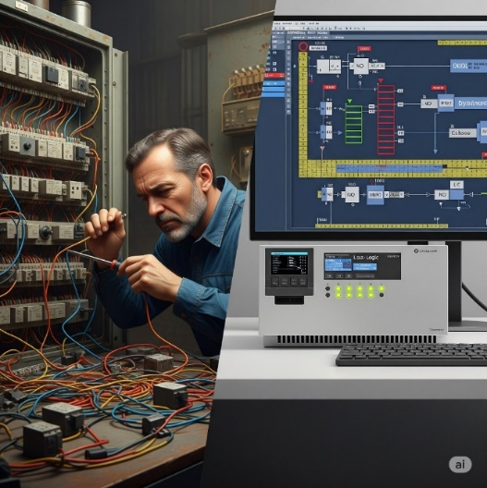

* In a PLC system, a *pushbutton* acts as a low-power input, sending a signal to the PLC to start a process.
* A *control relay* serves two purposes: it's an internal memory bit within the PLC's software, and it's a physical switch that handles high-power loads.
* The *PLC sends a low-power signal* to the relay's coil, and the relay translates that into a high-power signal to control a machine.
* This allows the sensitive PLC to *safely operate heavy machinery.* 💡

***Does a PLC convert ladder logic into its own code to control hardware, using intermediate relays to manage heavy-power machines?***

Got it 👍 let’s make this exam-ready with short, quick bullets:

* The PLC CPU executes the ladder logic program.
* When a rung is true, it sends a small signal to the output module.
* Control Relays (CR) inside the PLC are just memory bits, not real electricity.
* When a physical output coil is true, the PLC switches a transistor on the output card.
* That tiny signal activates an external relay or contactor.
* The external relay handles the heavy current for motors or machines.
* The PLC commands → Relays deliver the real power.

⚡ Simple rule to remember: *PLC = brain and signals, Relays = muscles and power.*

***Is my understanding of the PLC scan cycle correct: Does the PLC read an input, evaluate the logic in a rung, and then send a low-power signal to an output module to activate a high-power external device like a conveyor motor?***

* **Input Scan:** The PLC checks the status of all physical inputs (buttons, sensors), reading them as either TRUE or FALSE.
* **Logic Scan:** The PLC evaluates the ladder logic from top to bottom, one rung at a time. It checks the conditions of the contacts based on the input states.
* **Output Update:** If a rung's logic is true, the PLC sends a low-power signal to the output module to activate a specific output.
* **External Action:** The output module's signal energizes an external device, such as a relay or contactor, which then controls a high-power machine like a conveyor motor.

🤖 So,

*“When the PLC is scanning and gets to rung 3, it evaluates that rung’s logic (including your control relay contact). If the logic is TRUE, the PLC sends a signal from its output module to energize an external relay or contactor, which then powers the conveyor motor.”*

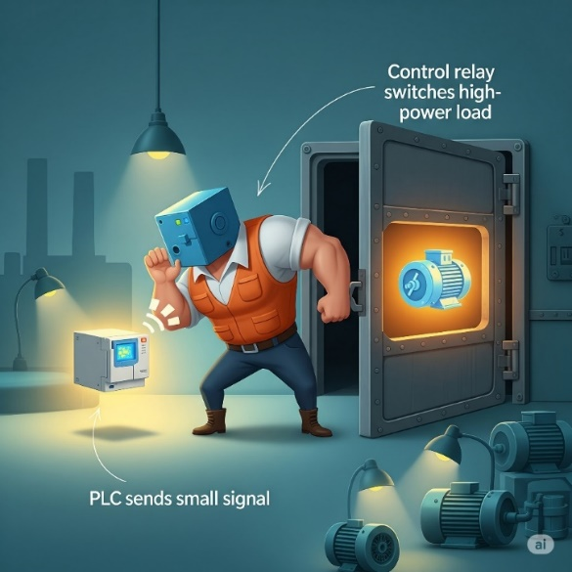

**⚡** The Evolution from Wires to Code – Ladder Logic’s Secret Sauce

Ladder Logic's "secret sauce" is that it **transformed** industrial control from a system of physically hard-wired relays to a digital language where circuits are programmed in software, **making changes simple** and **eliminating the need for complex rewiring.**

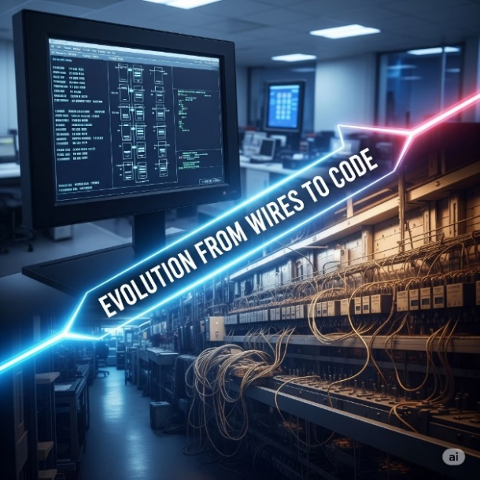

**🛠️** The Ins and Outs: Where Hardware Meets Software

A PLC lives in two worlds at once:

* **Physical world:** pushbuttons, sensors, motors, lights.
* **Digital world:** memory tables, logical rungs, and CPU scans.

The bridge between them? **Input/Output (I/O) modules.**



**✨** Temporary Storage and Modular Thinking

**Internal bits** aren’t just for keeping states.  
They’re also great for **holding intermediate results.**Instead of cramming everything into one messy rung, **split the logic into smaller rungs.** **Store** each step’s result in an internal bit.  
It makes your program cleaner, easier to read, and way easier to debug later.

Beyond Basic Contacts and Coils: The Modern PLC's Capabilities

Today’s PLC CPUs offer a vast array of sophisticated functions, transcends its relay logic ancestors, becoming a powerful industrial computer:

* **Math Functions** → Add, subtract, multiply, divide, control variables like temp, pressure, flow.
* **Shift Registers** → Track items on conveyors or assembly lines by using sensors to monitor and shift the position of each item's data bit through memory as it moves down the line.
* **Drum Sequencers** → Step-by-step process automation (e.g., mixing, assembly).
* **PID Control** → Feedback control for stable temperature, pressure, speed.
* **Data Handling** → Move, compare, and manipulate data blocks.
* **Communication** → Talk to other PLCs, HMIs, SCADA via Ethernet/IP, Modbus, Profinet.
* **Advanced Languages** → Support for Structured Text, FBD, SFC for complex programs.

⚡ Key memory hook: *Math → Tracking → Sequencing → Feedback → Data → Networking → Advanced Coding.*

PLC MEMORY AND DATA REPRESENTATION

When working with PLCs, it's crucial to know how they store and interpret data. At their core, PLCs **don’t “see” numbers or words** the way humans do — they see **voltage levels**, **binary digits**, and **memory addresses**.

**🧩** 1. What Does a PLC Store?

PLCs handle two main categories of data:



**⚡** 2. How Is This Data Stored?

Unlike us, who use **decimal numbers (0–9)**, a PLC stores data using **binary (0 and 1)** — not just for fun, but because it physically uses **electrical signals** to represent these states. 

💡Inside the PLC’s memory chips (RAM or ROM), data is stored as millions of tiny switches that are either ON (1) or OFF (0), represented by voltage levels.

*This is how the PLC internally “thinks” about the number 24.*



🔄 *Binary ↔ Decimal conversion is your daily bread in PLC land. Don't skip it.*

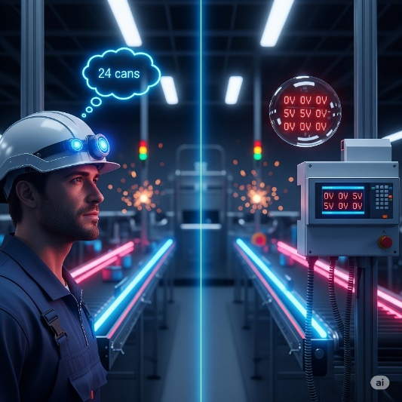

**For us**, numbers, words, and concepts carry inherent meaning. "24" immediately means a quantity, an amount, something we can understand and relate to. Our brains are wired for abstract thought and interpretation.

**For a PLC**, there's no "meaning" in the human sense. It's all about physical electrical states.

**🧠** Binary Number System (Base-2)

**Only 2 digits:** 0 and 1. These are called **bits.**

Groupings:

* 1 bit = 1 binary digit (duh)
* 4 bits = **Nibble**
* 8 bits = **Byte**
* 16 bits = **Word**
* 32 bits = **Double Word**

Each bit in a binary number has a weight — just like place values in decimal — but in **powers of 2**.



**🧮** Convert Binary to Decimal

Steps:

* Start from the right.
* Only look at positions that have a 1.
* Add their **weight** (the column value).

🧠 Example:

That’s how the PLC remembers it — as 00110010. But when you check on your HMI or software, it’ll show **50** in decimal.



**🔟** Decimal Number System (Base-10)

* Humans use **10 digits**: 0 through 9
* Each digit has a place value weighted in powers of **10**

Example:



The concept of **weighted columns** exists in both decimal and binary.  
The difference is that:

***Binary → Powers of 2***

***Decimal → Powers of 10***

**🧠** Why Does This Matter in PLCs?

Because whenever we:

* + Type a value into the PLC
  + Store a sensor reading
  + Set a timer

…The PLC stores it in binary, but you *see it* in decimal.

Understanding how those 1s and 0s are turned into human-friendly numbers helps you:

* Debug logic better 💻
* Spot errors quickly 🕵️
* Know how memory is being used 🧠

✅ In PLCs:

* 16-bit word = max value **65535** (if unsigned)
* 32-bit word = up to **~4.2 billion**

Word length determines how big a number your PLC can store or calculate.

🔠 BCD (Binary-Coded Decimal)

It’s a way of storing decimal numbers where each digit is converted to its 4-bit binary equivalent e.g. 45 is stored as two separate 4-bit groups: **0100** for the 4 and **0101** for the 5. Standard binary representation for **45** would be **00101101**.

BCD is used in **older industrial equipment** - thumbwheel switches and display modules.

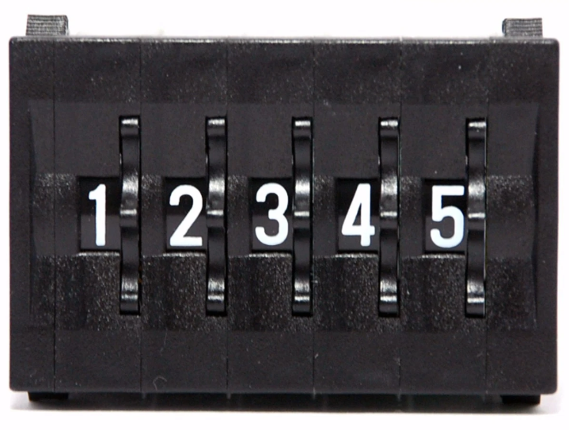

It **simplifies the process of converting** between binary and decimal values, which is helpful for applications where numbers need to be read or displayed by a human, like on an HMI.

While **manual conversion is rare**, BCD still exists in industrial gear because it makes displaying familiar decimal values straightforward without complex calculations.

🔥 HEX & DECIMAL CONVERSIONS

🧠 First, the Big Idea: Place Value Table

Just like decimal (base 10) uses powers of 10, hexadecimal (base 16) uses powers of 16.



Shows the comparison between decimal (10ⁿ) and hexadecimal (16ⁿ) place values.

When we say **"1st from the right"**, **"2nd from the right"** and so on, we are talking about the position of a digit in a number, starting with the rightmost digit as the first position.

Think of it like reading numbers. In the number 1234:

* 4 is the **1st from the right** (the ones place).
* 3 is the **2nd from the right** (the tens place).
* 2 is the **3rd from the right** (the hundreds place).
* 1 is the **4th from the right** (the thousands place).

This applies to any number system, whether it's decimal, hexadecimal, or binary – you always count positions starting from the rightmost digit and moving left.

**✨** Convert Hex to Decimal – Easy Mode:

You multiply each digit (starting from the right) by powers of 16, then add them all up.

💡 **Pro tip:** A-F in hex = 10-15 in decimal - A = 10, B = 11, C = 12, D = 13, E = 14, F = 15

Section 2: Example 1 - 3F9₁₆ to decimal



Example 2: AF1C₁₆ → 44,828₁₀



Example 3: 3B8D2₁₆ → 243,922₁₀



**🔄** Decimal to Hex: Division and Remainders

This is like reverse engineering. You divide by 16 repeatedly, collecting **remainders**. These remainders (in reverse order) give you the hex value.

**💻** Example: Convert 493 to Hex

Step-by-step:



💻 Example: Convert 57392 to Hex



How the Division Method Works



**🧠** Final Boss Trick: Why Hex is **🔥**

* **Compact**: 1 hex digit = 4 binary bits. Clean.
* **Readable**: Easier to debug than long binary strings.
* **Popular**: Memory addresses, opcodes, machine-level data—hex runs the show.



**🧠** LOGIC CONCEPTS - SUBTOPIC: BOOLEAN ALGEBRA

**📜** Quick History Drop

* **Year:** 1849
* **Inventor:** George Boole (England)
* **Why it matters:**  
  He created a mathematical way to describe logic—like "If A is true, then B must be false."  
  Every digital circuit, from your calculator to a PLC to an Intel CPU, is built on his rules.  
  This isn't just dusty philosophy—it *runs the world.*

**🔌** The Core of Boolean Algebra

* It's a way to write **logic expressions** (decisions, conditions) that can only be **True or False**.
* In digital electronics:
  + **True = 1**
  + **False = 0**
* Called a **two-valued (binary) system.**

**📐** Why Use Boolean Algebra in PLCs?

Because ladder logic *is literally* Boolean logic in disguise:

* A contact closed? = 1
* A coil energized? = 1
* Two conditions in series? = AND logic
* Two in parallel? = OR logic

**✅** Boolean Operators (The Building Blocks)



1. AND Gate

Output is 1 only when BOTH inputs are 1.

**Boolean Equation:**



**PLC Application**

Motor runs only when START button is pressed AND safety guard is closed.



**🌍 Real World Example**

Car engine starts only when key is turned AND seatbelt is fastened.

2. OR Gate

Output is 1 when AT LEAST ONE input is 1.



**PLC Application**

Alarm sounds when temperature is high OR pressure is high.

**🌍 Real World Example**

Room light turns on from wall switch OR bedside switch.



3. NOT Gate

Output is the OPPOSITE of the input.



**PLC Application**

Conveyor stops when emergency stop button is NOT pressed.



**🌍 Real World Example**

Security light turns ON when motion sensor is OFF (no motion).

4. NAND Gate

**NOT-AND:** Output is 0 only when BOTH inputs are 1.



**PLC Application**

Safety system triggers unless BOTH sensors detect normal conditions.



**🌍 Real World Example**

Car alarm is OFF only when key is in AND door is locked.

***If A or B is false, then Q is true.***

5. 3-input AND





4. NOR Gate

NOT-OR: Output is 1 only when BOTH inputs are 0



**PLC Application:** System is safe only when NO faults are present.

**🌍 Real World Example:**

Safe opens only when NEITHER alarm is active NOR motion is detected.

5. XOR Gate

Exclusive OR: Output is 1 when inputs are DIFFERENT.

**Boolean Equation**



**PLC Application**

Parity checker: output is 1 when odd number of 1s.



**🌍 Real World Example**

* **Binary Addition**: XOR gates are used in half adders and full adders to perform binary addition of two bits, producing the sum bit.
* **Parity Generation and Checking**: XOR is employed to generate and check parity bits, ensuring data integrity by verifying whether the number of 1's is odd or even.
* **Data Encryption and Decryption**: In cryptographic algorithms, where it combines data during encryption and reverses the process during decryption.
* **Digital Signal Processing (DSP)**: In signal processing applications, such as modulation, demodulation, and noise shaping in audio systems.
* **Error Detection and Correction:** In error-detecting and error-correcting codes like Hamming code.
* **Parity Bit in Memory Storage:** In computing and verifying parity bits in memory cells, ensuring data consistency and error correction.

6. XNOR Gate

Exclusive NOR: Output is 1 when inputs are the SAME.

**Boolean Equation and Logic Gate**



**An XNOR** **gate** produces a high output (1) only if its two inputs are equal. Commonly used in digital circuits to perform arithmetic and data processing operations.



***If A and B are the same, then Q is true.***

**PLC Application:** Quality control - pass when measurements are equal.

**🌍 Real World -** Garage door: opens when remote signal MATCHES security code.

BOOLEAN TO LADDER LOGIC CONVERSION



🧾 7 Main Boolean Laws (Clean Version)

Master the fundamental laws that govern Boolean algebra - the building blocks of digital logic! 🚀

1. Commutative Laws

* **A + B** = **B + A** (OR doesn't care about order)
* **A · B** = **B · A** (AND doesn't care about order)

 

Just like 2 + 3 = 3 + 2 in regular math, Boolean operations don't care about the order of inputs!

2. Associative Laws

Grouping doesn't change the result.

You can group operations however you want - the parentheses can move around freely!

 

Parentheses can group operations differently without changing the result –

(2 + 3) + 4 = 2 + (3 + 4)!

3. Distributive Laws

Like algebra with a logic twist.

You can distribute operations across parentheses, just like in regular algebra!

 

You can 'distribute' one operation across another, just like a(b + c) = ab + ac in algebra!

The dot doesn’t mean anything, just multiply. That’s why it could be written as above highlighted in yellow. **AND** means multiply. **OR** means addition. Have that in mind.

4. Identity Laws

0 is the identity for OR, 1 is the identity for AND.

These are the 'do nothing' operations - they leave values unchanged!

 

In Boolean algebra, **Identity Laws** describe operations that don't change the original value.

For the **OR** operation, the identity is **0**, meaning anything OR'd with 0 remains unchanged.

For the **AND** operation, the identity is **1**, so anything AND'd with 1 remains the same.

5. Null Laws

1 in OR dominates, 0 in AND kills everything.

These are the **'dominating'** values that override everything else!

 

These values **completely dominate** the result, no matter what the other input is!

6. Involution Law

Double negation cancels out.

Two NOTs make a positive - just like in regular language!



Two negations cancel each other out - 'It's not true that it's not raining' means 'It's raining'!

7. Complement Laws

A variable with its opposite.

When you combine a variable with its opposite, you get predictable results!

 

These fundamental Boolean laws, such as the principle that a variable cannot be both true and false at the same time, are the basis of all digital logic.

THE CONTACTS

**🔌** Normally Open (NO) Contact – The “Push‑to‑Start”

A normally open contact is like a doorbell button. By default, it's open and the logic bit is false. When the button is pressed, the contact closes, and the bit becomes true, allowing logical power to flow. 🛎️



**🔌** Normally Closed (NC) Contact – The “Safety Gate”

A **normally closed contact** is like a safety gate that's already allowing current to flow. By default, its logic bit is **TRUE**. When the button is pressed, the contact opens, its bit becomes **FALSE**, and it blocks the logical power on that rung. ⚠️



✨ Positive Transition-Sensing Contact ---|P|---

**What it does:**

✅ Fires **only for one scan** when your variable flips from FALSE → TRUE   
✅ Think of it as a **one-shot rising edge detector**   
✅ It only passes power if the left input is already TRUE at that moment

**Real-world examples:**

**Start button:** Press to start a machine → you want it to start once, not keep trying to start every scan while held down.

**Part counter:** When a sensor first detects a part → increment counter once, not continuously while the part passes by.

**Door opening:** When a door switch goes from closed to open → log one "door opened" event, not hundreds while it stays open.

**Emergency reset:** After fixing an alarm → acknowledge it once when the reset button is pressed, not repeatedly.

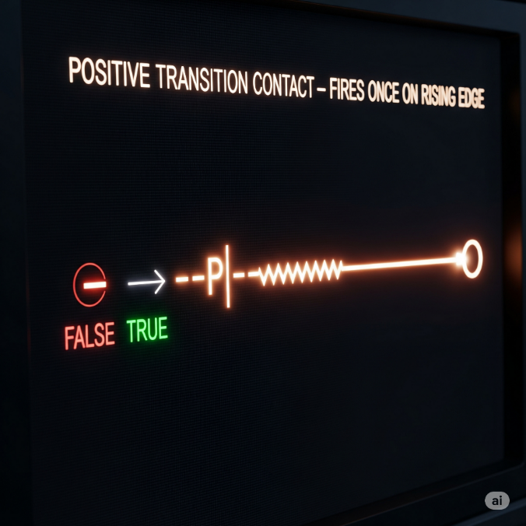

✨ Negative Transition-Sensing Contact ---|N|---

**What it does:**

✅ Fires **only for one scan** when your variable flips from TRUE → FALSE   
✅ A **one-shot falling edge detector**   
✅ Left input must be TRUE at that moment too

**Real-world examples:**

* **Conveyor control:** When a box leaves the sensor → start the next conveyor section once, not continuously while the sensor is empty
* **Safety logging:** When an emergency stop is released → log one "system restored" event at the exact moment of release
* **Production tracking:** When a part exits the work station → trigger completion counter once as it leaves, not while the station stays empty
* **Door security:** When a door closes → send one "door secured" signal to the alarm system, not constant signals while it stays closed
* **Process completion:** When a tank empties (level sensor goes FALSE) → start the refill cycle once at that instant

**Why it's crucial:** This catches the exact moment something stops or leaves, preventing your system from missing the transition or triggering multiple times. Perfect for "cleanup" actions that should happen right when something ends.

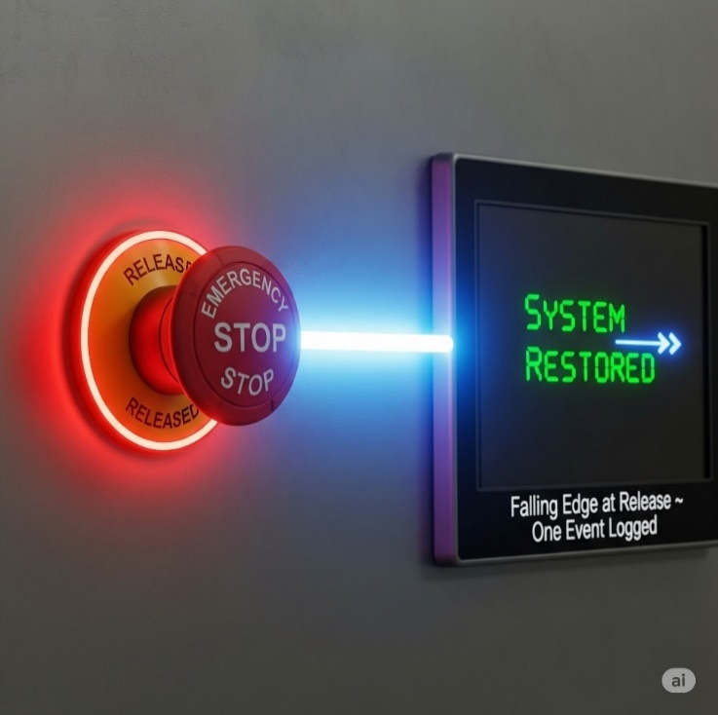

**🌩** OTE (Output Energize) or Output Coil

The *OTE (Output Energize) instruction* is the final result of a ladder logic rung. It behaves like a light bulb controlled by your program's logic. Every time the PLC scans the program thousands of times per second:

* **If YES** → OTE energizes (turns ON)
* **If NO** → OTE de-energizes (turns OFF)

Imagine an automatic parking garage gate:



* Car sensor detects a vehicle AND payment was received AND gate isn't broken → gate opens
* Missing any one condition (no car, no payment, gate broken) → gate stays closed
* The gate follows these conditions in real-time - if payment expires while the car is there, gate closes immediately

OTE has zero memory. It's like a faithful dog - it does exactly what you tell it, no thinking or remembering. Just pure execution.

🚧 Latch (OTL) and Unlatch (OTU)

OTL (Output Latch) - The Memory Keeper

OTL is like a **sticky switch** - once you turn it ON, it STAYS on until something specifically turns it OFF.

How it's different from OTE:

* **OTE:** Acts like a regular light switch - follows your logic constantly
* **OTL:** Acts like a **hotel room keycard** - once activated, it remembers and stays active

When the rung logic goes TRUE (even for just one scan), OTL sets the output to ON and then **remembers** that state. Even if the rung logic goes back to FALSE, the output STAYS ON.

Emergency alarm system (we’ll unlatch it next):



* Smoke sensor triggers for 2 seconds → alarm turns ON
* Smoke clears (sensor goes FALSE) → alarm STAYS ON (latched)
* Alarm keeps blaring until someone manually resets it with an OTU instruction

**Why use latching?** Perfect for situations where you need something to **stay active** even after the trigger condition disappears:

* Emergency alarms that need manual reset
* Equipment that should stay running once started
* Status flags that mark "something happened" until cleared

**Key point:** OTL has **permanent memory** - it's like writing with a pen instead of pencil. Once it's set, only an OTU (Output Unlatch) can erase it.

OTU (Output Unlatch) - The Reset Button

In simple terms, the **OTU (Output Unlatch)** instruction is a specific "off" switch that turns off outputs previously latched on by an OTL instruction when its rung logic becomes true.



* Emergency button pressed → alarm latches ON and STAYS on
* Even if emergency button is released → alarm keeps sounding
* Only when technician presses reset AND system is safe → OTU turns alarm OFF

**Key differences:**

* **OTL:** Sets something ON permanently (until reset)
* **OTU:** Sets something OFF permanently (until latched again)
* **OTE:** Just follows current logic (no memory)

**Important:** OTU only affects outputs that were previously latched with OTL. It's like having a specific key that only works on doors that were locked with a matching lock.

**⏱️** PLC TIMERS DEMYSTIFIED: TIME-BASED CONTROL MADE SIMPLE

Chapter IV: Mastering Timing Logic

We’re now in the deep waters, let’s go! 💥  
In the real world, **not everything happens instantly**.  
Need a delay before a conveyor starts?  
Want a light to stay on for 10 seconds?  
Or pause between steps in a process?

That’s what **timers** are for.  
They let you go **beyond simple ON/OFF** logic — adding time-based control to your ladder program.

**🚀** What Are Timers in PLC?

Timers are **built-in instructions** that count time when conditions are met.  
They trigger events **after** a specified time delay.

**Examples:**

* Keep a fan running for 5s after machine stops
* Flash a light every 0.5s
* Add a delay between solenoid activations

**🧩** All PLC Timers Have These Core Parts

**Let’s break this down in plain English: PLC Timer parameters**

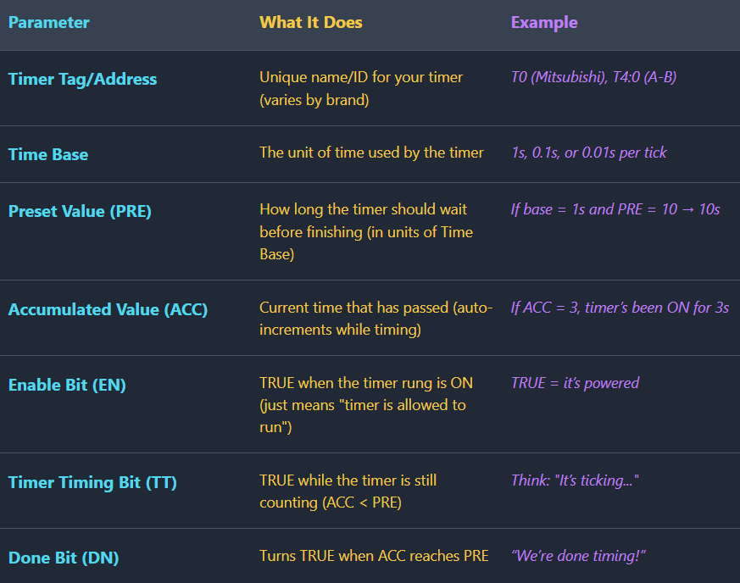

PLC Timer Parameters: Quick Notes

**Timer Tag/Address:** This is the unique name or ID that identifies a specific timer in your program.

**Time Base:** This defines the unit of time, like seconds or milliseconds, for each "tick" of the timer.

**Preset Value (PRE):** This is the total amount of time, in Time Base units, that the timer must count up to.

**Accumulated Value (ACC):** This tracks the current time that has passed since the timer started running.

**Enable Bit (EN):** This bit is TRUE when the timer’s circuit is powered, allowing it to start counting.

**Timer Timing Bit (TT):** This bit is TRUE only while the timer is actively counting, before it reaches its Preset Value.

**Done Bit (DN):** This bit turns TRUE as soon as the timer’s Accumulated Value is equal to or greater than the Preset Value.

**🔁** Real-Life Analogy

Let’s say you're boiling an egg for 5 minutes:

* **EN** = you turned on the stove.
* **TT** = it's still boiling.
* **DN** = timer rings after 5 mins (egg done!).
* **ACC** = shows how long the egg has been boiling.
* **PRE** = your 5-minute goal.
* **Time Base** = counting in seconds or tenths.

**⚙️** Use Case Examples

Light turns off 10s after button press

Use ON-delay timer with PRE = 10

The ON-delay timer starts counting when the button is pressed, and after 10 seconds, it activates the output to turn the light off.

Motor starts 3s after system power-up

Delay with PRE = 3 before output

A timer is initiated on system power-up and counts for 3 seconds before activating the output that starts the motor.

Flash alarm light every second

Toggle logic + timer reset loop

A timer with a Preset of 1 second is used in a loop that resets itself, and its timing bit is used to toggle the alarm light on and off.

***Timers*** *control over when things happen, not just what happens. They’re the heartbeat of delays, sequences, and safety timeouts.*

**⏳** On-Delay Timer (TON): Wait Before You Act

**Think:** *"I’ll wait for X seconds, then I’ll turn ON"*

**🔍** What Does TON Do?

An **On-Delay Timer** delays its output from turning ON until a preset time passes — *but only if the input stays ON the whole time*.

So, it’s basically saying:

*“If you’re serious about this signal, hold it steady. No quick taps.”*

**⚙️** TON Timer Behavior Breakdown

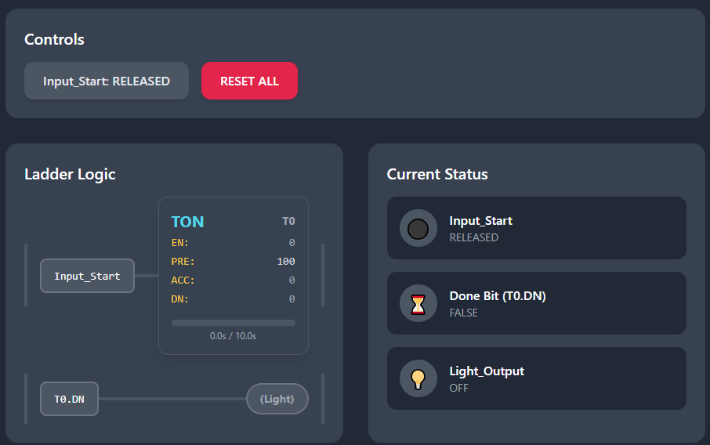

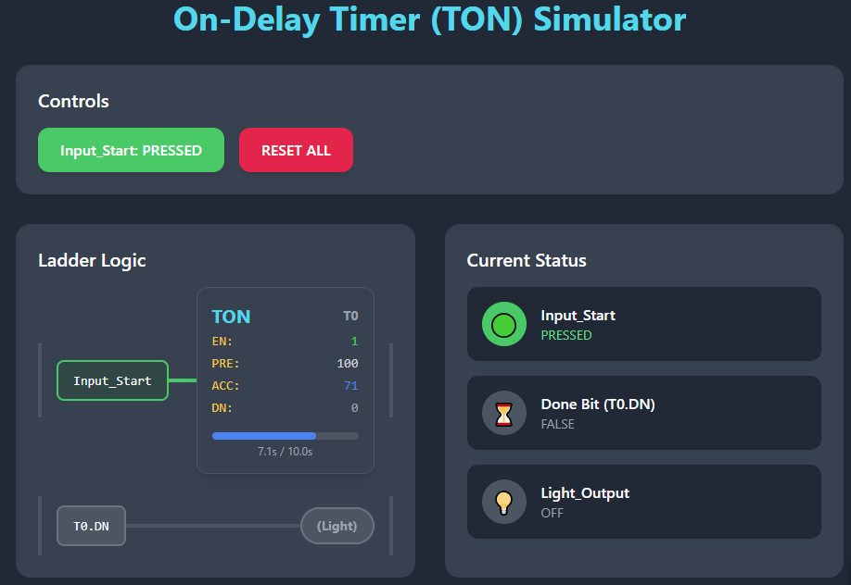

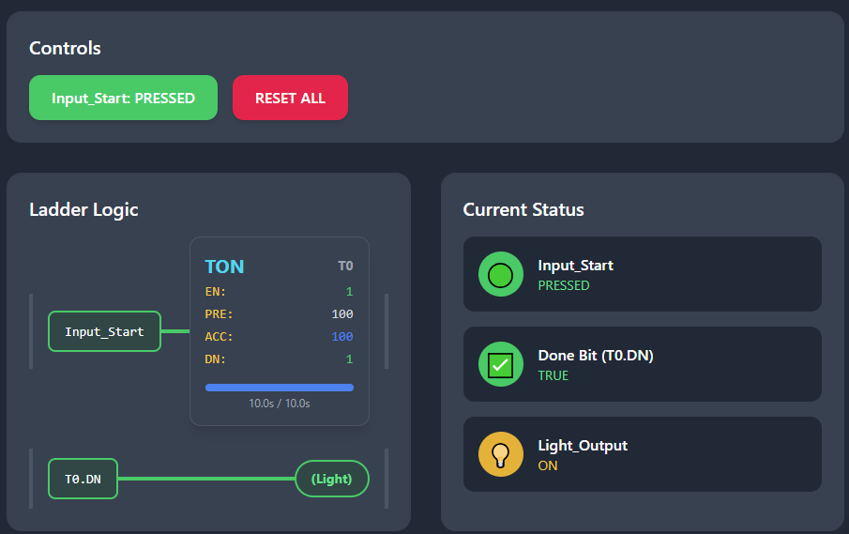

When the input rung turns **TRUE**, the timer starts counting up, and the accumulated value (ACC) increases.

If the input remains **TRUE** until the accumulated value (ACC) equals the preset value (PRE), the **Done (DN)** bit turns **TRUE**, activating the output.

If the input goes **FALSE** before the accumulated value (ACC) reaches the preset (PRE), the ACC resets to **0** and the DN bit remains **FALSE**.

If the input goes **FALSE** after the DN bit is **TRUE**, the ACC resets and the DN bit turns **FALSE** again.

🧠 In short:

* **It waits** to turn ON.
* **It resets instantly** if input is lost.
* **No memory** — doesn’t hold state once input dies.

**🛠** Real-World Uses for TON:

* Safety delays (e.g., wait 5s before re-starting)
* Signal debouncing (ignore fast button taps)
* Sequential process delays (e.g., wait before opening next valve)

**🔁** TON = Patience Timer

* It **doesn’t rush** into action.
* It needs **consistent input.**
* It **resets instantly** if trust is broken.

**🧯** Off-Delay Timer (TOF): Stay ON a Bit Longer

Think: *“I’ll stay ON for X seconds after input goes OFF.”*

**⚙️** TOF Behavior Breakdown

Normal state.

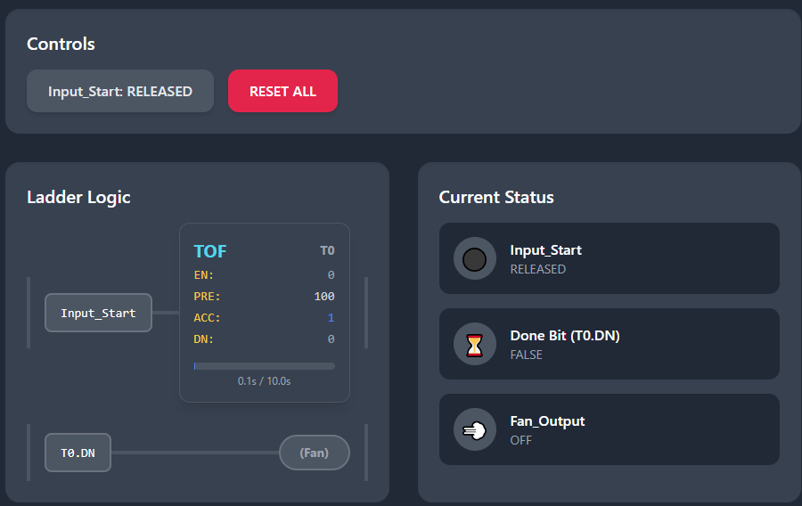

Input pressed:

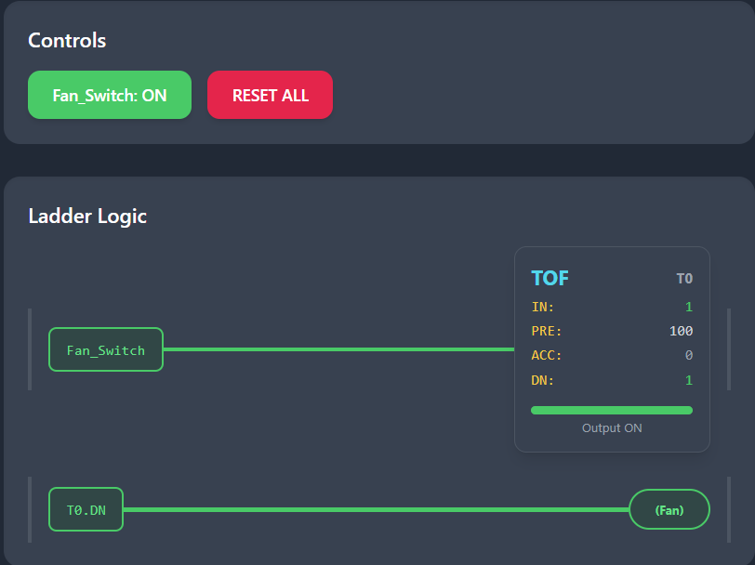

Input released and becomes False counts, then goes back to state 1:

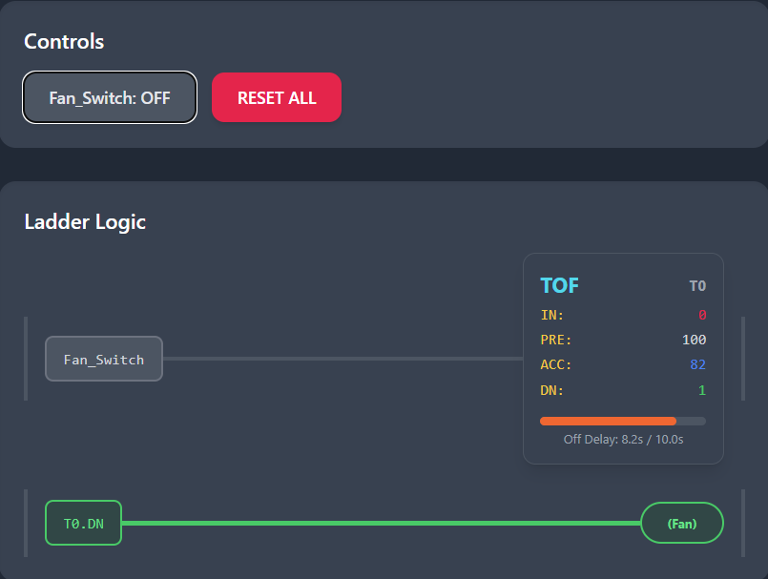

When the input rung turns **TRUE**, the **DN (Done)** bit turns **TRUE** immediately.

While the input remains **TRUE**, the timer stays idle and the accumulated value (**ACC**) remains at **0**.

When the input turns **FALSE**, the timer begins counting and the **ACC** value starts increasing.

When the **ACC** reaches the preset value (**PRE**), the **DN** bit turns **FALSE**, which causes the output to turn **OFF**.

If the input turns **TRUE** again during the countdown, the **ACC** resets to **0**, the **DN** bit stays **TRUE**, and the delay restarts.

🧠 In short:

* **Output turns ON immediately.**
* **Stays ON** even after input is OFF — but only for the preset time.
* **Cancels countdown** if input turns ON again.

**🛠** Real-World Uses for TOF:

* Cooling fans (e.g., after welding, drying, or heating)
* Ventilation after motor stops
* Delay-off buzzers or alarms
* Lights that stay ON for a few seconds after leaving a room

**💥** TOF = “Let me finish my job before I shut off”

* It’s **immediate on**, **delayed off**
* Adds **grace period** before shutting down
* Helps prevent **premature shutoffs**

*You’ve now mastered both ends of the timer spectrum:*

* **TON** = waits to turn ON
* **TOF** = waits to turn OFF

⏳ Retentive Timer (RTO): The Timer That Remembers

While a TON resets if its input drops, RTO is like:

*“Nah, I’ll keep counting... even if you try to stop me.”*

🔁 How RTO Works

The original state:

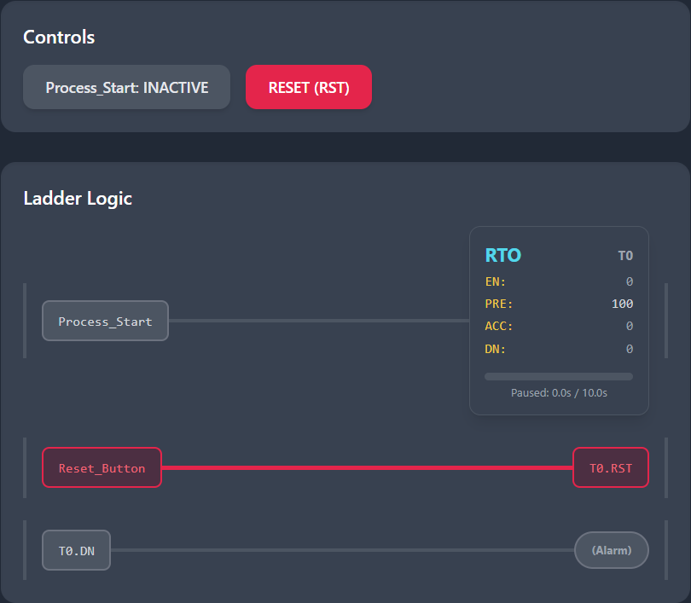

When the rung turns **TRUE**, the Retentive Timer On (RTO) starts counting, and the accumulated value (ACC) increases.

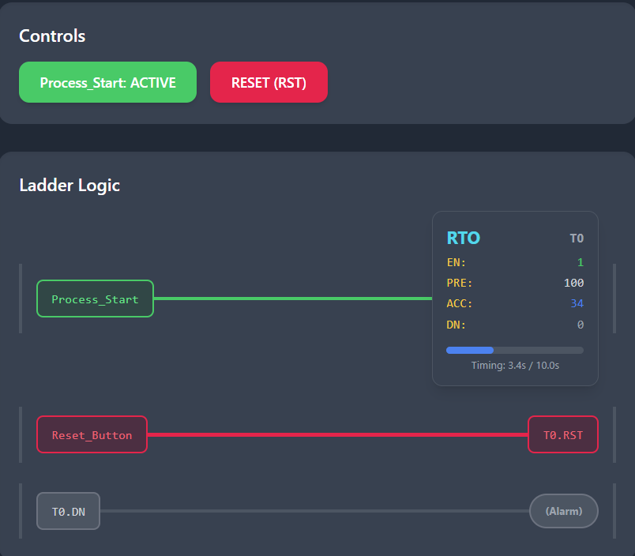

If the rung turns **FALSE**, the timer holds its current accumulated value and does **not** reset.

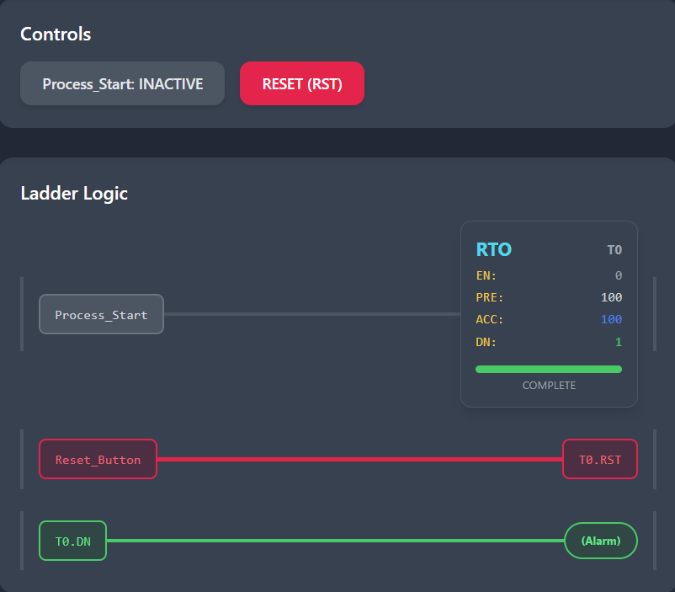

When the rung turns **TRUE** again, the RTO resumes counting from where it left off.

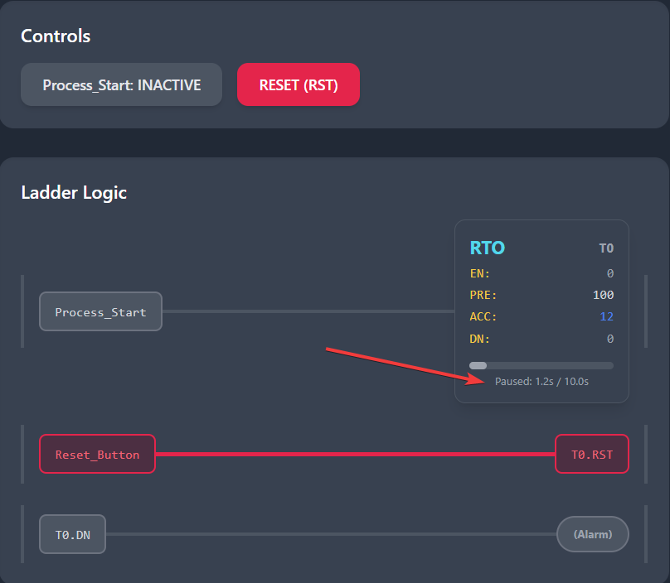

Resumes:

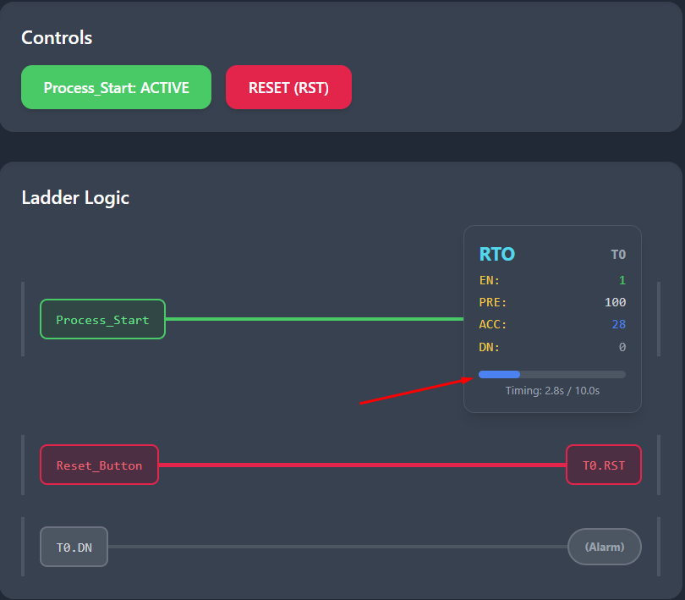

Once the accumulated value (ACC) is **greater than or equal to** the preset value (PRE), the **Done (DN)** bit becomes **TRUE** and remains TRUE.

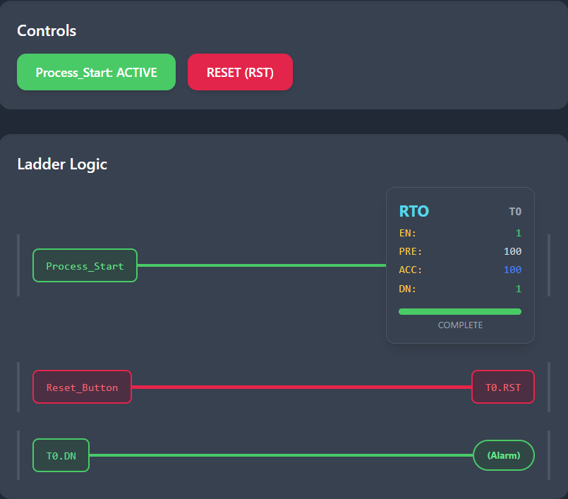

**Retentive Timer (RTO): The Accumulating Memory Timer**

**Core Concept:** An RTO is a timer that **remembers its accumulated time** even when its enabling condition goes away. It only resets when explicitly told to do so by a separate Reset (RES) instruction.

Think of it like the **odometer** in your car. It keeps counting the total miles you've driven, whether you're stopped at a light, driving, or even if the car is turned off. The only way to reset the total miles to zero is by manually pressing the reset button.

**1. The Key Components (The Parts List)**

Every RTO instruction has three critical parts you must understand:

* **Rung Condition (Input):** This is the logic that enables the timer. It can be a switch, a sensor, a bit—anything that can be TRUE or FALSE.
* **Preset Value (PRE):** This is your **target time** (e.g., 10 seconds, 5 minutes). You set this value.
* **Accumulated Value (ACC):** This is the **current total time** the timer has spent with a TRUE rung condition. This value is stored in memory.

It also has status bits (like .DN for "Done") that tell you what's happening.

**2. How It Operates (The Step-by-Step)**

Let's track the values through a real-world scenario. We'll set a Preset (PRE) of 10 seconds.

**Step 1: The Timer is Enabled (Rung is TRUE)**

* The timer sees a TRUE rung condition.
* The **Accumulated Value (ACC)** begins increasing (e.g., 0.0s -> 1.0s -> 2.0s...).
* The **Done (.DN) bit** is OFF (0) because ACC < PRE.

**Step 2: The Input Drops (Rung goes FALSE)**

* This is the **CRITICAL difference** from a standard TON timer.
* The **ACC freezes and holds its current value** (e.g., it stops at 3.7 seconds).
* The **.DN bit remains OFF**.
* The timer is now "paused," waiting.

**Step 3: The Input Returns (Rung goes TRUE again)**

* The timer does **NOT start over**.
* It **resumes counting from the frozen ACC value** (e.g., 3.7s -> 4.7s -> 5.7s...).
* It continues accumulating time towards the Preset.

**Step 4: The Timer Completes (ACC >= PRE)**

* Once the **Accumulated Value (ACC)** reaches or exceeds the **Preset Value (PRE)** (e.g., ACC = 10.0s), the **Done (.DN) bit turns ON (1)**.
* The ACC will stop counting once it reaches the PRE value.
* The .DN bit will **stay ON**, even if the rung condition goes FALSE again.

**Step 5: Resetting the Timer (The REQUIRED Step)**

* To use the timer again, you **must reset it**.
* This is done with a separate **Reset (RES)** instruction.
* The RES instruction must have the same timer address (e.g., RES T4:0).
* When the rung condition for the **RES** instruction is TRUE, it:
  + Sets the **Accumulated Value (ACC) back to 0**.
  + Turns **OFF the Done (.DN) bit** and all other status bits.

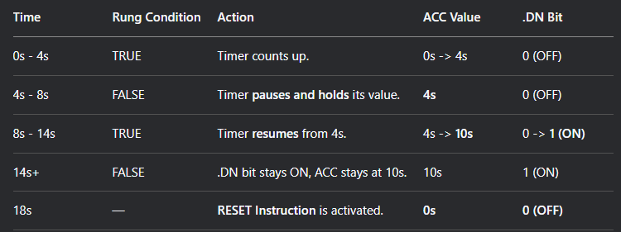

**3. Visual Timeline Example**

Let's visualize the process with a Preset (PRE) of 10 seconds.

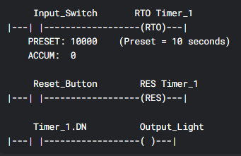

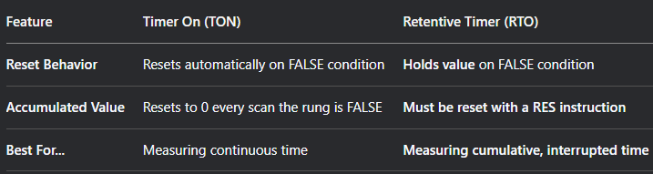

**🧠** Real-Life Uses of RTO:

* **Tracking machine runtime** (maintenance alerts)
* **Total cycle accumulation.**
* **“Resume where you left off” processes.**
* **Long processes that span across multiple sessions.**

**🔄** Summary:

* **RTO ≠ forgetful**
* Always pair it with a **RES**
* Think of it as a “**persistent TON**”
* If you don’t clear it, it’ll mess with your logic on the next run

**⏱️** 1. TON (On-Delay Timer)

**Analogy:** *A microwave oven with a delay before it starts heating.*  
When you press “Start,” the microwave doesn’t begin heating immediately. Instead, it waits for a few seconds (like a delay) before turning on. If you cancel before the delay ends, it never starts.  
→ The **TON** waits for the preset time **before** turning the output **ON** after the input turns **TRUE**.

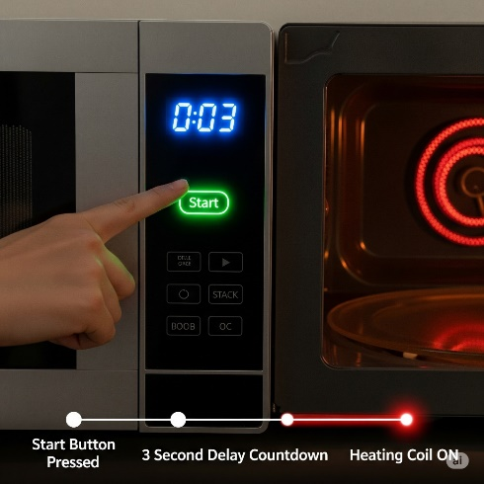

**❄️** 2. TOF (Off-Delay Timer)

**Analogy:** *A cooling fan for a hot engine.*  
The fan turns on immediately when the engine (input) starts. When the engine turns off, the fan continues to run for a preset time to cool things down. Only after this delay does the fan turn off.  
→ The **TOF** keeps the output **ON** for a preset time **after** the input turns **FALSE**.

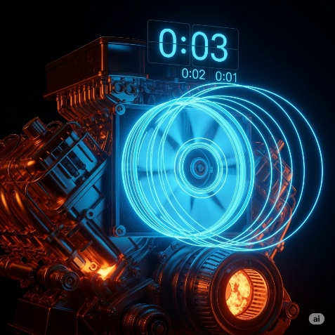

**🔁** 3. RTO (Retentive Timer On)

**Analogy:** *A stopwatch that pauses and resumes.*  
Imagine timing your workout with a stopwatch. You can pause it for a break, and when you continue, it resumes from where it left off — not from zero.  
→ The **RTO** retains the accumulated time when the input turns **OFF**, and resumes counting when the input turns **ON** again.

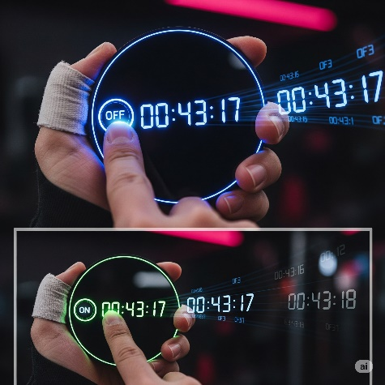

A batching machine that must complete a process in stages. If input signal stops mid-cycle, the timer pauses. When resumed, the timer continues from previous value. Show PLC logic box and machine visuals with glowing indicators.

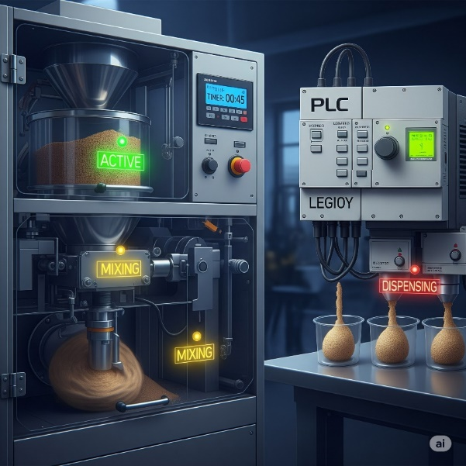

It will resume mixing and dispensing…

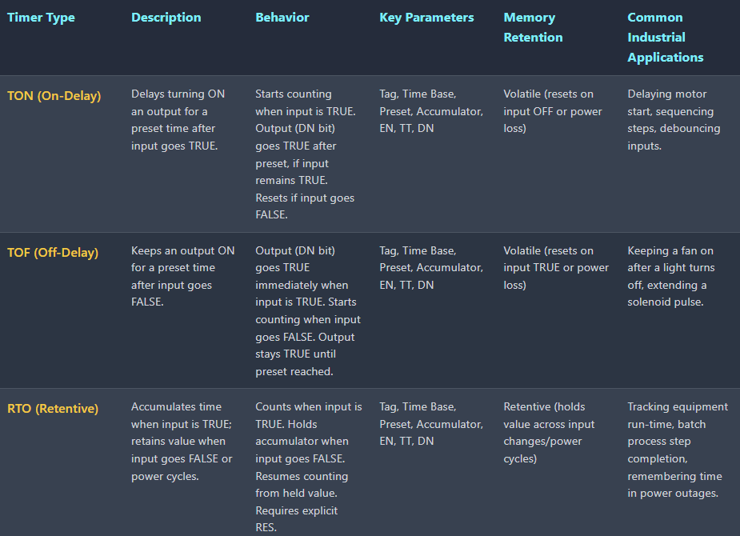

**🔢** EVENT-BASED CONTROL: MASTERING PLC COUNTERS

So, here’s the vibe:  
While **timers** handle *when*, **counters** handle *how many*.  
They're the go-to when you want to:

* Count products on a conveyor 🛒
* Trigger something after 5 button presses 🔘
* Batch a process after hitting a set amount 🎯
* Watch production output like a hawk 👀

**🔍** What Makes Up a Counter?

The Anatomy of a Counter

Just like timers, counters have a basic anatomy. Here is a breakdown of their key parameters. I’ll write and send in images for those who don’t read images:

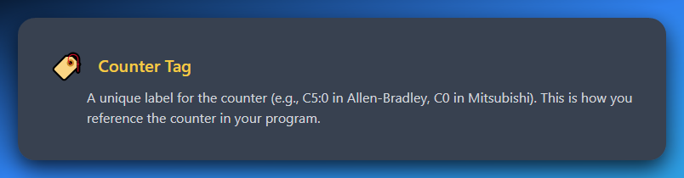

**Counter Tag:** A unique label for the counter (e.g., C5:0 in Allen-Bradley, C0 in Mitsubishi). This is how you reference the counter in your program.

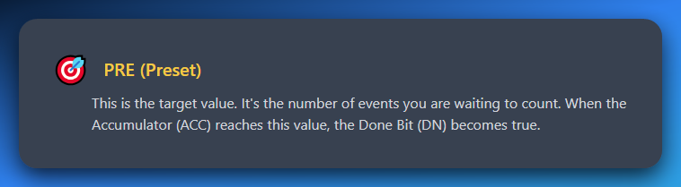

**PRE(Preset):** This is the target value. It's the number of events you are waiting to count. When the Accumulator (ACC) reaches this value, the Done Bit (DN) becomes true.

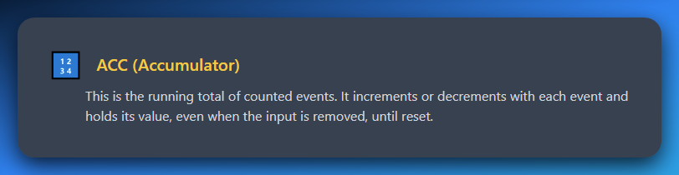

**ACC (Accumulator):** This is the running total of counted events. It increments or decrements with each event and holds its value, even when the input is removed, until reset.

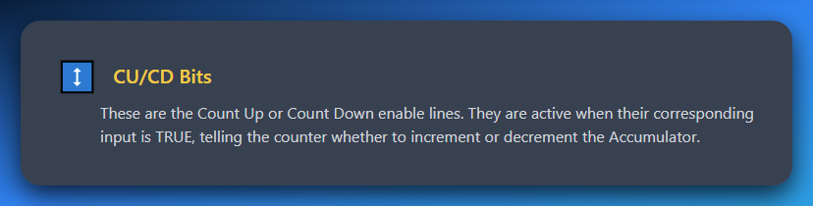

**CU/CD Bits:** These are the Count Up or Count Down enable lines. They are active when their corresponding input is TRUE, telling the counter whether to increment or decrement the Accumulator.

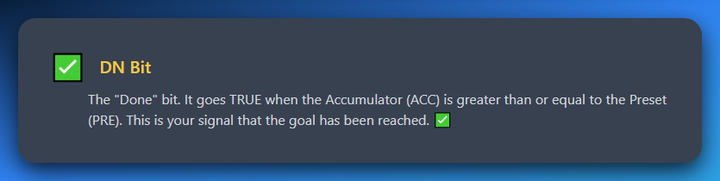

**DN Bit:** The "Done" bit. It goes TRUE when the Accumulator (ACC) is greater than or equal to the Preset (PRE). This is your signal that the goal has been reached. ✅

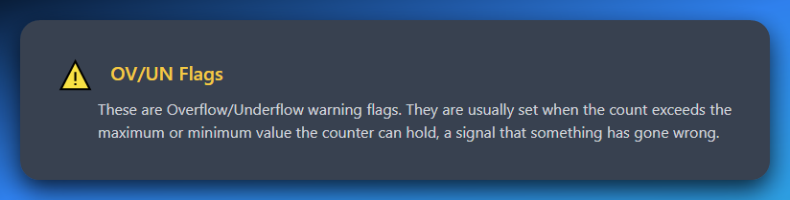

**OV/UN Flags:** These are Overflow/Underflow warning flags. They are usually set when the count exceeds the maximum or minimum value the counter can hold, a signal that something has gone wrong.

**🛠** Example in Real Life:

You want to count 100 bottles passing a sensor, then push a piston to pack them.

You’d use a **Count-Up (CTU)** counter:

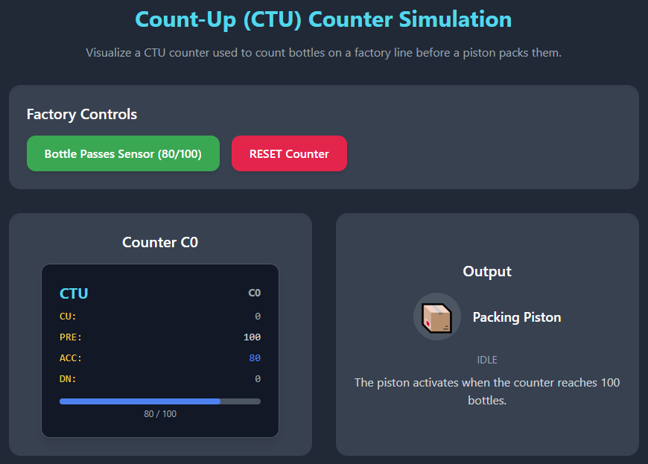

It says “Pushing” and then boom, DN becomes TRUE(1)…

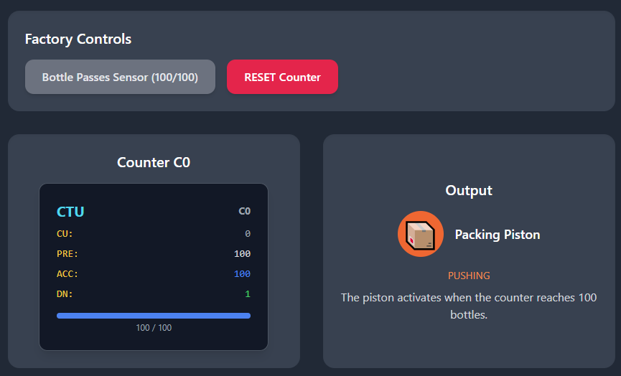

Then it returns to IDLE state till the reset counter is clicked or auto-clicked if the PLC is programmed that way.

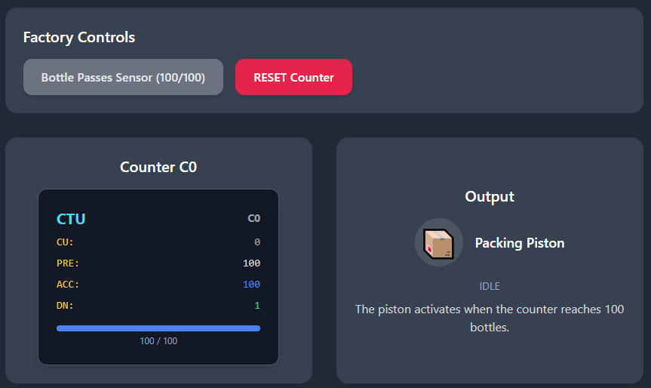

You set:

* Preset = 100.
* Every bottle triggers CU → ACC increases.
* When ACC == 100, the **DN bit** goes high → triggers piston.
* You then **reset** the counter to start the next batch.

**💡** Overflow / Underflow?

You usually won’t touch these in basic setups, but:

* **OV** = “Yo, I counted too far!” (ACC > limit)
* **UN** = “Whoa, can't go negative!” (in count-downs)

Good to keep in mind for **error handling** in critical systems.

**🔄** Summary:

* **Counters = event watchers.**
* They’re basically “if this happened X times, do Y”.
* **Preset** = your goal.
* **ACC** = your live progress bar.
* DN = your “it’s go time” flag.

**🔼** Count Up (CTU) Instruction: Count Like a Boss

**😎** What It Does:

The **CTU** (Count Up) instruction is like a tally counter.  
Every time the input changes from **OFF → ON**, it adds **1** to the total.

But wait—this isn’t just dumb counting. It’s smart.  
It watches for **rising edges** (the moment a signal *switches* ON), not just the fact that it’s ON.

**⚙️** How It Works — The Behavior:

I showed you already using the above diagram. The Behavior of UpCounter:

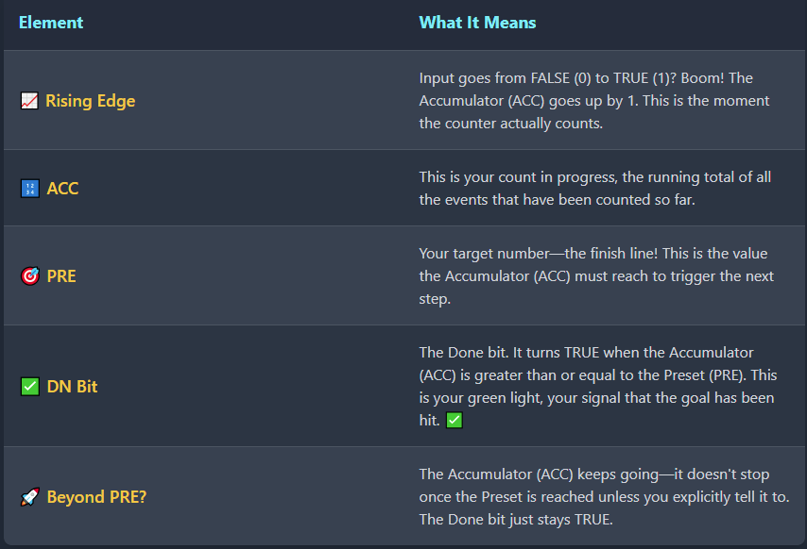

⚠️ Avoiding Double Counting — The One-Shot Hack

Sensors often remain **ON** for multiple scan cycles when detecting objects. Without proper handling, this creates a critical issue: **your accumulator (ACC) will increment multiple times for the same part**, leading to wildly inaccurate counts.

*Example: One part passes by → Sensor stays ON for 5 scan cycles → ACC increments 5 times → You think you counted 5 parts when it was actually just 1*

**The Solution: PTS (Positive Transition Sensing)**

**PTS is your safeguard against overcounting.** It works on a simple principle:

*"Only count the* ***first moment*** *this signal transitions from OFF to ON. Ignore all subsequent ON states until the signal goes OFF and back ON again."*

How PTS Works

1. **Monitors signal transitions** instead of signal states
2. **Triggers only on the rising edge** (OFF → ON transition)
3. **Ignores sustained ON signals** until the next OFF → ON cycle
4. **Ensures one-shot counting** per detection event

The Impact

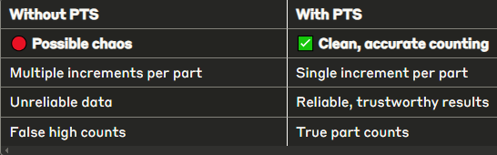

Key Takeaway

**PTS transforms continuous sensor signals into discrete counting events**, ensuring that each physical part is counted exactly once, regardless of how long the sensor remains active.

*Think of it as the difference between counting every heartbeat versus counting every person who walks by.*

**🧾** Ladder Logic Example: Counting Parts on a Conveyor

Normal state:

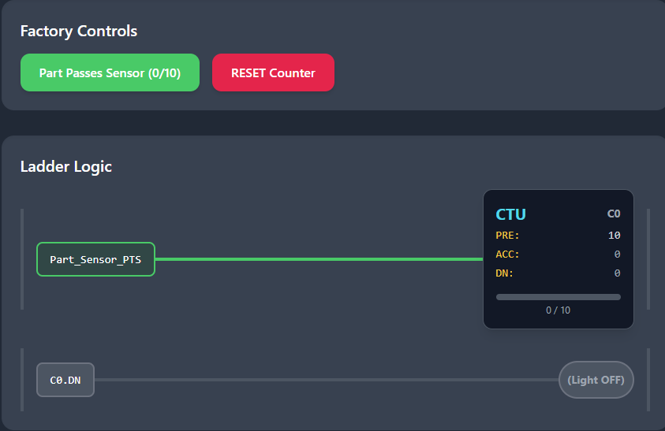

After the count:

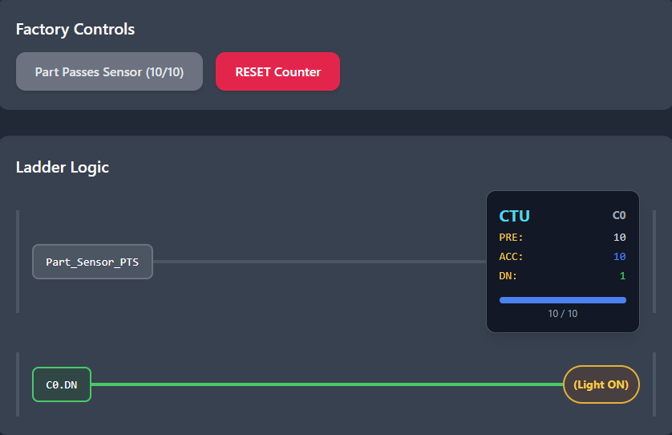

**🧠** What’s happening:

* **Part_Sensor_PTS** = One-shot pulse from sensor
* **Every time a part passes** → C0 gets +1
* **When ACC = 10** → C0.DN goes TRUE → Light turns ON

This is how factories count 10 juice bottles and send 'em to packaging.

Or 10 pizzas into a box. Or 10 screws into a bag. You get the idea.

**💬** Real Talk:

**You MUST pair your Counter (CTU) with a one-shot in high-speed or held-input scenarios.**

Here's what happens if you don't:

**Without One-Shot Protection:**

* *Part passes sensor → Sensor stays ON for 3 scan cycles*
* *Scan 1: "Input is ON! Count = 1"*
* *Scan 2: "Still ON! Count = 2"*
* *Scan 3: "Still ON! Count = 3"*
* *Result: 1 part = 3 counts* ❌

**With PTS/One-Shot:**

* *Part passes sensor → Sensor stays ON for 3 scan cycles*
* *Scan 1: "Input just turned ON! Count = 1"*
* *Scan 2: "Still ON, but I already counted this" (ignored)*
* *Scan 3: "Still ON, but I already counted this" (ignored)*
* *Result: 1 part = 1 count* ✅

**The Bottom Line:** Skip the one-shot protection and your PLC will count like an overeager kid: *"Oh it's still on? Count again! Still on? Count again! AGAIN!"*

And boom — your count is wrong, your batch fails, and someone's having a very bad day.

**PTS transforms continuous sensor signals into discrete counting events**, ensuring that each physical part is counted exactly once, regardless of how long the sensor remains active.

**🔽** Count Down (CTD): Counting in Reverse Like a Pro

**🧠** What’s the Vibe?

Think of CTD as the **reverse twin** of CTU.  
Instead of going up, we’re counting **down** every time something happens — like items being removed, tasks being undone, or lives in a game dropping (💀).

**⚙️** How CTD Works — The Behavior Rundown:

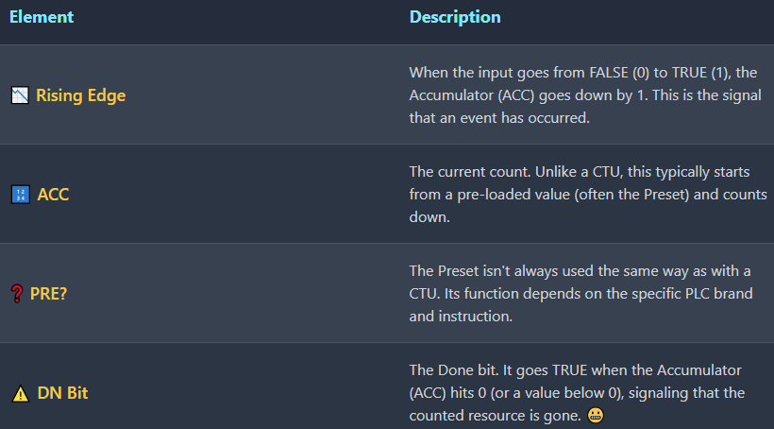

**🔧 Use Case? Inventory Depletion. Life Tracking. Countdown Before Shutdown.**

CTD is a go-to when you want to scream:

*“Yo, we’re running low on something. Time to alert the operator!”*

**🔄** One-Shot Still Matters

Just like CTU, CTD also needs to be protected by a **PTS (Positive Transition Sensing)** instruction to avoid **multiple counts per scan**.

You only want **one decrement per actual event**, not 5 for one held signal.

**🏭** Warehouse Stock Alert Simulation

A visual representation of a simple CTD counter used to track inventory.

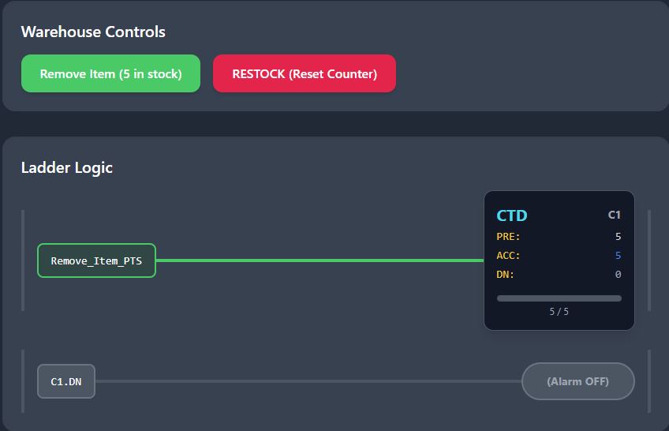

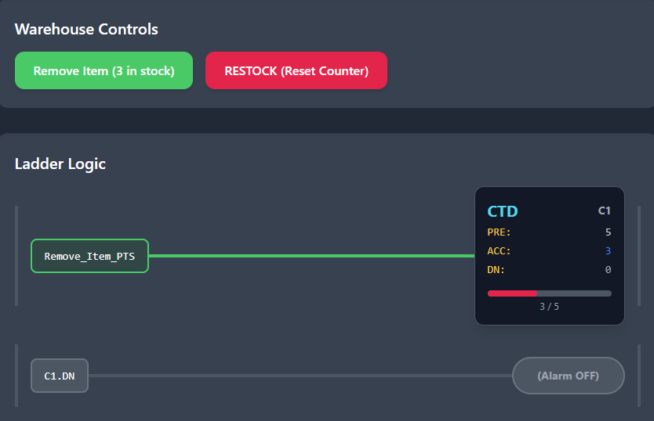

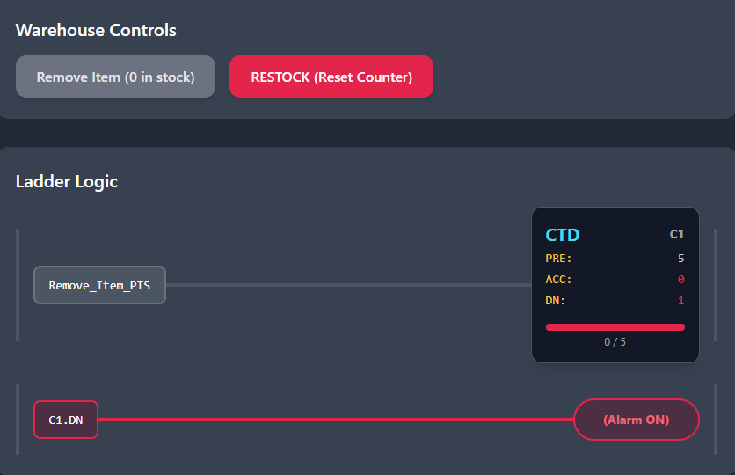

**🧠** Translation:

* C1.ACC starts at 5. Each Remove_Item_PTS pulse drops the ACC by 1
* When ACC hits 0 → C1.DN becomes TRUE → Low_Stock_Alarm goes 🔔

This could be a sensor at a storage bin counting how many items have been picked up. When it hits empty — boom — alert the crew.

**🧪** Bonus Tip: Preloading CTD Counters

You don’t normally "set" the accumulator manually in the rung.  
Instead, you **preset it** using a **MOV (Move)** instruction or **by running another logic branch** that writes a starting value into ACC before the CTD starts working.

**Example:**

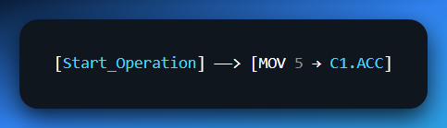

That way, the counter has something to count down *from*.

**❗** Why CTD Matters:

* You can use it to trigger restocking actions.
* It’s perfect for **error prevention** (e.g. avoid trying to fetch from empty storage).
* It works great for **maintenance cycles**, **buffer tracking**, or even **game lives** if you're doing gamified real-world systems like in casinos.

PLC counters are *underrated game dev tools* in the real world. Whether you’re tracking:

* **Tokens inserted** into a slot machine 🎰
* **Buffer level drops** between two conveyor lines 🏭
* Or **maintenance cycles** where a machine gets flagged after X uses 🛠️

...these counters shine. Just pair them with **one-shot inputs** and you're good to go! 😎

**🔁** Now: The RES Instruction — The Unsung Hero of PLC Counters

Okay fam, here's the deal:  
Counters, like stubborn old machines, **don't forget** on their own.  
They **remember** counts even when you're long gone—unless you say,

***“Yo, clear that memory!”***

That’s where **RES** comes in. It’s the digital **reset button**, and without it, your counter could act possessed.

**⚙️** RES Instruction – Core Behavior

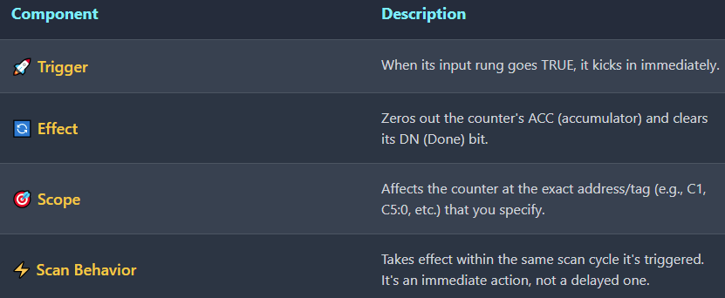

**🧠** Why It’s So Dang Important:

Without a RES:

* Your **batches never restart properly.**
* Alarms stay stuck ON (because DN is still TRUE).
* Counters **keep adding** instead of resetting, making you think you’ve produced 5000 parts... when you’ve only done 200 😬

**🧾** Ladder Logic Example:

Normal state…

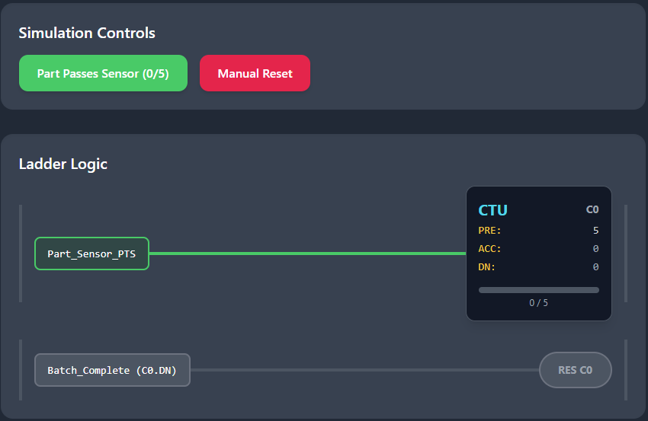

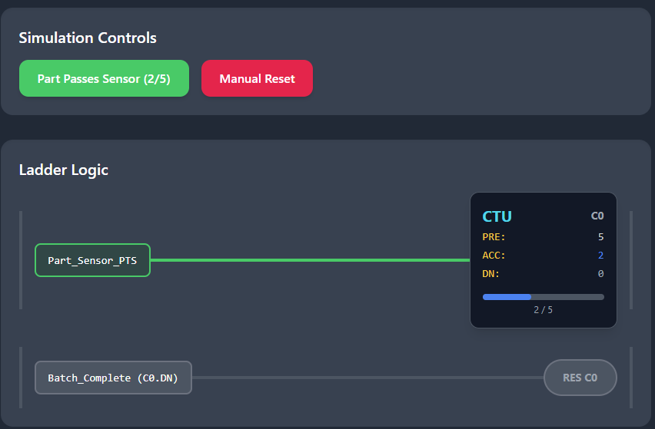

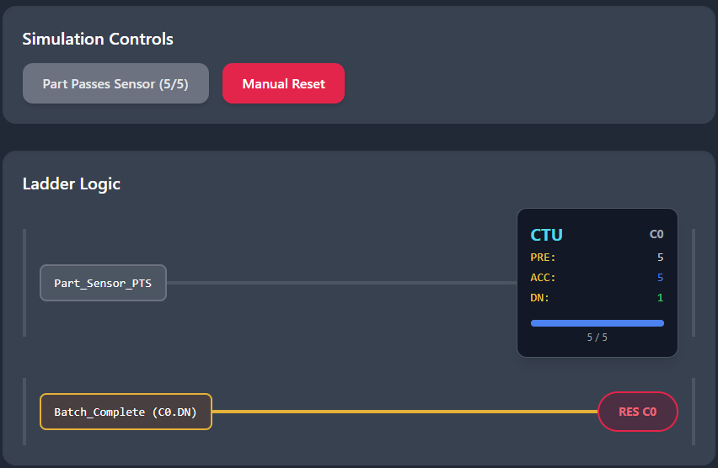

And finally, after the manual reset (RES):

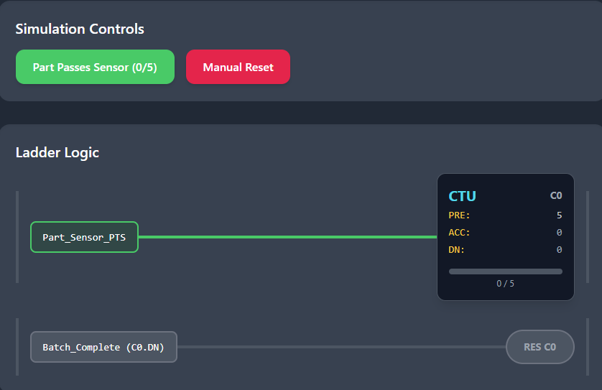

Here, when **Batch_Complete** becomes TRUE (maybe after a light or buzzer signals it's done), counter C0 gets reset and is ready for the next batch.

**⚠️** Common Mistake Alert: Counter Reset

DON'T try to reset a counter by turning off its CU or CD bit. That doesn't reset the count value — it just stops counting. Only RES explicitly clears the data.

Reset Best Practices:

* **Use one-shots to trigger the RES** — prevents continuous resetting
* **Avoid continuous TRUE conditions** or you'll keep zeroing out your counter and never actually count up/down!

Wrong Way vs Right Way:

**❌ Wrong:** Turn off CU input (counter stops but keeps its value)

**✅ Right:** Pulse the RES input (counter value goes to zero)

**💡** Real-World Example: Casino Operations

Casinos use counters extensively for automated management:

Maintenance Scheduling:

* Machine tracks **1000 spins** → triggers **maintenance alert**
* Prevents breakdowns through predictive maintenance

Promotional Systems:

* Every **10 credits used** → triggers **promo light**
* Automated customer engagement without staff intervention

Daily Reset Operations:

* At end of shift, **operator hits master reset switch**
* Runs RES on all counters simultaneously
* **Clean slate for tomorrow's operations**

This automated counting eliminates human error and ensures consistent, reliable tracking across hundreds of machines.

Key Takeaways

**PTS transforms continuous sensor signals into discrete counting events**, ensuring that each physical part is counted exactly once, regardless of how long the sensor remains active.

**Counter Reset:** Only the RES input can clear counter data — turning off CU/CD inputs just stops counting. Always use one-shot triggers for RES to avoid continuous reset conditions that prevent normal counting operations.

**🧩** Combining Timers and Counters: Real-World Control Scenarios

Timers and counters? **Deadly combo**. When you use them together, you go from basic control to *pro-level logic orchestration* — the kind that runs factories, theme parks, and yeah, even casino games if you're feeling spicy. 🎰

**🌃** 1. Batching with Time Limits

**Use case**: Ensure that X number of parts are processed **within a time limit**.

* 🔢 A **CTU counter** counts each item detected by a sensor.
* ⏱️ A **TON timer** starts when the batching begins.
* 🛑 If the timer expires **before** the count is reached, raise an alarm or stop the process.
* ✅ If the count hits preset before the timer’s done, mark the batch as complete.

**Why it matters**: Prevents processes from hanging forever waiting for missing parts.

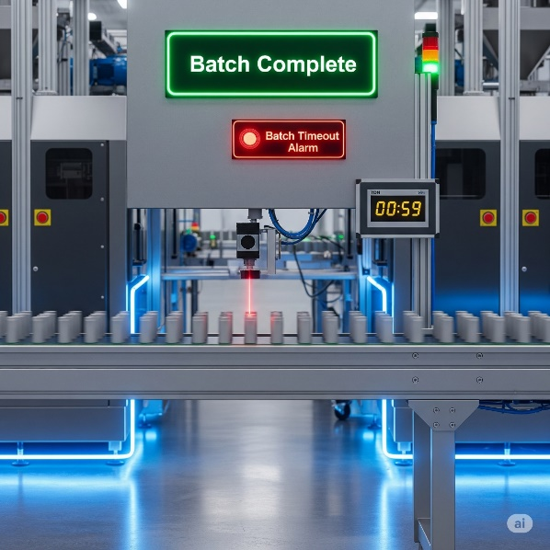

**🏭** 2. Timed Production Runs

**Use case**: Run a production line for a **set duration**, and track how many units were produced.

* ⏳ A **TON** (or **RTO**) timer controls the total run time.
* 🔢 A **CTU** counts each completed unit.
* When time’s up, stop the process — and log how many units were done in that session.

**Why it matters**: Production stats, OEE monitoring, shift-based operations.

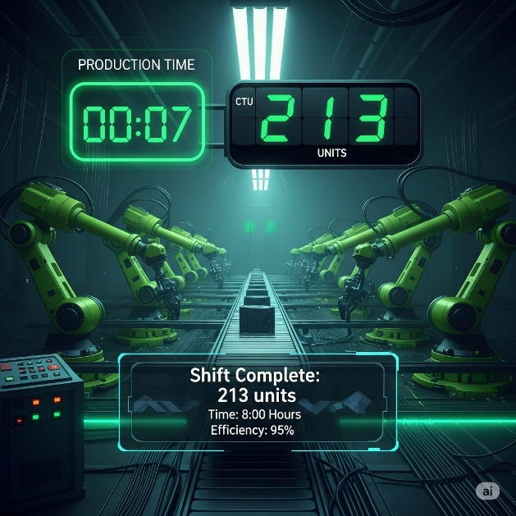

**🚚** 3. Traffic Light Control

**Use case**: Simulate timed sequences + traffic or pedestrian events.

* ⏱️ Multiple **TON** timers drive Red → Yellow → Green sequencing.
* 🔢 Optional **counters** track:
  + Number of vehicles that passed.
  + Pedestrian button presses (trigger walk sequence after 3 people?).
* Combine timers and counters for smart logic like:
  + “Only switch lights **after X cars have passed** or **Y seconds have elapsed**.”

**Why it matters**: Traffic control = real-time safety + logic sequencing under constraints.

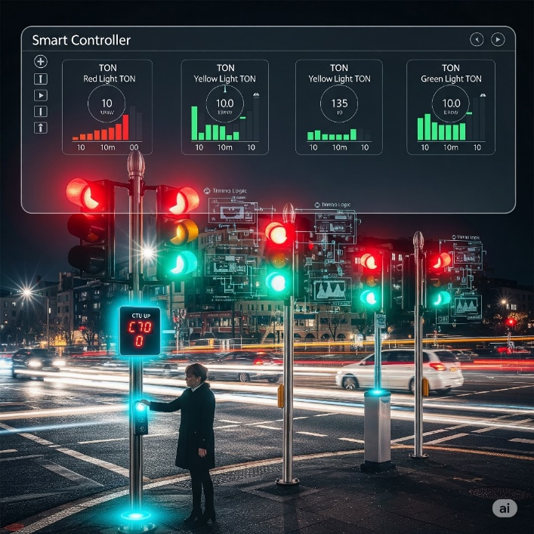

**🍾** 4. Bottle Filling & Counting

**Use case**: Precise control of filling station.

* 🥫 Sensor triggers **CTU** counter for each bottle.
* 🧴 A **TON** timer controls valve open time (e.g., 2s per bottle).
* Logic:
  + When a bottle arrives, timer activates fill valve.
  + Counter keeps track of total bottles processed.

**Bonus**: If combined with an RTO, total bottles filled this shift can be retained even if power drops!

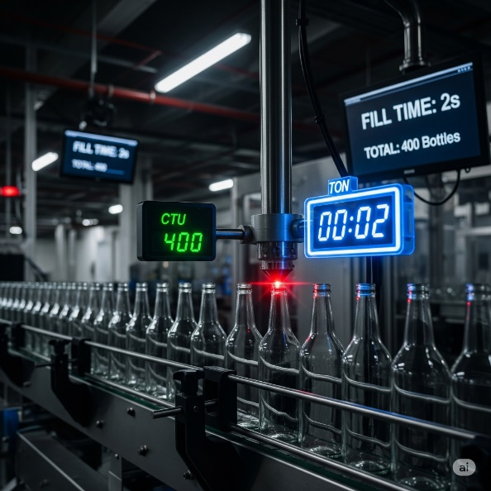

**🔥** Final Note:

Combining timers + counters = **event-based control inside a time-based framework.** It’s like scheduling + tracking — together.

We’re done with that stuff… now let’s finish some missing pieces before we jump into drawing ladder logic.

**🔄** THE PLC SCAN CYCLE: MASTER CLOCK OF YOUR LOGIC WORLD

Every PLC lives and breathes through one thing: the **scan cycle**. It’s a continuous, high-speed loop that drives the logic engine — like a DJ spinning the same record, but remixing it every millisecond.

**🧠** What Happens in One Scan?

The scan cycle runs through *three phases*, always in this order:

1. **📥 Input Scan**
   * The PLC checks *every input device* (sensors, buttons, switches).
   * It stores the current ON/OFF state in internal memory.
2. **🧾 Program Execution**
   * Ladder logic is executed **top to bottom**, rung by rung.
   * The CPU uses only the *stored* input states from this scan.
3. **📤 Output Update**
   * Based on the logic results, it updates all output devices (lights, motors, solenoids).

**⏱️** How Fast Is It?

A full scan usually takes a few **milliseconds**. But even that blazing speed can cause *timing surprises*.

**🕳️** Gotchas to Watch For?

**❌ Outputs aren't instant:** *If a button is pressed mid-scan, the logic doesn't “see” it until the next scan.*

**⚡ Missed pulses:** *If an input turns ON and OFF faster than the scan time, the PLC might* ***never notice it****. This is why high-speed counter modules exist. They monitor inputs in hardware, outside of the scan cycle.*

**🔁 Volatile vs Retentive behavior:** *OTE instructions follow the scan cycle: if the logic is FALSE, output goes OFF that same scan. But OTL, RTO, and counters? These guys remember their state between scans (and even power cycles if designed that way).*

**📌** Why It Matters

Understanding the scan cycle helps you debug weird bugs like:

* *"Why did my output flicker?"*
* *"Why didn’t that pulse get counted?"*
* *"Why is my motor still ON even though the button was released?"*

The answer almost always comes back to:  
➡️ *“The scan didn’t catch it.”*

**🛠️** Pro Tip:

For high-speed or event-driven systems (e.g. 1000+ parts/min sensors), you must:

* **Use One-Shot triggers (e.g. PTS / N_TRIG).**
* **Or upgrade to interrupt-driven inputs or high-speed modules.**

LOGIC CONCEPTS ILLUSTRATIONS





The boolean equation **AB=Y** represents an AND gate, while **A**⋅**B̅** =**Y** is an AND gate with a NOT gate applied to input B, meaning output Y is true only when A is true AND B is false.



An OR gate, represented by the boolean equation **A+B=Y**, means a solenoid (SOL) is energized if either input A or B (such as a limit switch, LS) is activated.



The boolean equation **(A+B) C=Y** describes a circuit where output Y is true if either A or B is true, and C is also true. This is different from the provided scenarios, which only describe an OR gate, where the solenoid (SOL) is energized if either LS1 or LS2 is actuated.



Boolean Equation: **(A + B) (C + D) = Y**



*We're done with note-taking and basic PLC theory. Now it's time to focus on understanding ladder logic through practice, discussions here, and using online PLC simulators for better clarity. Let’s first do Timers and Counters which are the final topics that we shall need for this ladder logic drawing… then we shall jump straight into questions beginner to advanced topics….*

LADDER LOGIC PART 3

Elements of ladder logic

* **Rails** – Vertical lines that carry electrical power to the control circuit.
* **Rungs** – Horizontal lines where the logic is built; they contain inputs, outputs, and branches.
* **Branches** – Parallel paths on a rung that allow multiple input conditions.
* **Inputs** – Devices like switches or sensors that control the logic flow.
* **Outputs** – Devices like motors or lights activated by the logic.
* **Timer** – Delays actions for a set time (e.g., turn on a light after 5 seconds).
* **Counter** – Counts events or cycles and triggers actions after a set number.

I see a small naming confusion I have always had.

In my school, we used “Ladder Logic” to refer to the programs we were drawing.



Some Practice

Y = (X1+X2) X3



Read it using the AND, OR gates.

Y=(X1+X2) (X3+X4)



You could attach the midpoint lines as one, or separate them as above.

Y= (X1X2) + X3





Basic Symbols (on the left)

--| |-- (Normally Open Contact)  
A switch that is open by default and closes to allow current flow when an input is active.

--|/|-- (Normally Closed Contact)  
A switch that is closed by default and opens to stop current flow when an input is active.

--( )-- (Output Coil)  
A symbol that, when the rung's logic is true, energizes and activates a corresponding output device.

--[ ]-- (Special Instruction)  
A block used for advanced functions like timers, counters, or data operations.

This makes retentive memory **invaluable for industrial processes** where a power cut shouldn’t mean starting over.

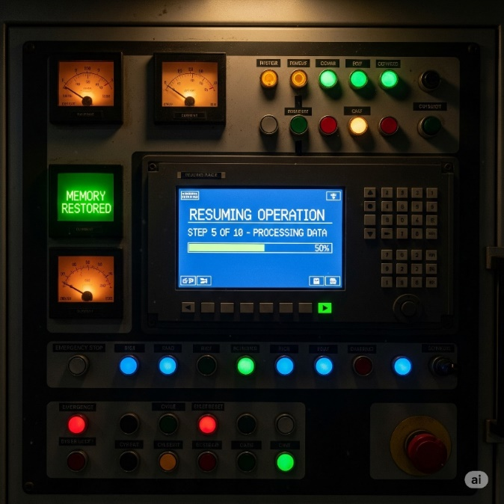

Key Concept: Data Handling and Comparison in Ladder Logic

This image introduces **special PLC instructions**—specifically, **MOV (Move)** and **Compare instructions**—which are essential for going beyond simple ON/OFF control. These tools let you handle numeric data, set thresholds, and build smarter logic based on real-world values (like temperature or pressure).



1. MOV (Move Instruction)

The MOV (Move) instruction is a data handling block used to copy a value from a **source** memory location to a **destination** memory location. When its rung is true, it moves the data, which is useful for tasks like setting a timer's preset or moving a counter's current value to a display.

2. > (Greater Than – Compare Instruction)

The ">" (Greater Than) instruction is a comparator that checks if a **source** value (S) is greater than a **destination** value (D). If the condition is met, the instruction evaluates as true, allowing the program to continue along the rung to the right. This is useful for tasks like comparing a sensor's reading to a setpoint.

3. Practical Application: ≥ and ≤ for High/Low Limits

The logic for this alarm system is triggered when the value of S (a process variable like temperature) is greater than or equal to the constant value of 80, and the master alarm relay (IR) is also active, which then energizes the alarm coil.

4. Bottom Rung: Low-Limit Control (IR Relay)

The ≤ (Less Than or Equal To) instruction compares a value S to a constant of 70, activating the internal relay coil IR when S is 70 or less, which can then be used to trigger other logic, such as a heater or alarm.

**MOV and Compare instructions** give PLCs the ability to handle **numeric data** rather than just boolean states.

The ADD Instruction



The **ADD instruction** which is an arithmetic instruction in Ladder Logic is a function block that performs addition using three key fields. It takes the values from the **Au (Augend)** and **Ag (Addend)** fields, adds them together, and then stores the final sum in the **R (Result)** field. ➕

How it Works

When the conditions on a rung are met, the PLC will execute the **ADD instruction**. It retrieves the values from the specified memory addresses for **Au** and **Ag**, adds them together, and then stores the resulting sum in the **R** memory address.

Example Use Case

Imagine you have a process where you need to track a total count

* **Au** → Current total register (e.g., D100).
* **Ag** → Constant (1) or another register (e.g., D101).
* **R** → Destination register (same as Au or new one like D102).
* **Example** → ADD D100, 1, D100 increments D100 by 1 each scan. ✅

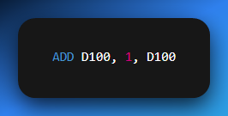

The ADD instruction—along with SUB (subtract), MUL (multiply), and DIV (divide)—is essential for handling numeric data from sensors and implementing calculations inside the PLC. These instructions are the backbone of more advanced control strategies.

**SUB, MUL, and DIV work the same way as ADD**—they just change the operation performed on the two values.

They all use:

* **Au (first value/memory)**
* **Ag (second value/memory)**
* **R (result destination)**

The only difference is:

* ADD → Adds **Au + Ag → R**
* SUB → Subtracts **Au – Ag → R**
* MUL → Multiplies **Au × Ag → R**
* DIV → Divides **Au ÷ Ag → R**

So yeah, we don’t need to write separate full notes for each.

Data Conversion Instruction: BIN

This image introduces another key PLC instruction—**BIN (Convert to Binary)**—which is used to **convert data from one numerical format (e.g., BCD) into pure binary** for internal processing.



BIN Instruction Breakdown

* **Ladder Symbol** → Box labeled **BIN** (with S & D).
* **S (Source)** → Original data address.
* **D (Destination)** → Memory Address for converted binary value. ✅

How It Works:

When the rung condition to the left is true, the PLC:

1. Reads the value from **S**.
2. Converts it into pure binary (if it’s in another format, such as BCD).
3. Stores the converted value into **D**.

Why Conversion Is Needed

* **BCD Inputs** → Some devices (e.g., thumbwheel switches) output in BCD.
* **PLC Processing** → PLCs use pure binary for math/logic.
* **Compatibility** → Convert BCD to binary before using ADD, SUB, or COMPARE. ✅

Example Use Case

Suppose a thumbwheel switch outputs a BCD value (e.g., 25) into register **I_Data_Register**

You want this number to be used as a **timer preset**. You’d use:

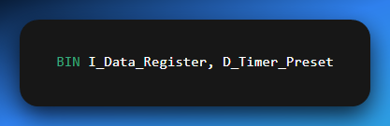

When the rung is true, the PLC converts 0010 0101 (BCD 25) into 0001 1001 (binary 25) and stores it in D_Timer_Preset.

Why It’s Important

The BIN instruction acts as a **bridge between external devices and internal PLC logic**, ensuring that data coming from different encoding schemes can be processed correctly.

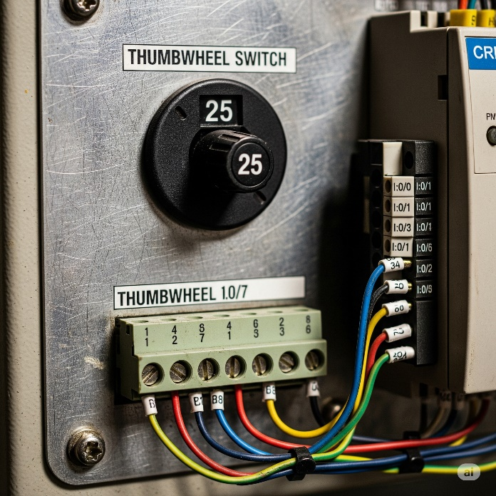

These were my personal notes, they mostly have no order of topics, I just threw in a bunch of pdfs together and made sense of them.

**🎯** One-Shot Contacts: Mastering Momentary Logic

**🔫** Fire Once, Then Chill.

In ladder logic, sometimes you don’t want an output to stay ON — you just want to **trigger it once** when something changes. That’s what **one-shot** contacts are for. They’re like digital snipers: **One pull. One shot. One scan cycle. Done.**

**⚡** Positive Transition (Rising Edge) — P_TRIG / ONS / --[↑]--

It’s a special instruction in PLCs.

It only activates for ONE scan when an input changes from OFF (0) → ON (1).

After that first moment, it goes OFF again, even if the input stays ON.

So basically: It detects the "moment of change," not the whole ON period.

🌍 Real-World Example

A sensor sees a bottle pass. The sensor stays ON while the bottle blocks it.  
If you used a normal contact, the PLC might count **10 times** (because the bottle blocks it across 10 scans).  
With a **one-shot**, it only counts **once**, the moment the bottle first arrives.

**🧯** Negative Transition (Falling Edge) — N_TRIG / --[↓]--

It **only activates for ONE scan** when an input changes from **ON (1) → OFF (0)**.

After that first moment, it goes OFF again, even if the input stays OFF.

So: **It detects the “moment something turns OFF,” not the whole OFF period.**

🌍 Real-World Example

**Machine Safety Gate Alarm:**

A sensor monitors if a safety gate is closed.  
When the gate opens, the signal goes from ON → OFF.  
With a normal contact, the alarm might stay ON the whole time the gate is open.  
With a **negative one-shot**, it triggers **only once**, right at the moment the gate opens, to log or send a warning.

**⏱️** One-Shots & Scan Cycles: Timing Is Everything

Here’s the **catch** that most rookies miss:

If the input transitions **faster than your PLC’s scan cycle**, the one-shot might **completely miss it**.

Let’s say your PLC scans every 5ms, but your sensor goes ON and OFF in 2ms.  
Too fast. The PLC never sees the edge → your P_TRIG never fires → missed event. 😵

That’s why:

* You need to know your PLC’s scan time
* For **high-speed inputs**, consider using **dedicated high-speed input modules** or **interrupt routines**

**🧠** Bottom Line:

* One-shots are **event detectors**, not state detectors.
* They let you act on **transitions**, not just steady signals.
* Use them when **"just once"** matters more than **"while true"**.

They’re small, sharp, and surgical. Use with precision. 🩺

👉 Basically: **One-shots are like a camera shutter — they only click once per edge. If the blink is too fast, no picture.** 📸

**🔒** The Latching (Seal-In) Circuit

Holding Power Without Holding the Button

This is one of the **most common control patterns** you’ll ever use in ladder logic — the **seal-in**, also known as a **latching circuit** or **holding contact**.

What does it do?  
It **keeps an output ON** even after the button that started it has been released.

**🧠** Why is this useful?

Imagine pressing a "Start" button and having to **hold it forever** just to keep a machine running.  
Ridiculous, right? That's why we build a **logic memory loop** that says:

***"If I started, I’ll stay ON — until told to stop."***

**🔧** Classic Latching Circuit Breakdown

**Components:**

* 🟢 **Start button** → Normally Open (NO) contact
* 🔴 **Stop button** → Normally Closed (NC) contact
* ⚙️ **Output coil** (motor, light, etc.) → OTE
* 🧠 **Seal-in contact** → NO contact tied to the output

**How It Works:**

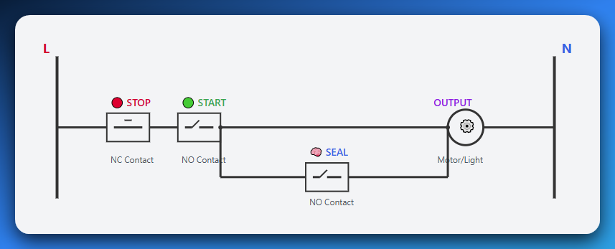

**Start pressed**: Logic flows through **NC Stop** and **NO Start** → energizes output coil

**Output turns ON**: Its associated contact (seal-in) **closes** — now there’s a **new path** for logic

**Start released**: Doesn’t matter — seal-in is doing the job now. Output stays ON.

**Stop pressed**: NC Stop opens → logic is cut off → output de-energizes → seal-in opens → resets the loop

**🧰** Real-World Use Case: Motor Start/Stop

* Press "Start" → Motor turns ON
* Release "Start" → Motor keeps running
* Press "Stop" → Motor shuts off

This behavior is **crucial** in:

* Motor control
* Conveyor systems
* Pumps
* Anything where **continuous operation** is needed after a momentary trigger

**🧠** Why It Matters

Seal-in logic introduces the idea of **memory** — holding a state across time.  
You’re not using a retentive bit yet, but it’s the **first step** to understanding:

* Retentive timers.
* Latching bits.
* Preserving state through logic loops.

And it’s also critical for **safety** — a machine shouldn't stop just because a button was accidentally let go. It should stop only when the operator **deliberately presses STOP**.

💡 **Key Concept: Self-Holding** - The seal-in contact creates a **parallel path** around the start button. Once energized, the output "holds itself ON" through this parallel path, even when the start button is released. Only the stop button can break the circuit and reset the system.

3 MAIN OUTPUT INSTRUCTIONS

In Ladder Logic, there are three main output instructions that control how a PLC behaves:

* **OTE (Output Energize)**: This is a basic, volatile output. It turns on only when its rung logic is true and turns off immediately when the logic becomes false. It has no memory and is best for outputs like lights or fans that need to respond instantly to changes.
* **OTL (Output Latch):** This instruction sets an output to ON and keeps it that way, even if the rung logic becomes false. It has memory and is **retentive**, meaning the output stays on until it is specifically turned off. This is useful for emergency alarms or status flags that require a manual reset.
* **OTU (Output Unlatch):** This instruction is the "off" switch for a latched output. It forces the output to turn OFF and clear its memory when its rung logic becomes true. OTL and OTU are often used in pairs on the same output to provide full manual control.

The Key Difference: Memory

The main difference between these instructions is the concept of memory.

* **OTE is reactive;** it instantly mirrors the state of its rung's logic.
* **OTL and OTU are retentive;** they remember the last command (ON or OFF) and hold that state until explicitly commanded otherwise.

This distinction is crucial for building complex, sequential control systems where a machine needs to remember its state, such as after a fault or for a multi-step process.

Using OTL/OTU gives you, the programmer, precise control over a machine's state, which is essential for safety and reliability.

**📦** M-BITS / INTERNAL RELAYS / FLAGS — WHATEVER YOU CALL THEM

Okay, so you already know that X is for inputs and Y is for outputs in Mitsubishi PLCs.

But what if you want to store a result, remember a condition, or build logic that has **nothing to do with physical wiring**?

That’s where **internal memory bits** come in — the M range.

**⚙️** What Are M-Bits?

M-bits (M0, M1, M100...) are **virtual switches** inside the PLC’s brain.

* They’re **Boolean variables**: either ON (1) or OFF (0).
* You **don’t wire them** to anything.
* They live entirely **in software.**

💡 You can think of them like this:

If physical inputs/outputs are the muscles, M-bits are the neurons — internal signals making decisions behind the scenes.

**🧩** How Are They Used?

Let’s say you have a huge condition like:

* Input A is ON.
* AND Input B is OFF.
* AND the motor isn’t already running.
* AND a timer has expired.
* AND another condition from 5 rungs back is true.

😵 **Trying to cram that into one rung?** Good luck debugging that in an exam or real system.

Instead:

* **Break it into smaller parts.**
* Store partial results in M bits (M100, M101, etc.)
* Use those M bits as contacts in other rungs.

Now your logic is **clean**, **modular**, and **easy to follow**.

**🔁** Example in Mitsubishi:

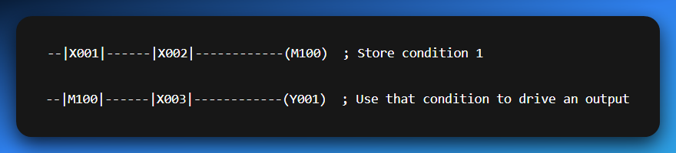

This lets you “build logic in layers” — just like you do with if statements or functions in Python or C.

**🧼** Why Use M-Bits?

* ✅ To **store results** from previous logic.
* ✅ To **simplify complex rungs.**
* ✅ To **add memory** to your logic without using OTL/OTU.
* ✅ To create **modular, reusable chunks** of control.
* ✅ To make your program **easy to debug** and maintain.

It’s the difference between spaghetti logic and **engineered control flow**.

**🧠** Pro Tip for Mitsubishi Folks:

* Inputs → X (e.g., X001)
* Outputs → Y (e.g., Y001)
* Internal relays → M (e.g., M100)
* Timers/Counters → T, C
* Constants/Data → D, K, etc.

Think of M-bits as your **scratchpad memory** — they hold your thoughts while you solve the puzzle. Once you master them, your ladder diagrams will go from basic to pro-level real quick.

**⚙️** Practical Power: How to Use M-Bits Like a Pro

Flags, Intermediate Logic, and Master Control — The Real Deal

M-bits, or internal memory bits, are essential for controlling your PLC's logic. Let’s walk through **three powerful ways** to use them:

**🏁** 1. Flags — Status Indicators

M-Bits act as status indicators or checkpoints for your program.

This allows you to set a bit in one part of your logic when a certain condition is met, and then use that "flag" anywhere else in the program to easily check if that condition occurred.

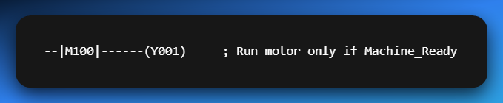

**🧮** 2. Intermediate Logic — Break It Down to Build It Right

Complex logic can get ugly fast.  
Instead of this mess:

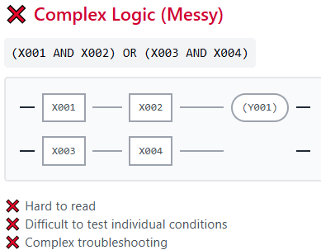

Split it up like a smart coder:

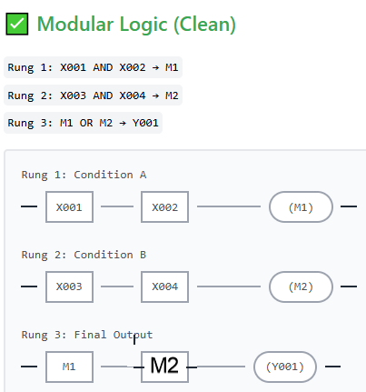

✅ Easier to read  
✅ Easier to test  
✅ Easier to debug during an exam or live run

It’s **ladder logic modularity** — just like clean code in Python or C.

**🧷** 3. Master Control Relay — The Big Switch

This is **crucial for safety and system structure**.

Let’s say you’ve got a whole section of outputs — motors, valves, alarms — and you want to **disable them all instantly** when something goes wrong or the operator hits STOP.

🔧 Create a master relay like M200 (e.g., System_ON)

Then put that M200 contact in every rung:

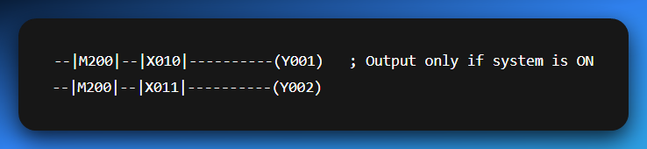

Control M200 with your start/stop logic:

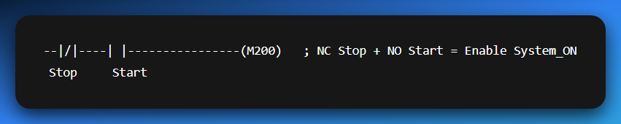

Now pressing STOP **cuts off everything**, like a master switch.  
✅ Safe.  
✅ Predictable.  
✅ Easier to read  
✅ Easier to test (M1, M2 individually).  
✅ Easier to debug during exams/live runs.

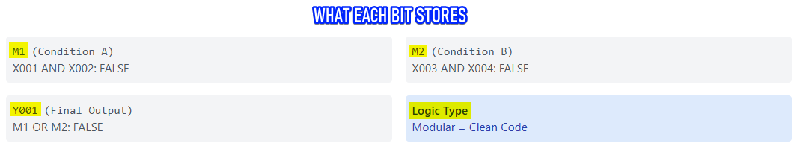

Internal M-Bits: Structured Control

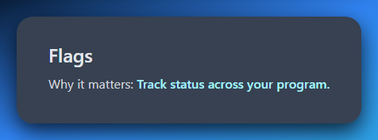

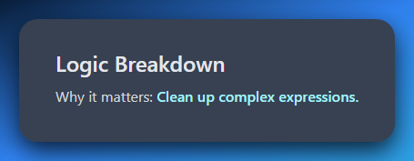

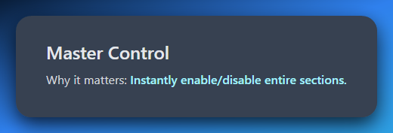

Internal memory is what takes your program from "works" to **works well** — clean, scalable, and *factory-ready*.

➡️ *Does your PLC remember... or forget everything the moment power dies?*

Let’s break this down so it **sticks like glue**, and you **never misuse a memory bit** again.

**🧠** Retentive vs Non-Retentive M-Bits

What Happens When the Power Goes Out?

Not all M-bits are created equal. Some forget like goldfish 🐠... others remember like elephants 🐘.

And you, the programmer, decide which behavior you want.

**🧼** 1. Non-Retentive M-Bits — The Forgetful Kind

Most M-bits (by default) are **volatile** — meaning:

* If the PLC **loses power** or is switched to **PROGRAM mode.**
* These bits **reset to OFF (0)**. Everything they “remembered” is gone.

✅ Good for:

* Temporary flags.
* Intermediate logic.
* States that should *always reset* on power-up.

📍Example: **M100: "Start_Pressed" → Only relevant during runtime.**

You *want* this to reset so no ghost input causes logic to fire when power comes back.

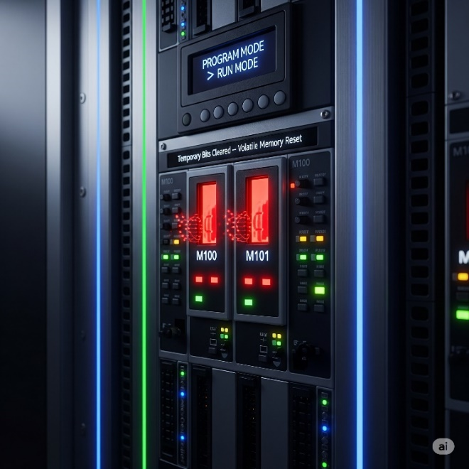

**🧲** 2. Retentive M-Bits — The Memory Keepers

Some M-bits are **retentive**. These are backed by internal battery power or stored in a persistent way inside the PLC.

* They **remember their state** even if:
  + Power goes out.
  + PLC is restarted.
  + Scan cycle is interrupted.

✅ Use them when you **must preserve state**. Example:

**M200: “System_Stopped_Due_to_Fault” → You don’t want this cleared, until operator resets it.**

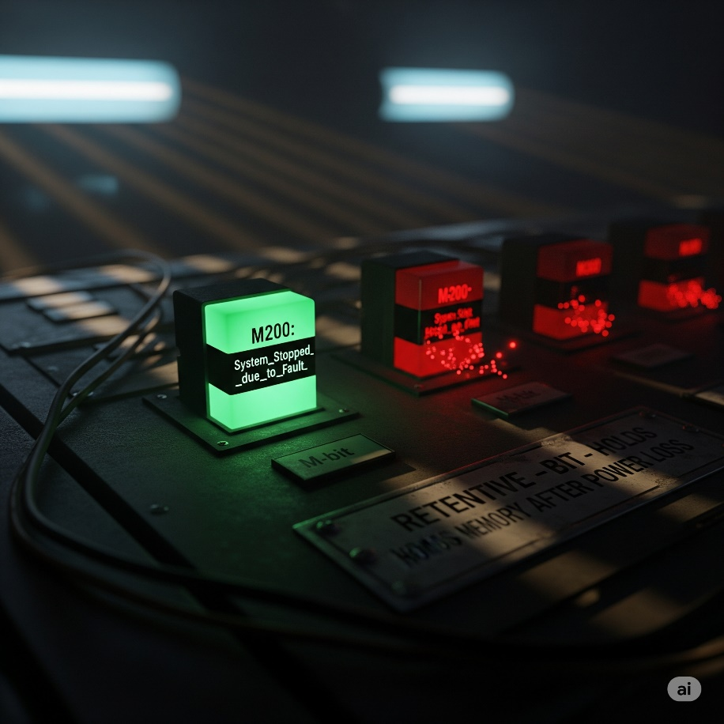

**⚠️** Why It Matters

Scenario A:

A batch mixing system is halfway through step 3 when the power dies.

* ❌ If all your M-bits were non-retentive → the PLC boots up and has no clue where it left off
* ✅ If you saved step progress in retentive bits → the system resumes like nothing happened

Scenario B:

A fault occurred. You want the operator to see it after reboot.

* ❌ Non-retentive = fault flag disappears
* ✅ Retentive = fault flag still ON → Operator sees and clears it

**🔐** Design Rule of Thumb

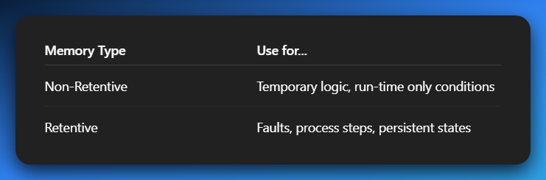

Mixing them up = recipe for **bad logic** or **unsafe resumes**.

**📌** In Mitsubishi PLCs:

You’ll often configure **ranges** of M-bits as retentive in the **PLC parameters**.

For example:

* **M0–M499 → Non-retentive.**
* **M500–M999 → Retentive.**

Check your software (like GX Works) to define or view this split.

**🧠** Final Word:

When power comes back, your program should either:

* **Restart cleanly** like a fresh boot.
* Or **pick up where it left off**, like nothing happened.

Your **choice of retentive vs non-retentive bits** is what makes that happen.

**🧩** Real-World Uses of M-Bits

Practical Logic with Flags, Intermediates, and Master Control

M-bits aren't just "extra space" — they're your secret tools for organizing, controlling, and simplifying your entire program.

Here’s **how pros actually use them** in everyday logic:

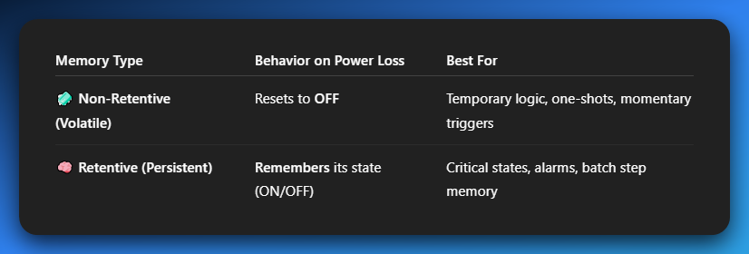

**✅** 1. Flags / Status Indicators

Flags = M-bits that mark something as ON/OFF (TRUE/FALSE) in your program.

Think of them as **checkpoints**:

* **M100 → Machine_Ready**
* **M101 → Fault_Active**
* **M102 → Sensor_Clear**

Instead of checking multiple raw inputs again and again, just check the flag:

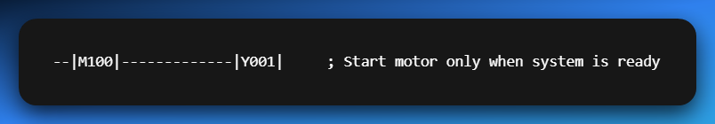

💡 **Flags simplify conditions and make logic readable**.

**🧠** 2. Intermediate Logic Storage

Ever seen an ugly rung like this?

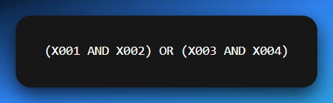

Messy and hard to debug, right?  **Solution:** Break it up using M-bits:

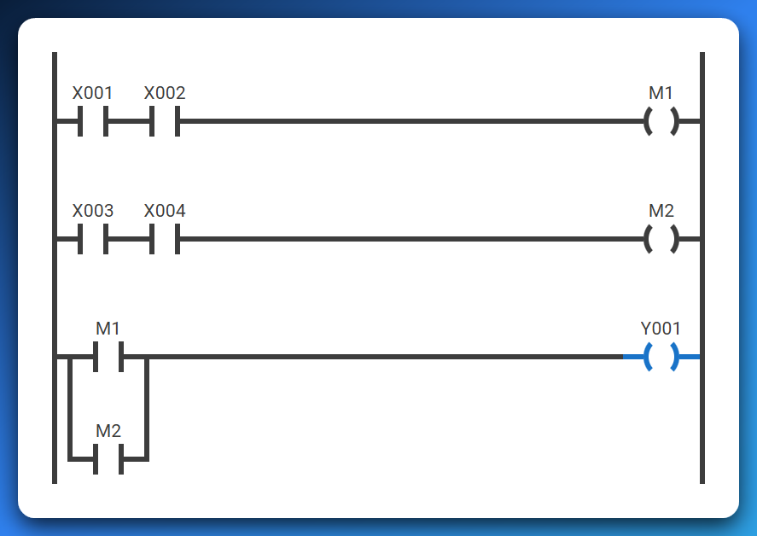

✅ Cleaner.  
✅ Easier to troubleshoot.  
✅ You’ll thank yourself during exams.

**🚨** 3. Master Control Bit (MCB)

Use an M-bit like a **main switch** to enable or disable entire sections of the program.

**Example: M200 → System_ON (controlled by start/stop buttons)**

Then use it like this:

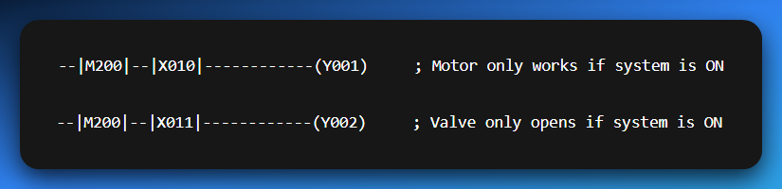

If the STOP button breaks the latch and M200 turns OFF, **everything shuts down** — instantly.

✅ Safety-compliant.  
✅ Easy to organize.  
✅ Clean sequencing control.

**🔑** Summary Table 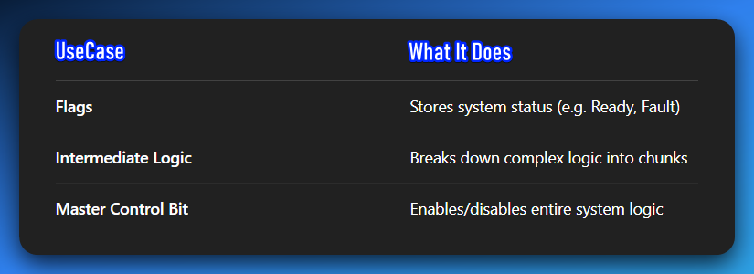

M-bits = **modular design, safety control, and clean programming.**  
Every decent PLC project uses these like glue holding everything together.